**1.**Sampath Valluri – [svalluri1@uco.edu](mailto:svalluri1@uco.edu)  
**2.**  
**Project Implementation**Project 3 is implemented as a cloud-based application with a clear separation of frontend and backend components, deployed on AWS. The Java code (CloudFormationDemo.java) automates the deployment of infrastructure using CloudFormation, configures S3 event notifications to trigger a Lambda function, and uploads files to an S3 bucket. The implementation follows a step-by-step process executed in the main method, with user interaction to handle dependencies between components.  
**Implementation Steps**The implementation is driven by the CloudFormationDemo class, which uses the AWS SDK to interact with CloudFormation, Lambda, and S3 services.   
**Development Environment**Tools: The code assumes a local environment with Java JDK, AWS SDK, and AWS credentials configured  
Deploying Infrastructure with CloudFormation  
Method: deployCloudFormationTemplate(Region, String url, String stackName)  
Process:  
Takes an S3 URL of a CloudFormation template (e.g., proj3_backend.yml) and a stack name.  
Creates a stack using CreateStackRequest with IAM capabilities (for resource permissions).  
**Execution:**Backend stack deployed first.  
- The deployCloudFormationTemplate() method uploads the proj3_backend.yml template and waits until the stack status is CREATE_COMPLETE.  
Outputs (like the API Gateway URL) are printed, which are manually copied into the frontend template.  
Frontend stack deployed after user confirmation (requires API Gateway URL from backend).  
- The user is prompted to confirm they've updated the frontend stack to include the backend's API URL.  
After confirmation, the frontend stack is deployed.  
Outputs (like S3 bucket hosting URL) are shown and used in the next step.  
Amplify stack deployed last (requires frontend outputs).  
- User confirms that Amplify stack is ready with required references (like S3 bucket info).  
The Amplify stack is deployed.  
**Configuring S3 Event Notifications**Method: setEventNotification(String accountId, Region, String bucketName, String lambdaFunctionName, String functionArn, String amplifyAppId)  
Process:  
Grants S3 permission to invoke a Lambda function using AddPermissionRequest.  
Applies a bucket policy allowing AWS Amplify to access the S3 bucket (specific to proj3/index.zip).  
Sets up an S3 event notification to trigger the Lambda function when proj3/index.zip is uploaded.  
Execution: Prompted for Lambda function name, ARN, and Amplify App ID manually via Scanner.  
**Uploading Files to S3**Method: uploadS3File(String bucketName, String keyName, String filePath, Region)  
Process:  
Uploads a local file (e.g., index.zip) to the specified S3 bucket and key using PutObjectRequest.  
Execution: Prompted for file path and key name manually via Scanner.  
**CICD Implementation**Added a GitHub Actions workflow to automate zipping and uploading your index.html to S3 on push to the master branch.  
Automatically runs when a push is made to the master branch  
Installs the zip utility  
Compresses the index.html into index.zip  
Uploads index.zip to s3://proj3-uco-cicc-media-group6/proj3/  
This zip file triggers the S3 event notification previously set up via Java code, which in turn invokes a Lambda function.  
That Lambda function then triggers the Amplify app deployment, closing the loop for automated delivery.  
**Any change to Lambda (e.g., logic update in lambda_function.py) triggers:**Auto zip  
Upload to S3  
Lambda is updated with latest code  
StartAmplifyDeployment  
Role: Deployment trigger Lambda  
When index.zip is uploaded to S3, this function:  
Checks filename  
Starts deployment using the Amplify App ID and branch (dev)  
CI/CD: Triggered when code under cicd-main/frontend/ changes  
Java SDK injects Amplify App ID dynamically as part of the S3 bucket notification setup (Step 4 in Java code)  
Deployed via:  
Zipping proj3_deployment_lambda.py  
Uploading to S3  
Updating the Lambda function code  
The Amplify App ID is passed dynamically into the Lambda environment during the setEventNotification Java method.  
**Testing:  
Unit Testing:**The Lambda function is individually tested using sample test events (mimicking the payload from the frontend) to ensure that image uploads, face detection, text extraction, and DynamoDB writes work as expected. **End-to-End Testing:**The complete workflow is tested from the frontend (using AWS Amplify) through API Gateway to the Lambda function.The DynamoDB table is checked to verify that participation records are correctly stored.  
  
3.  
**Screenshots**  
  
  
  
  
  
  
  
  
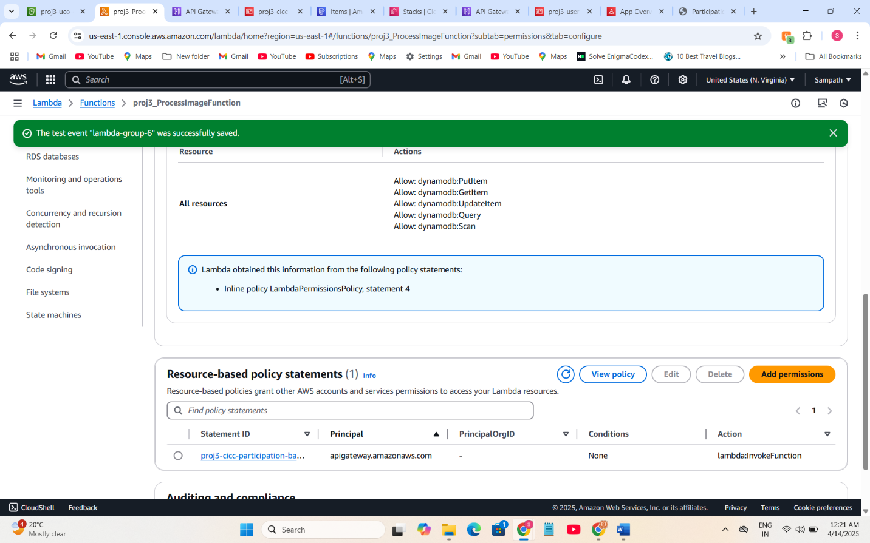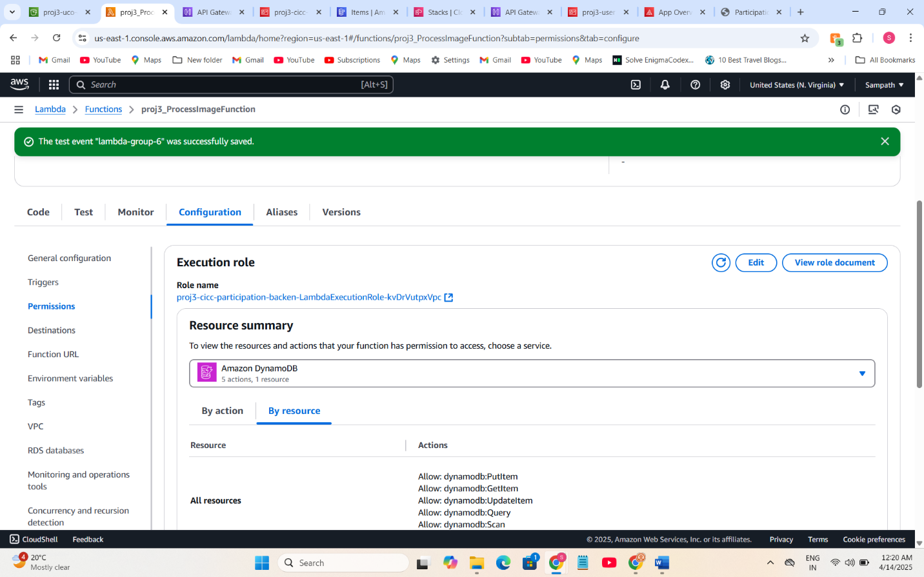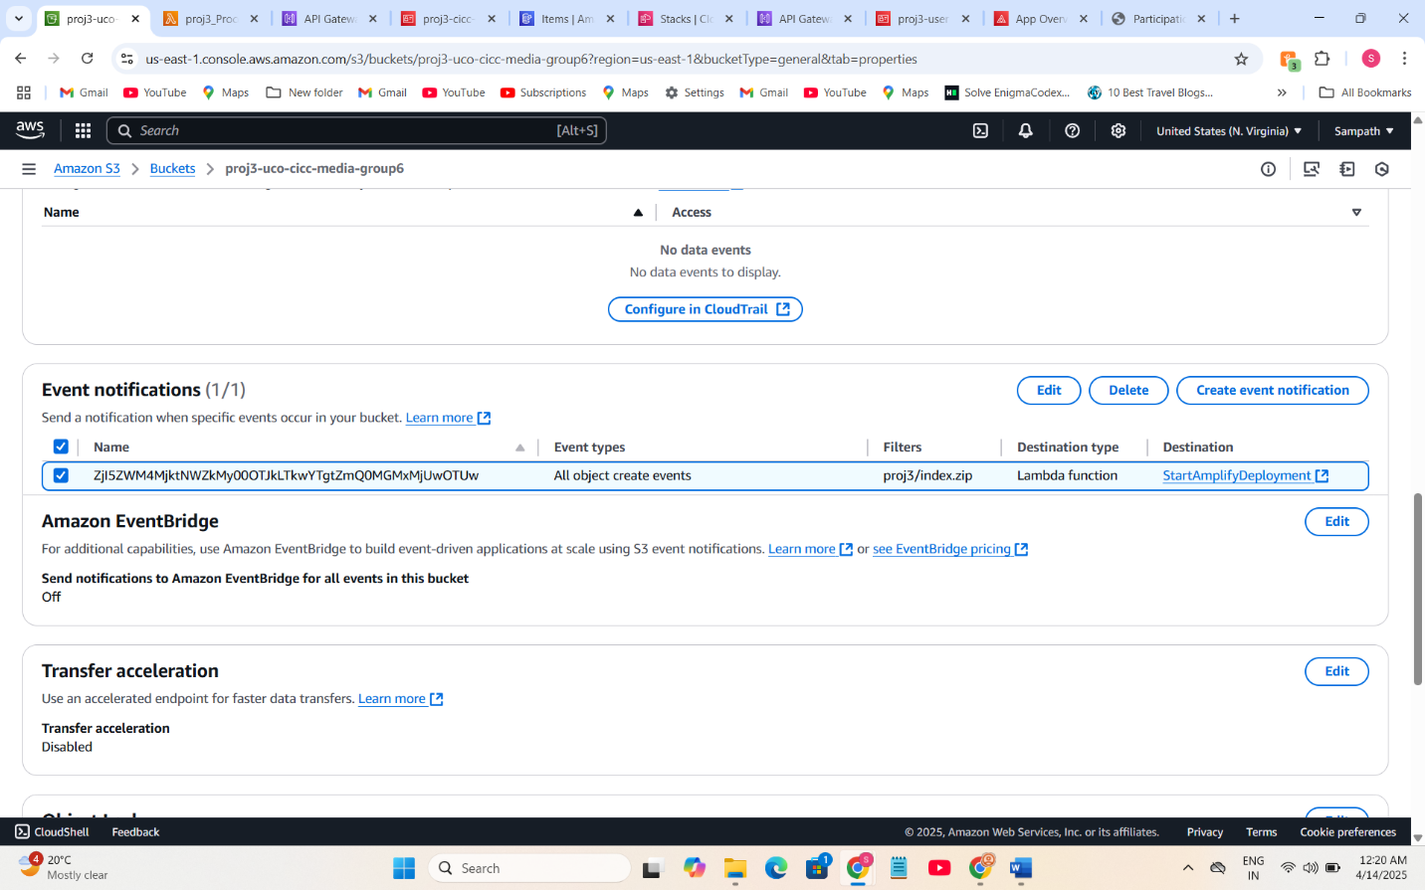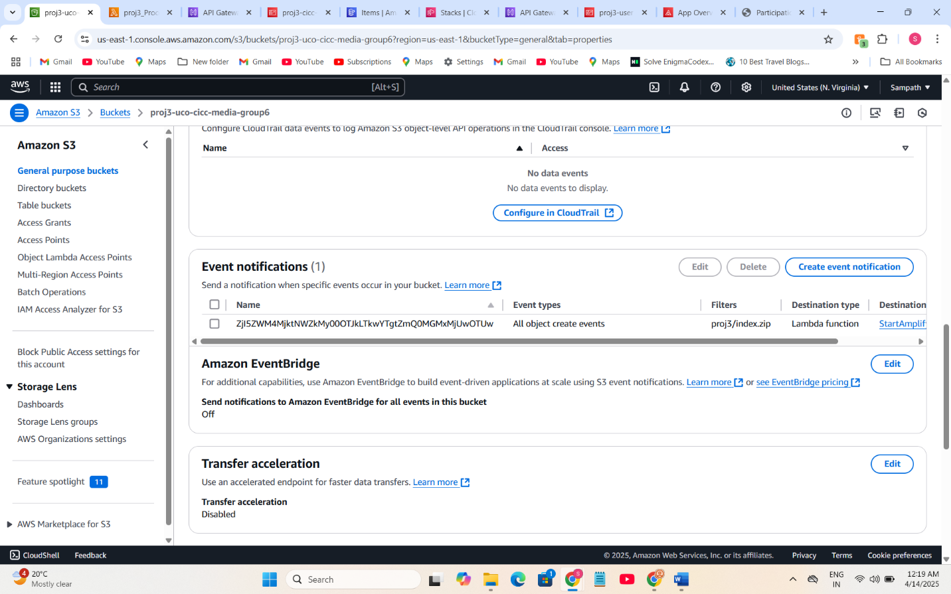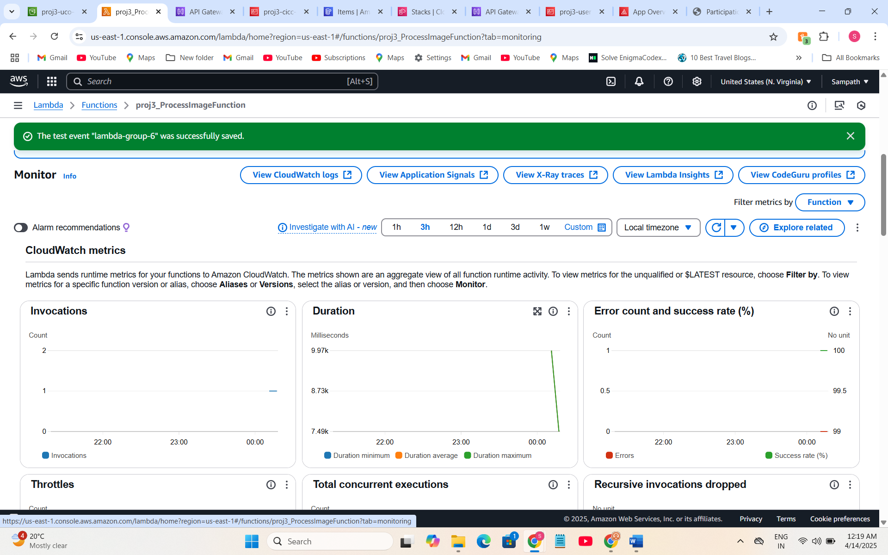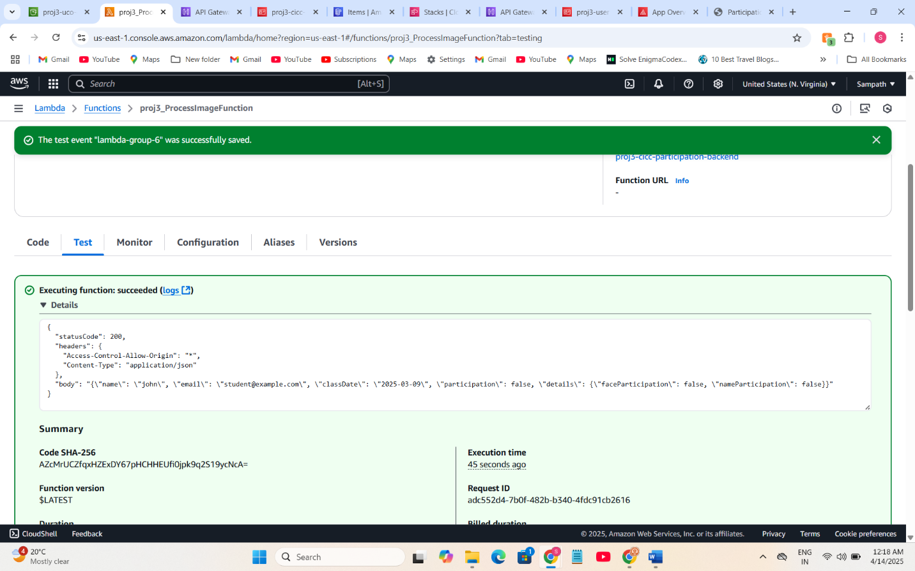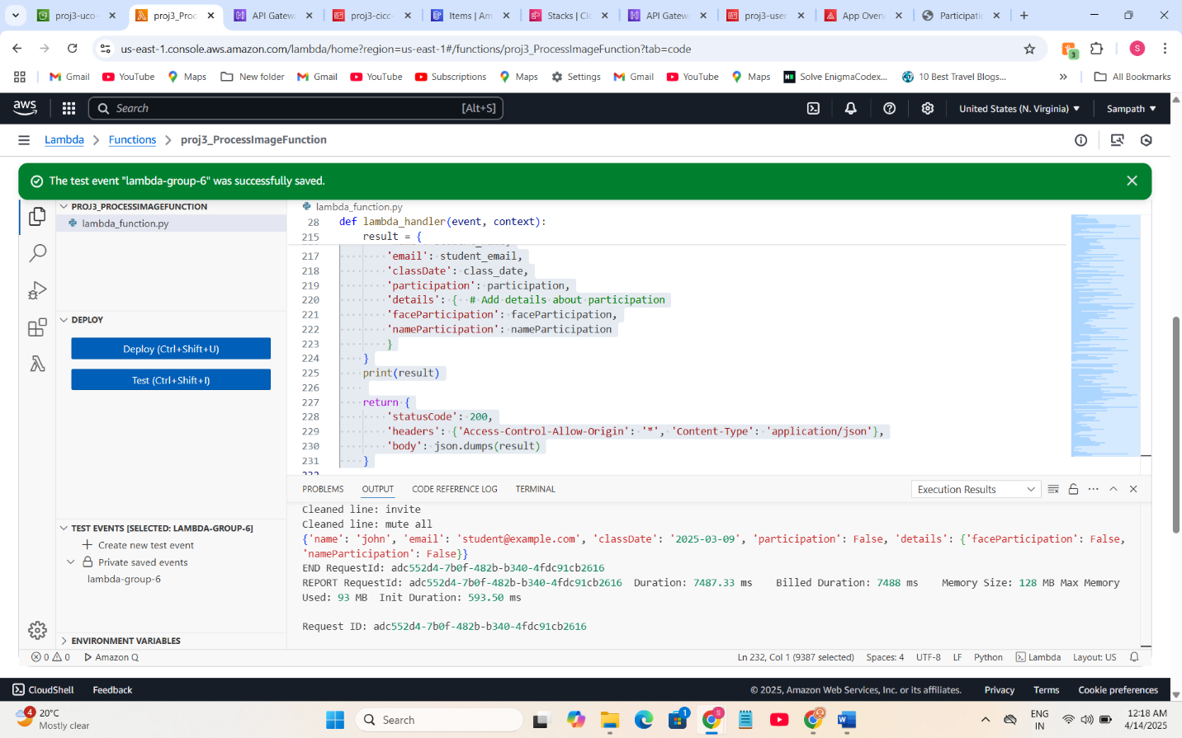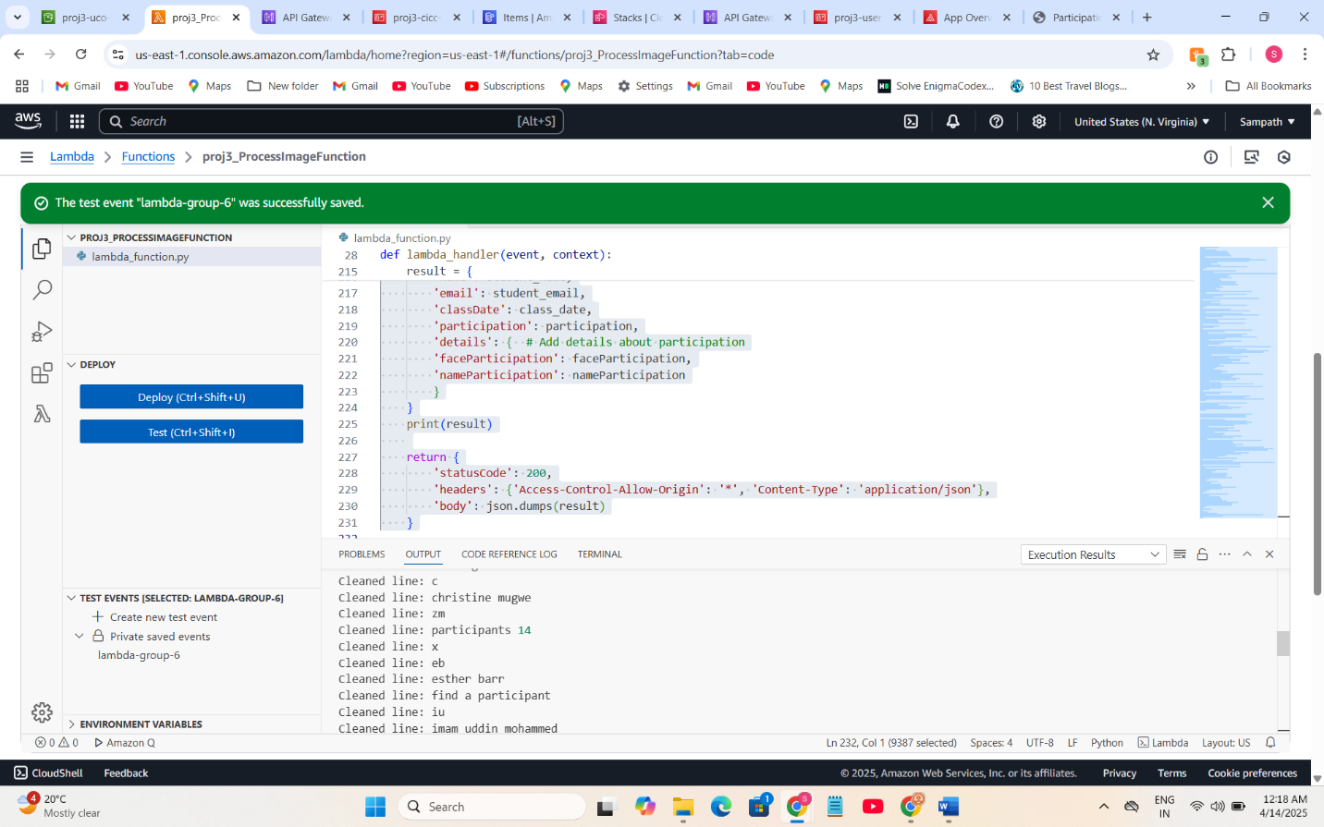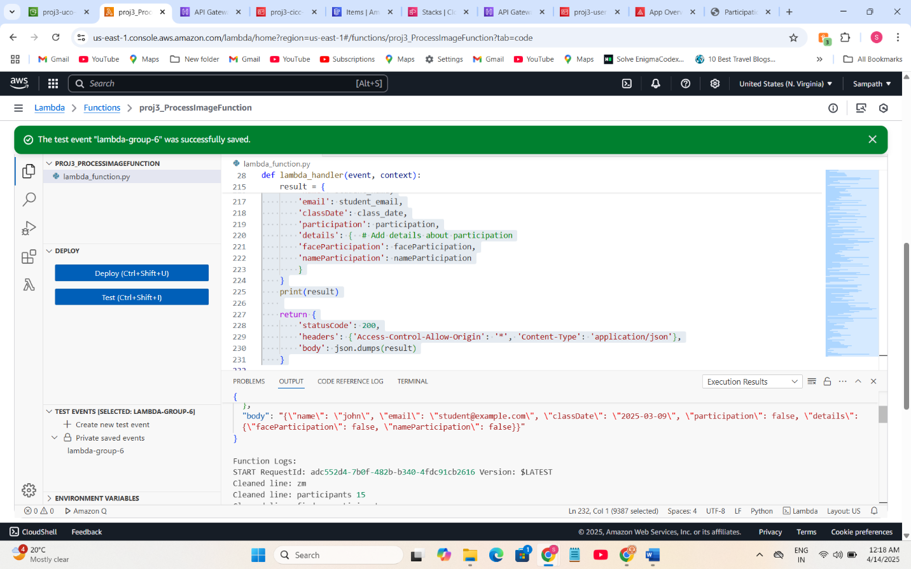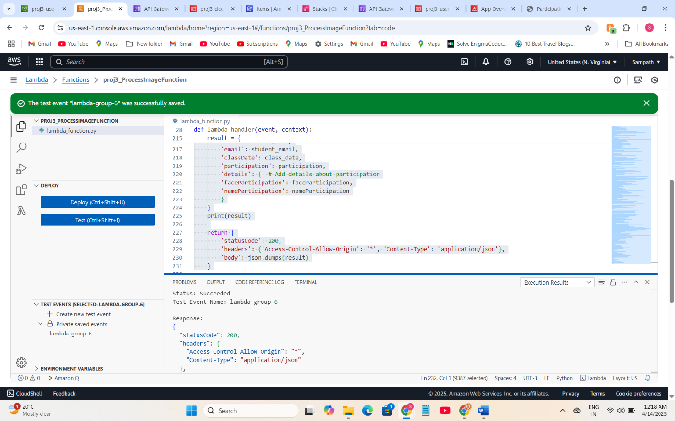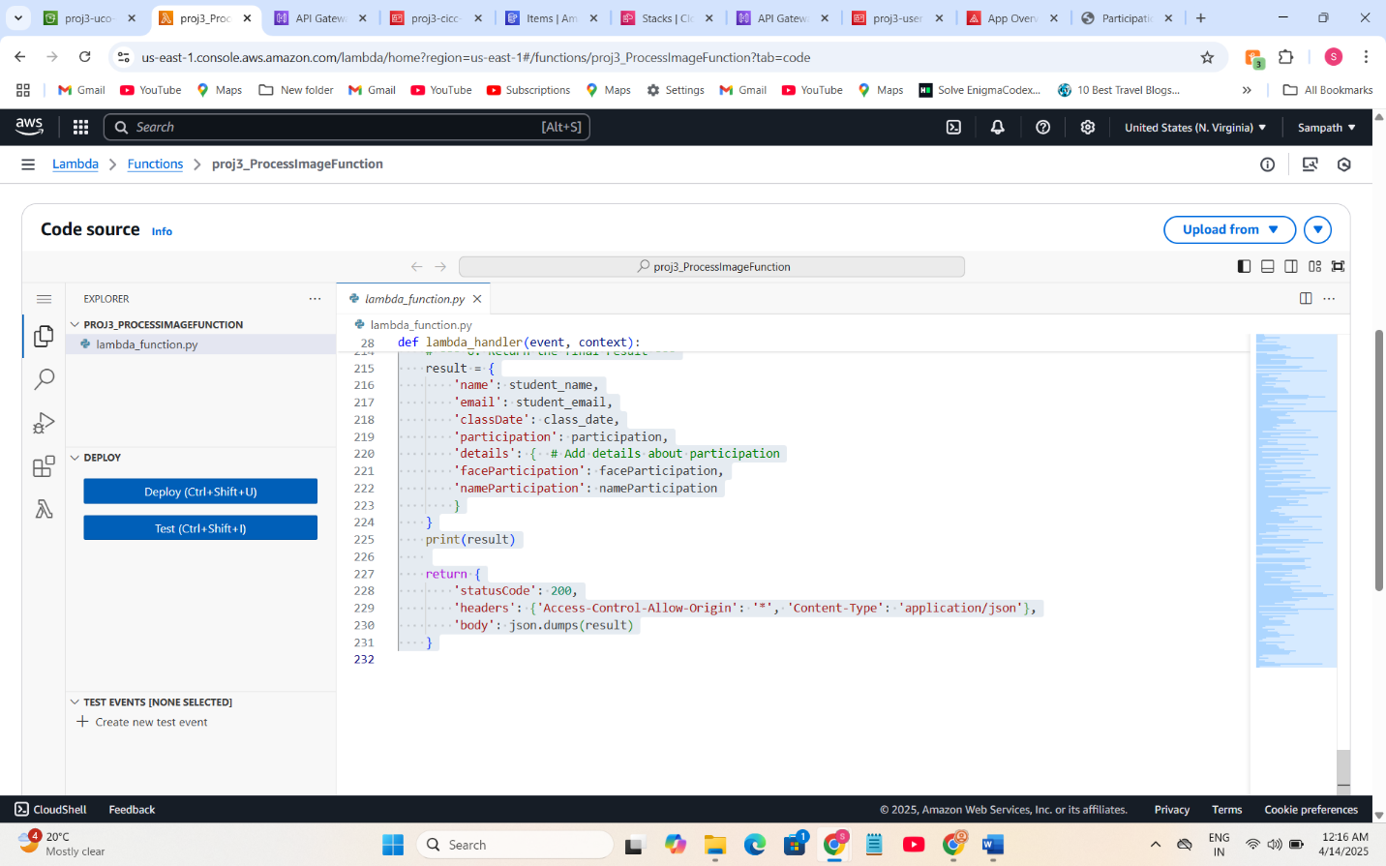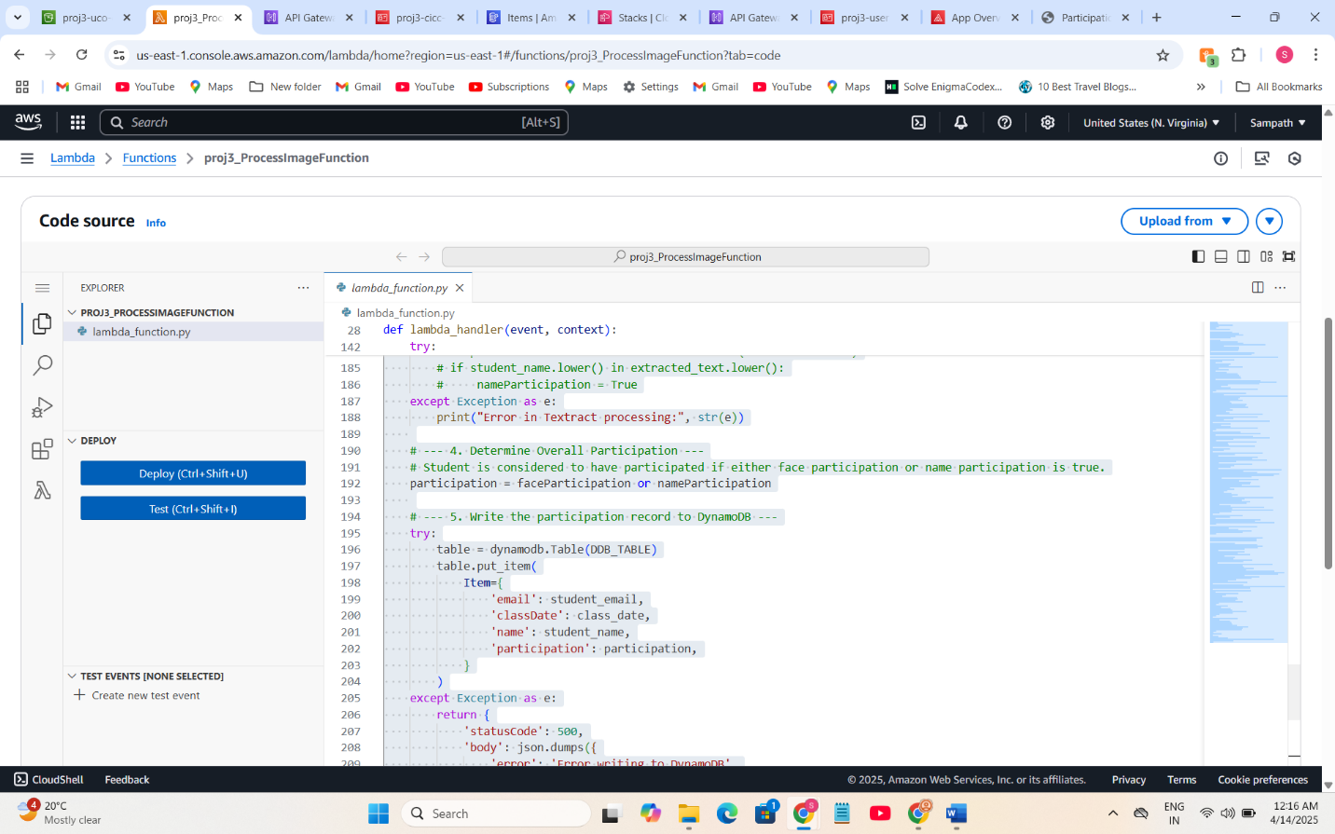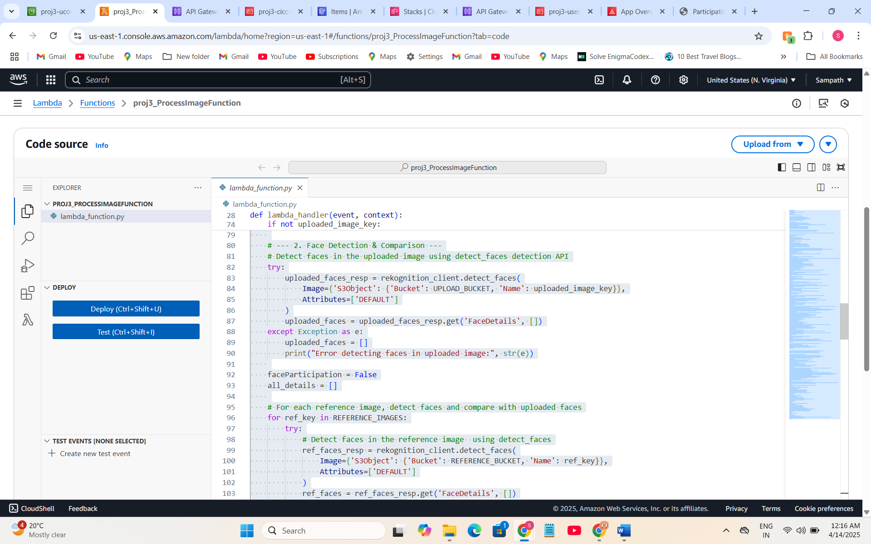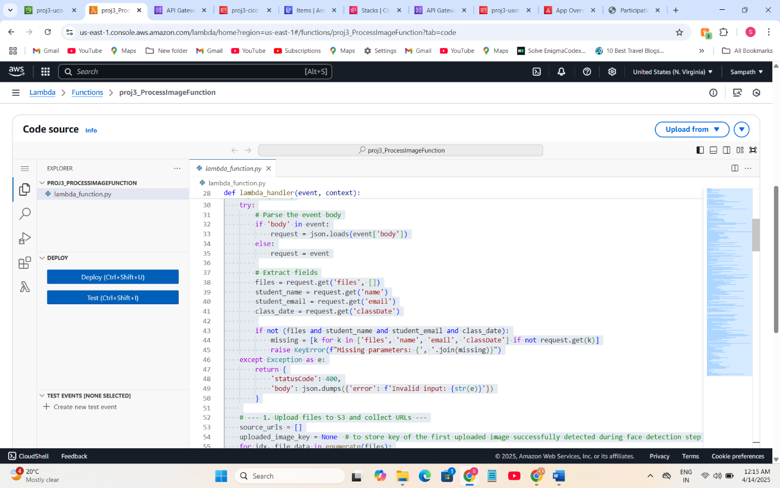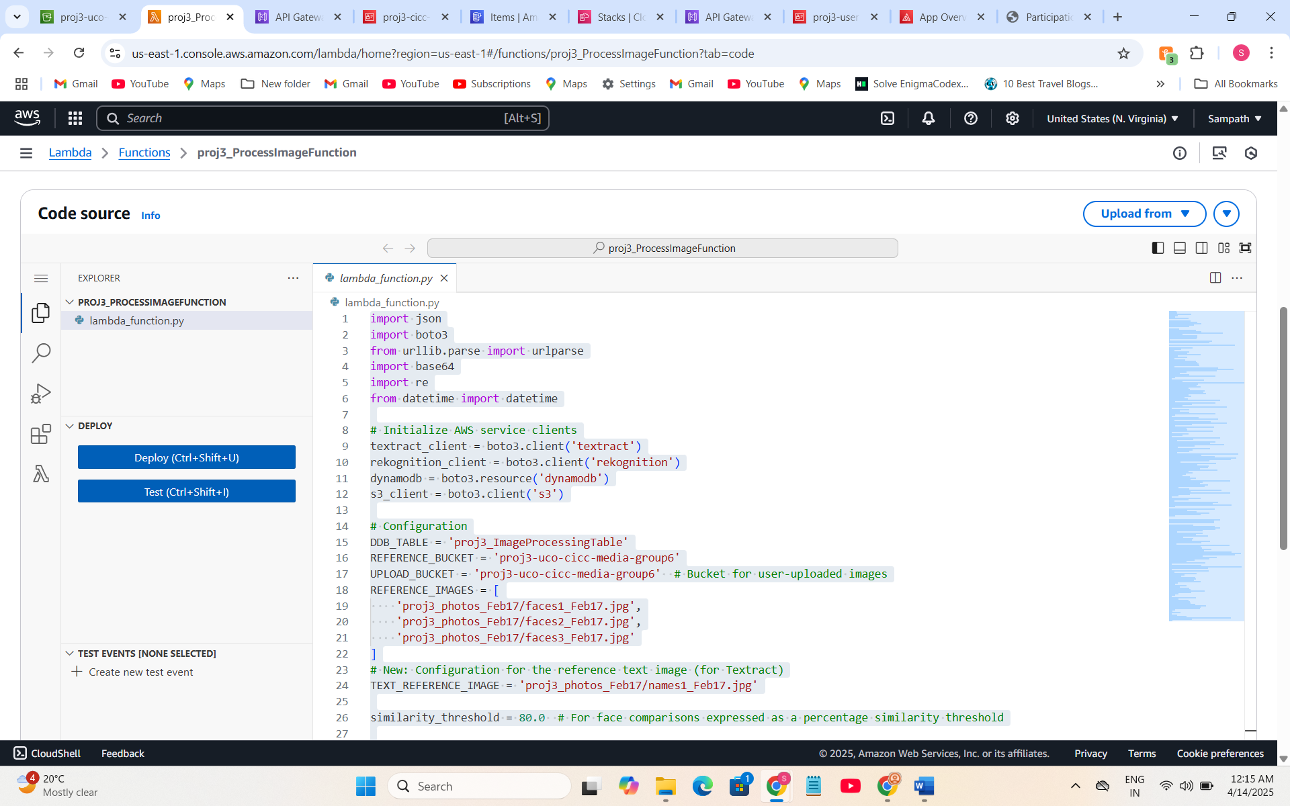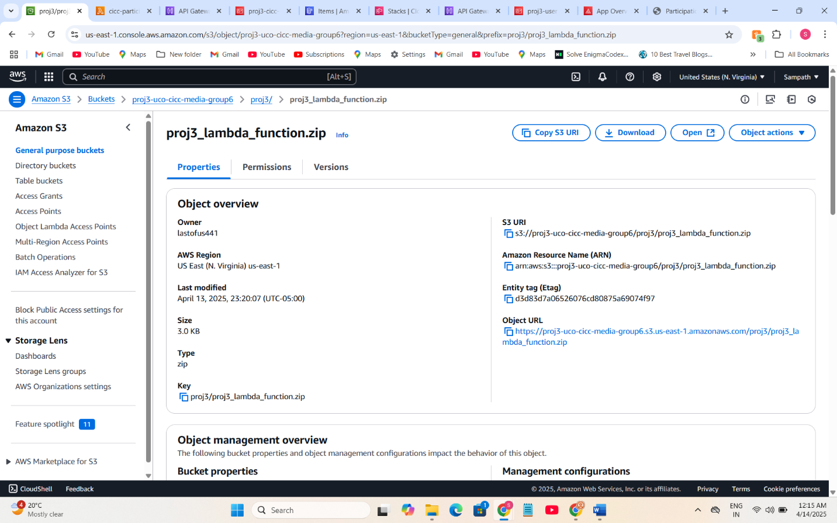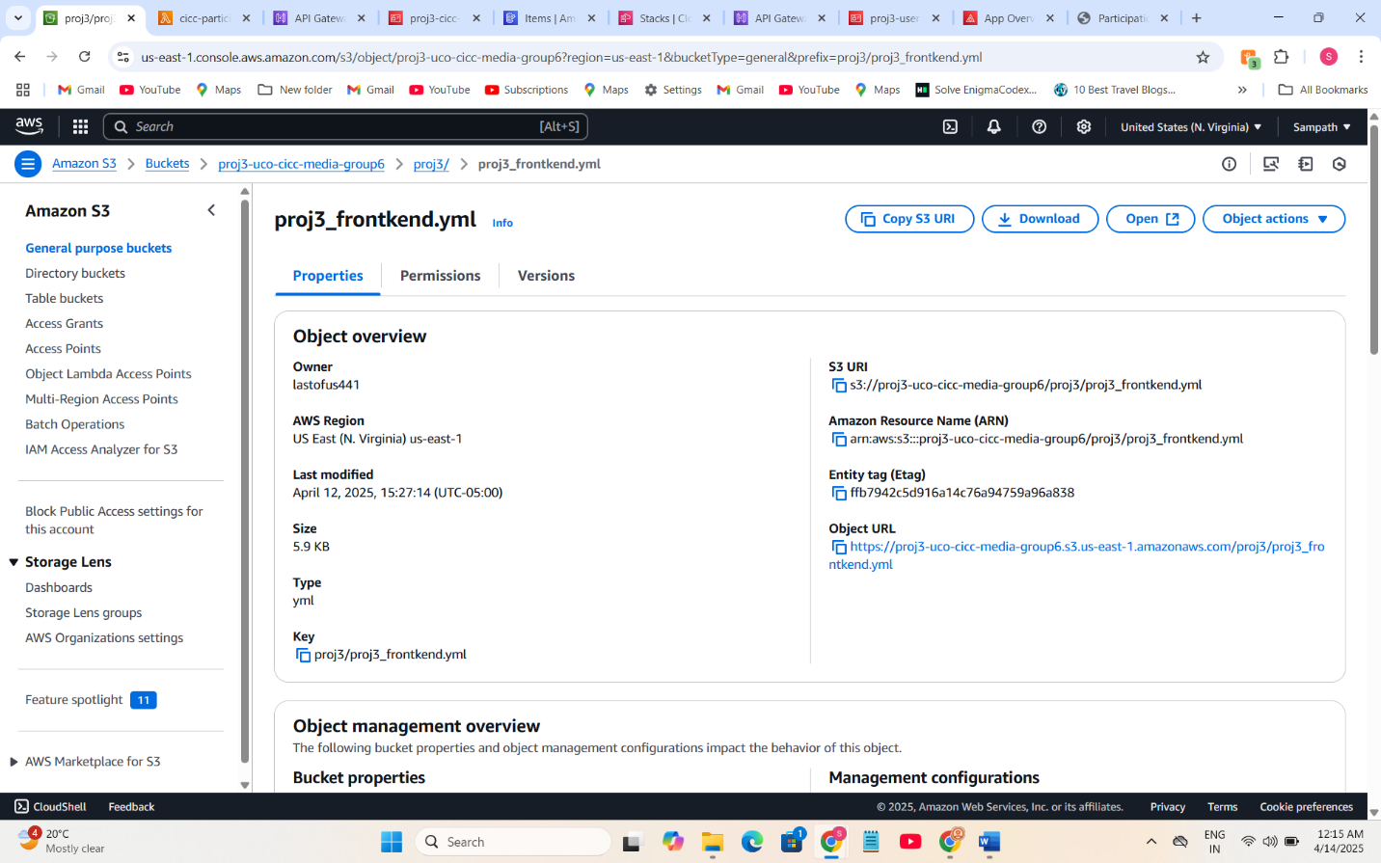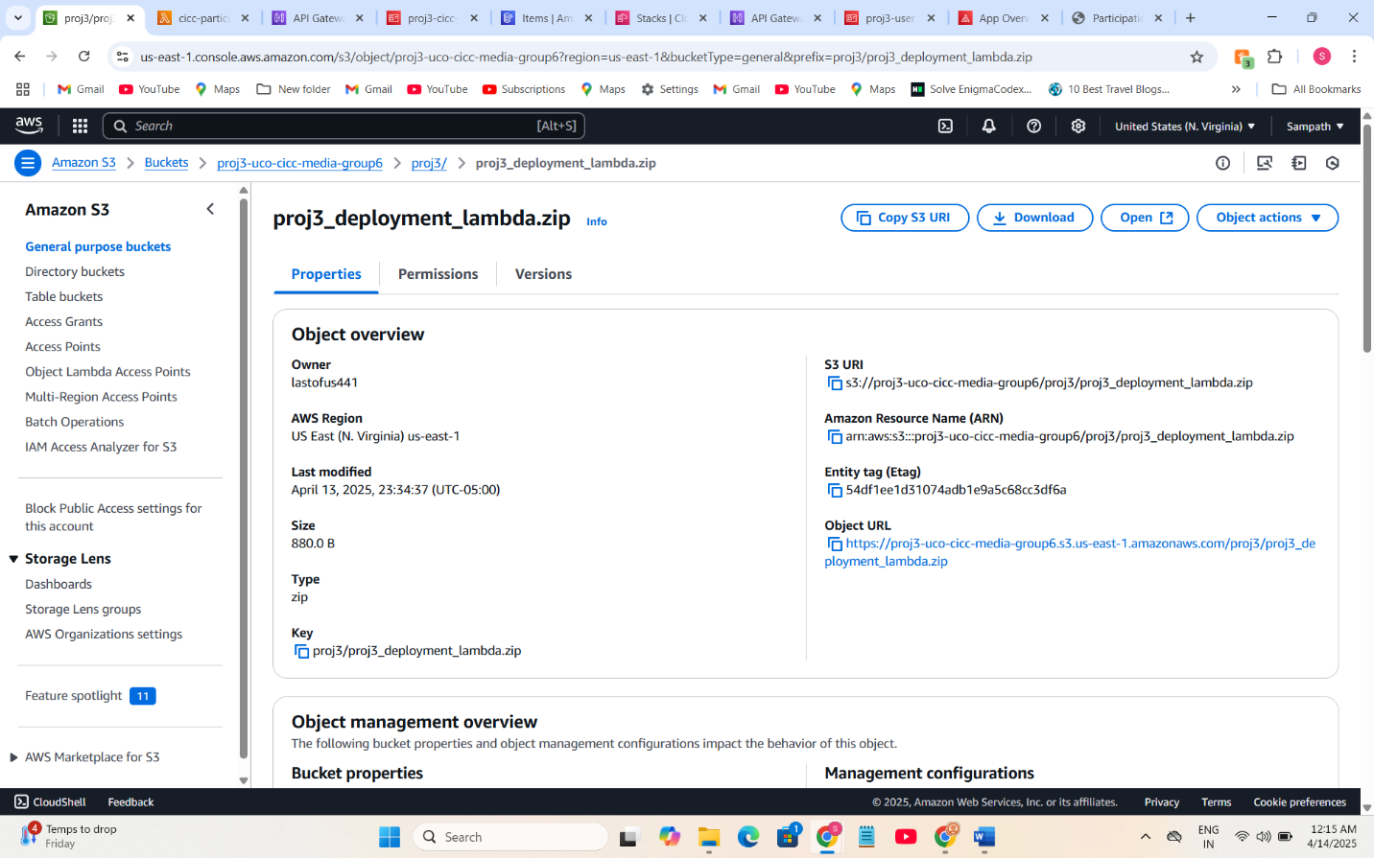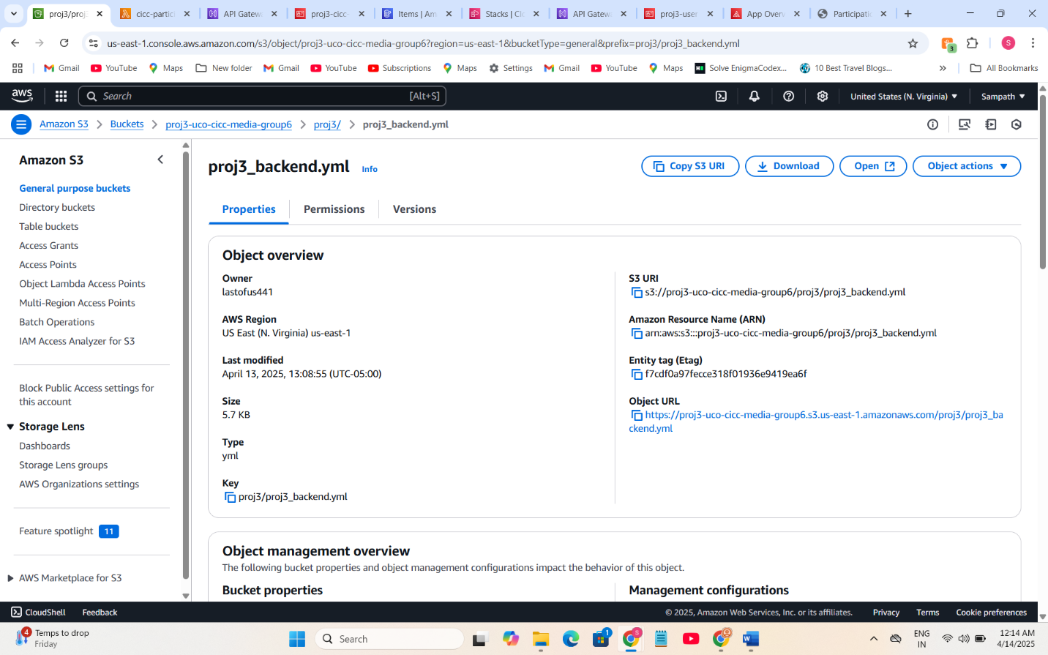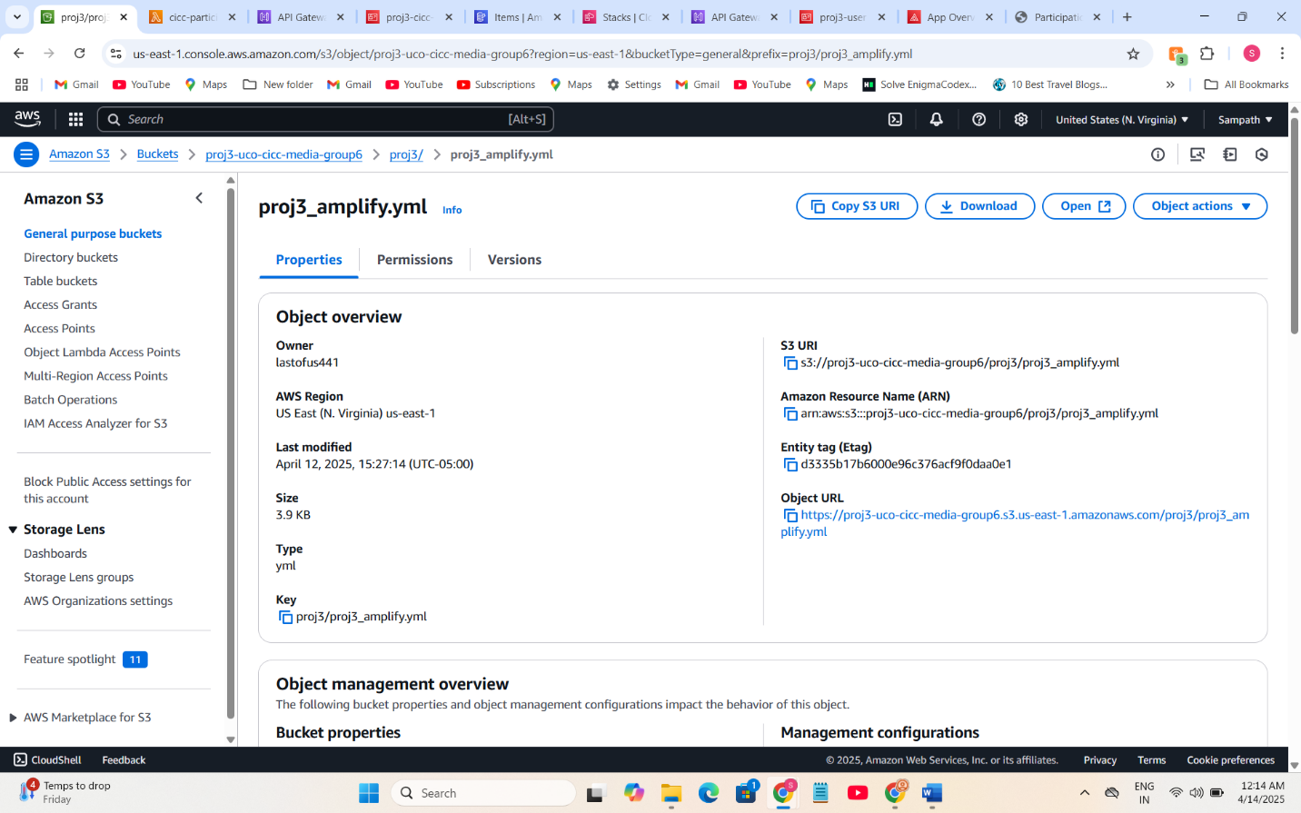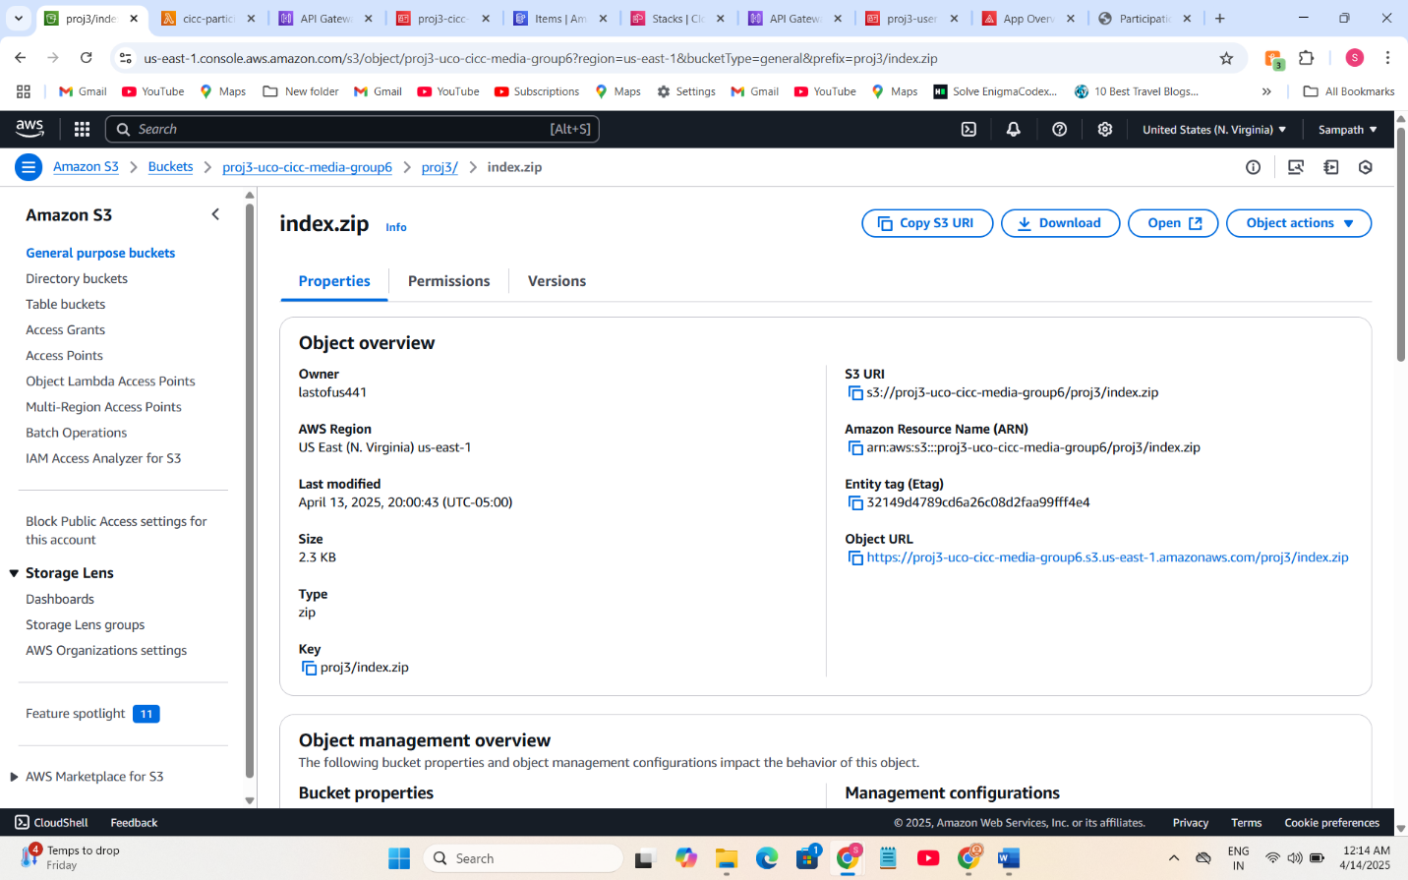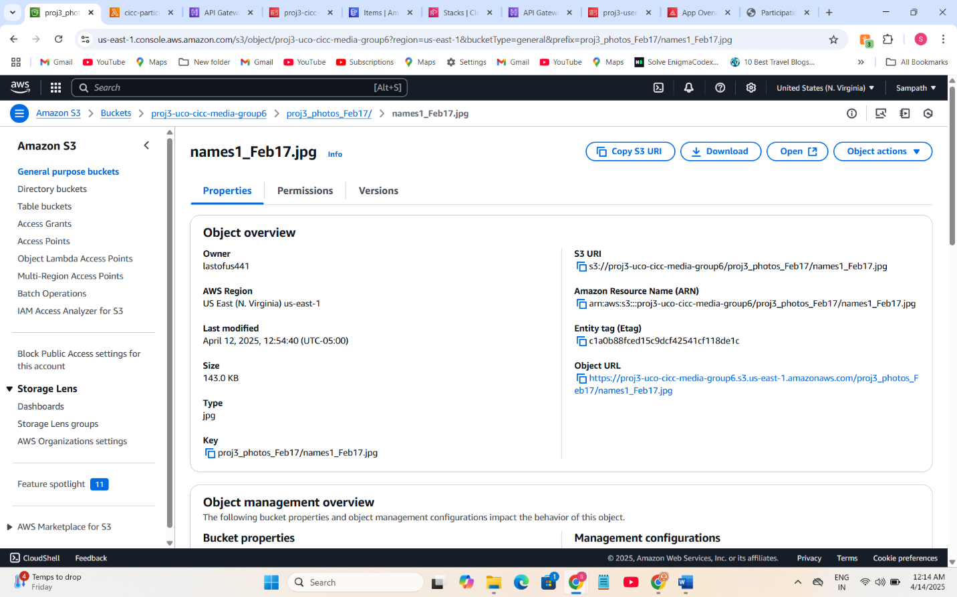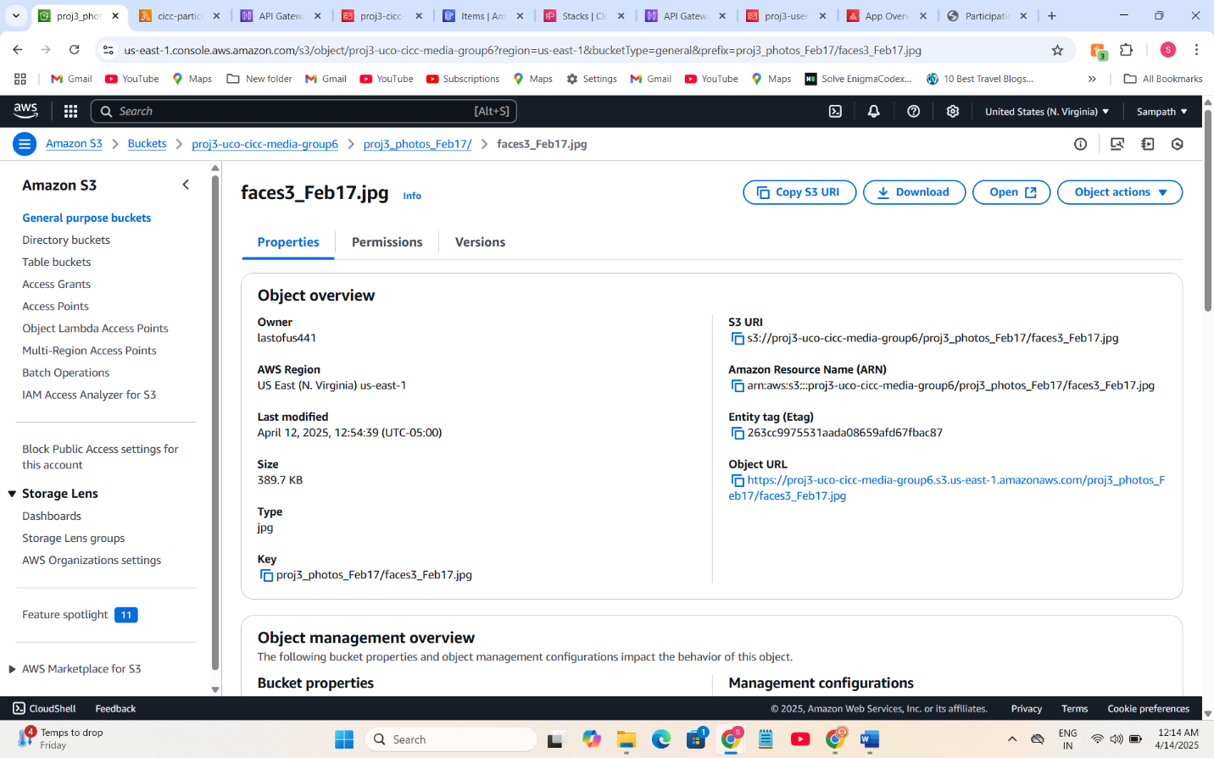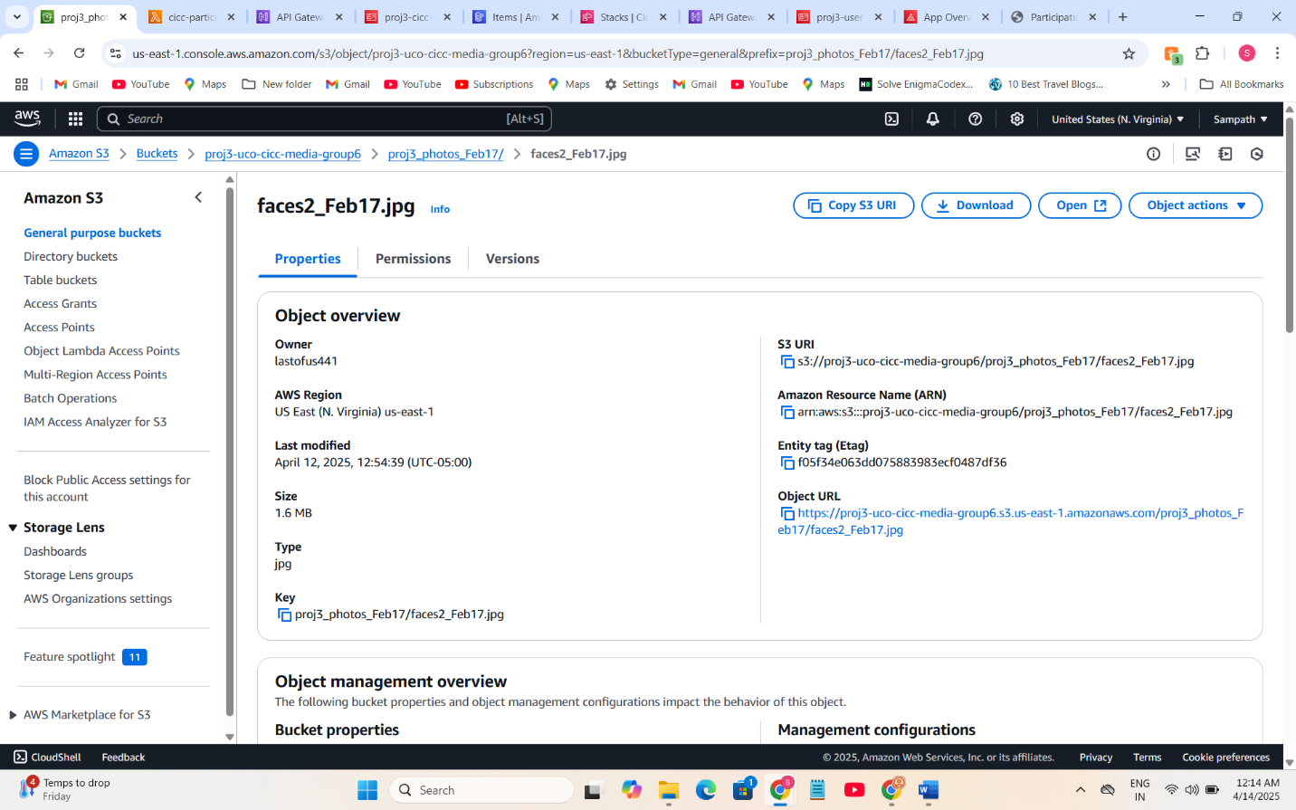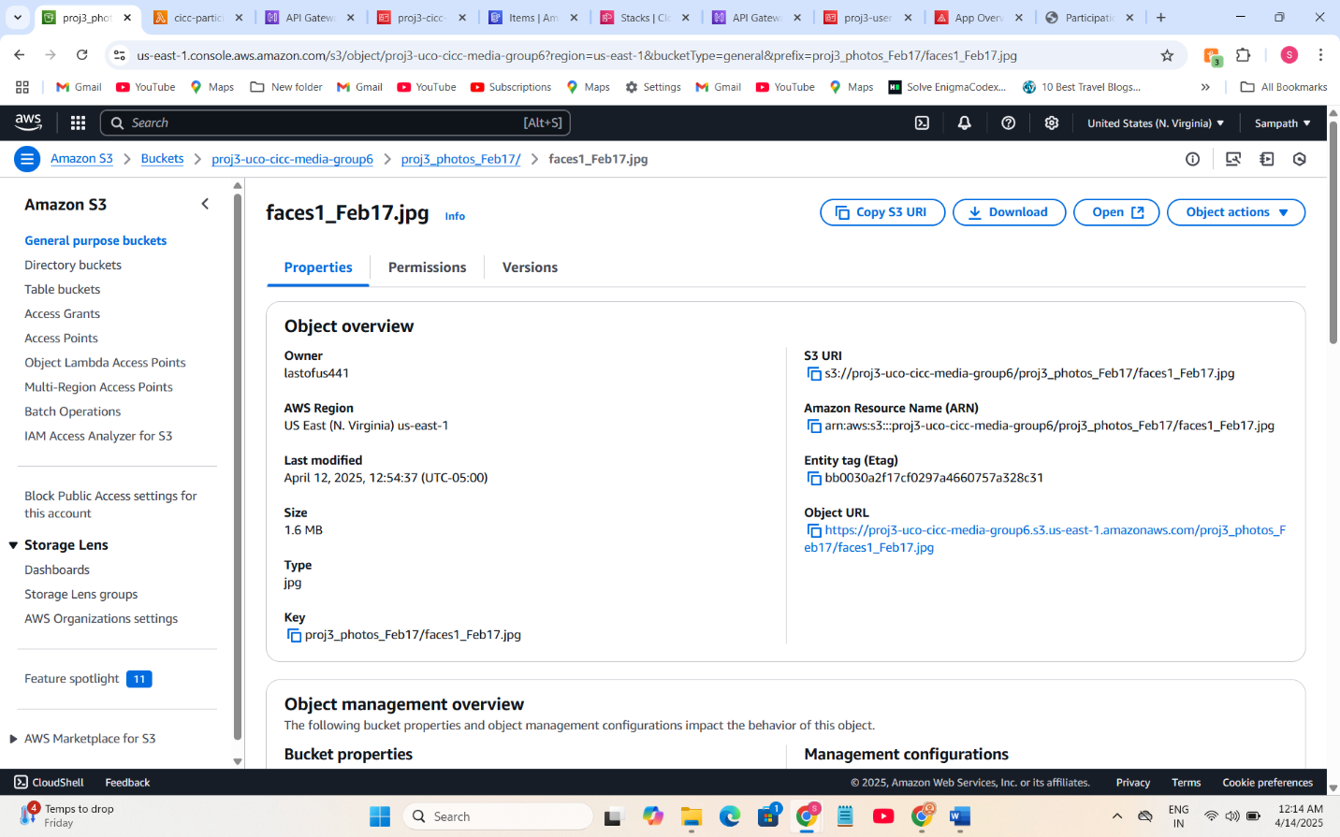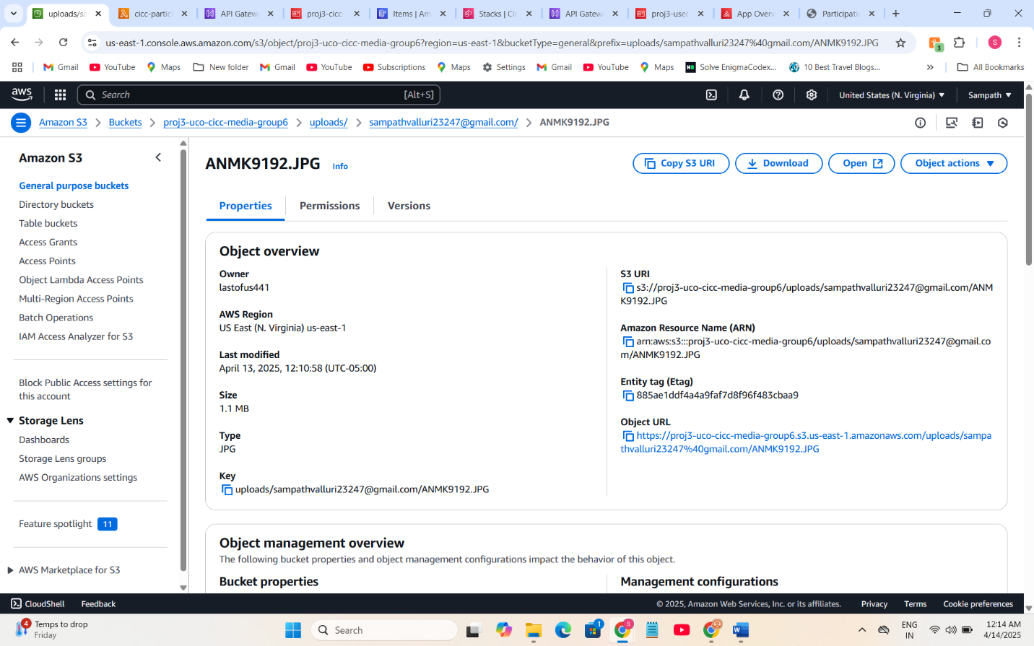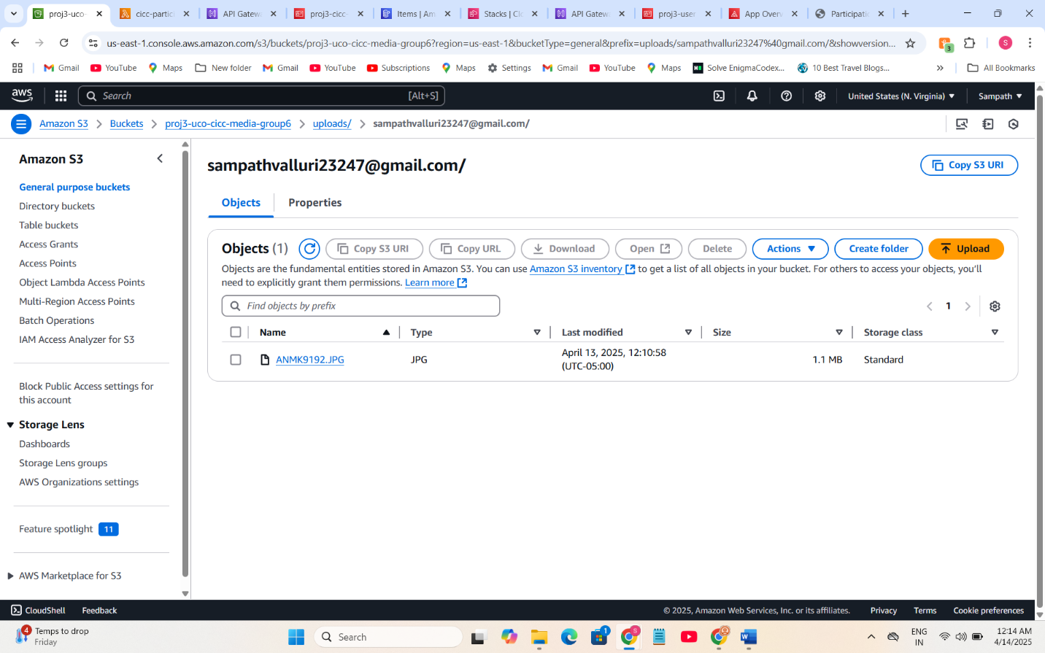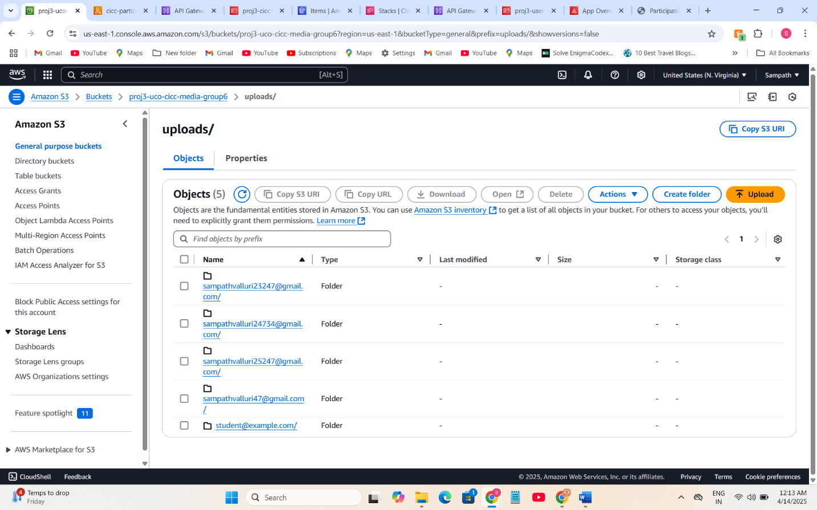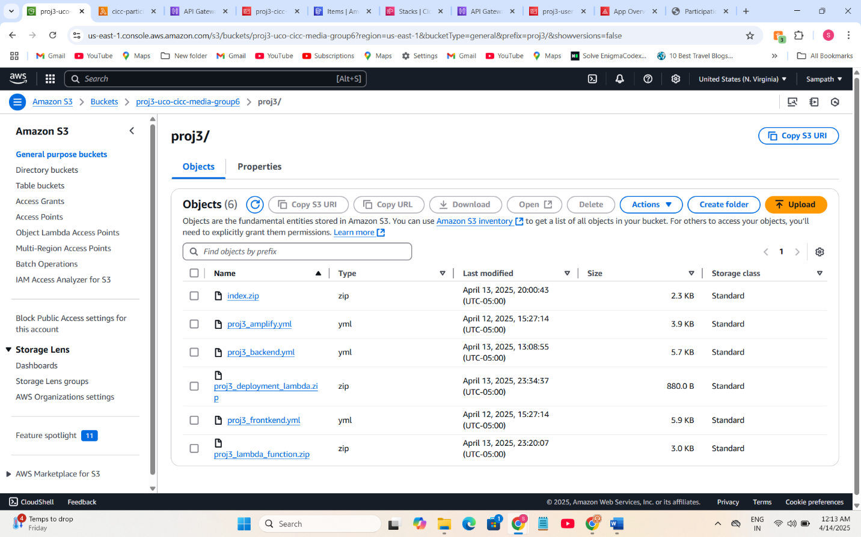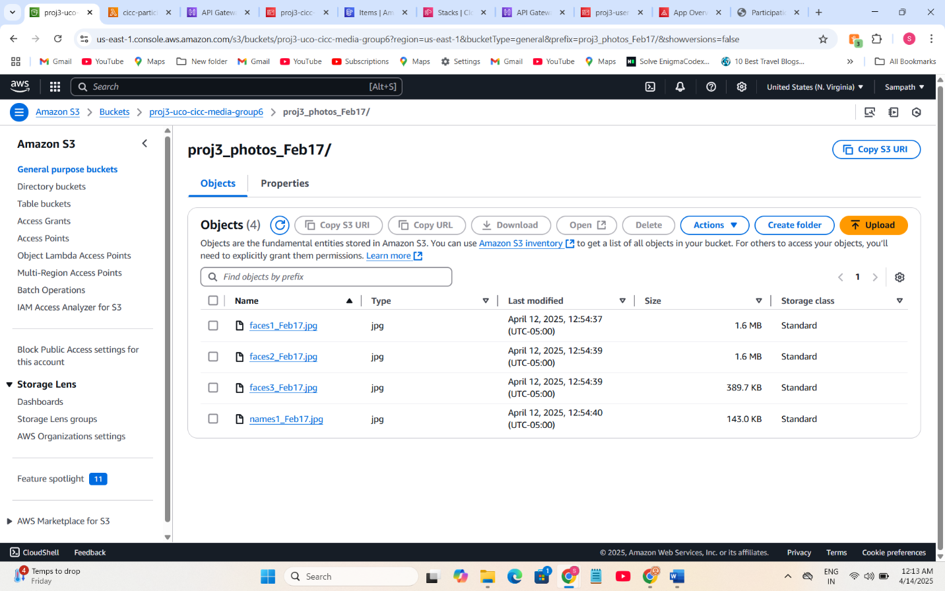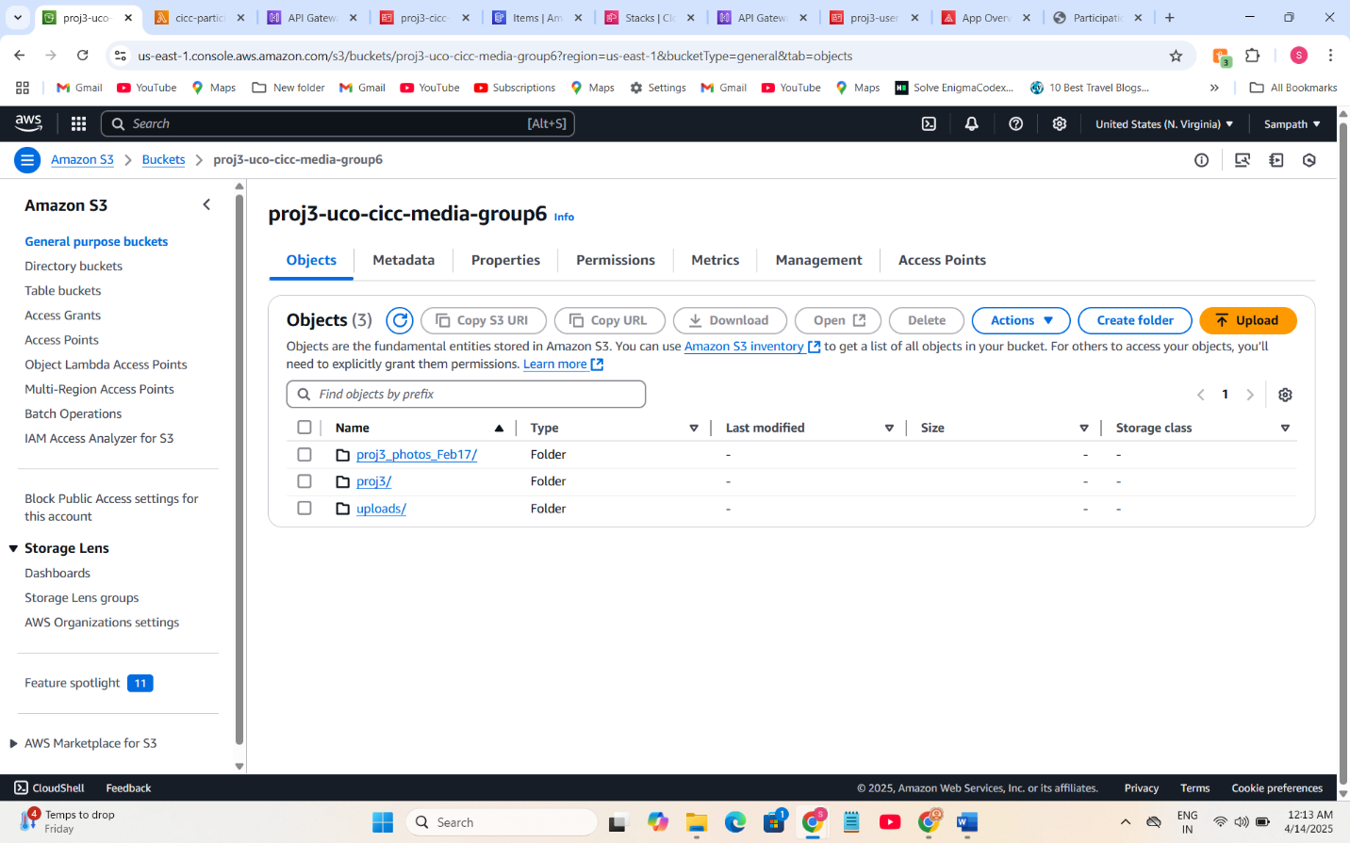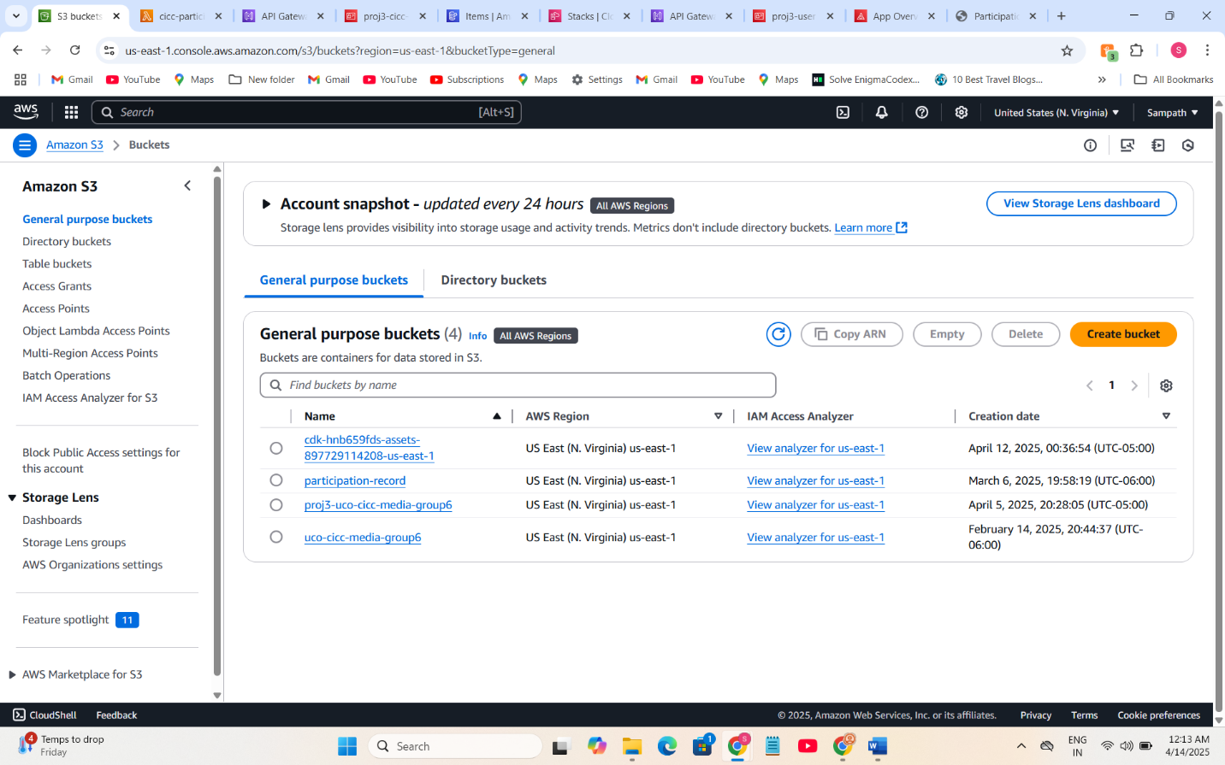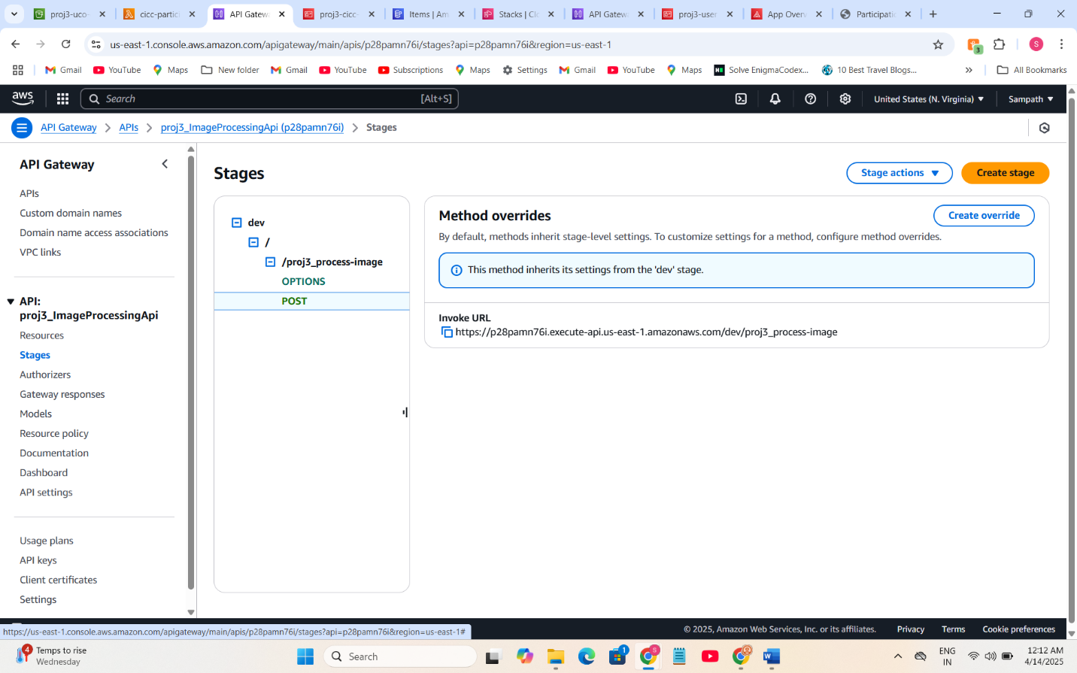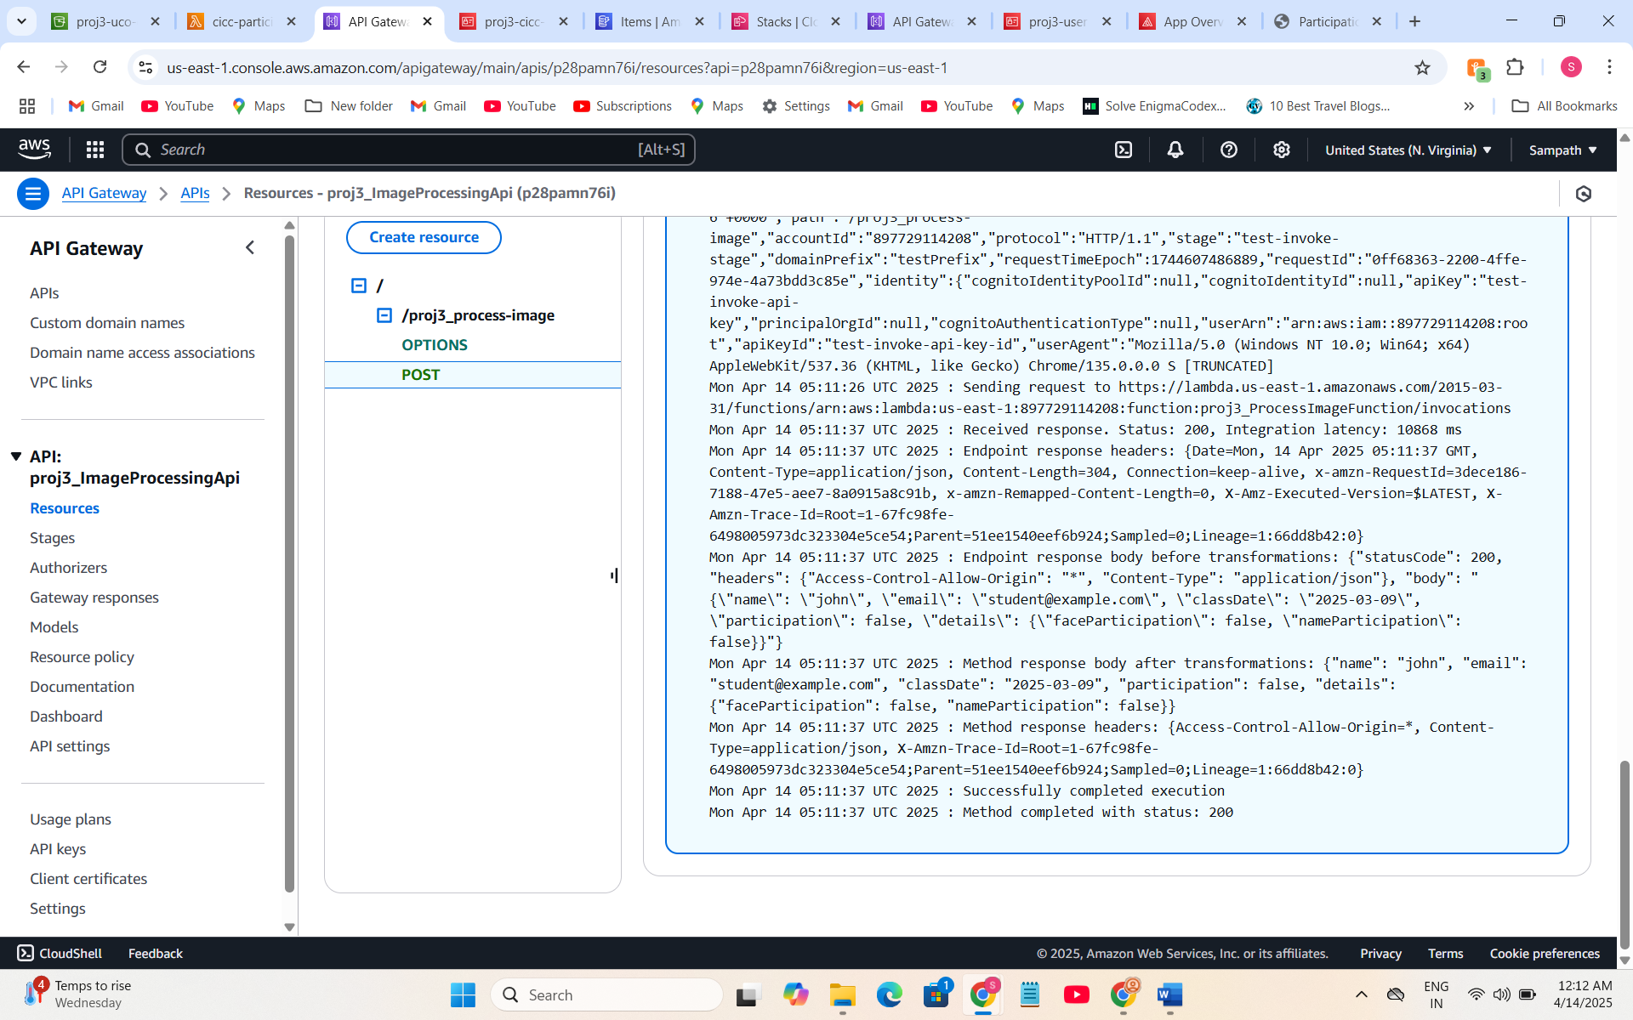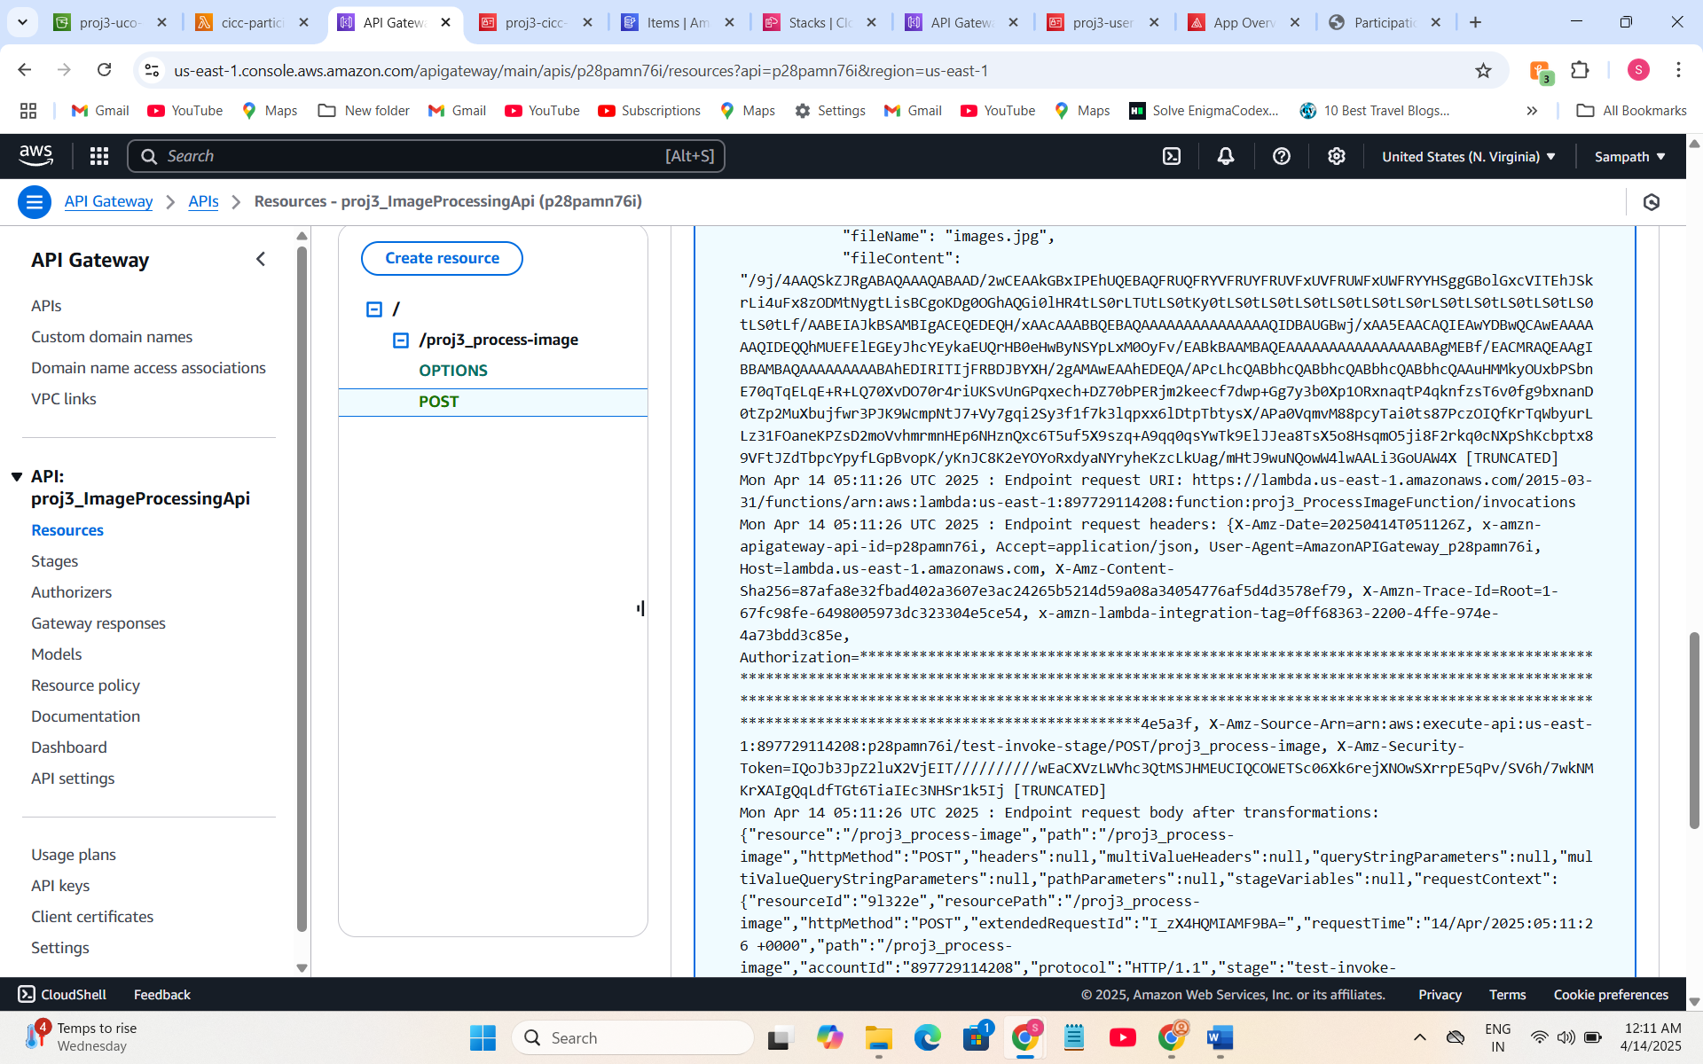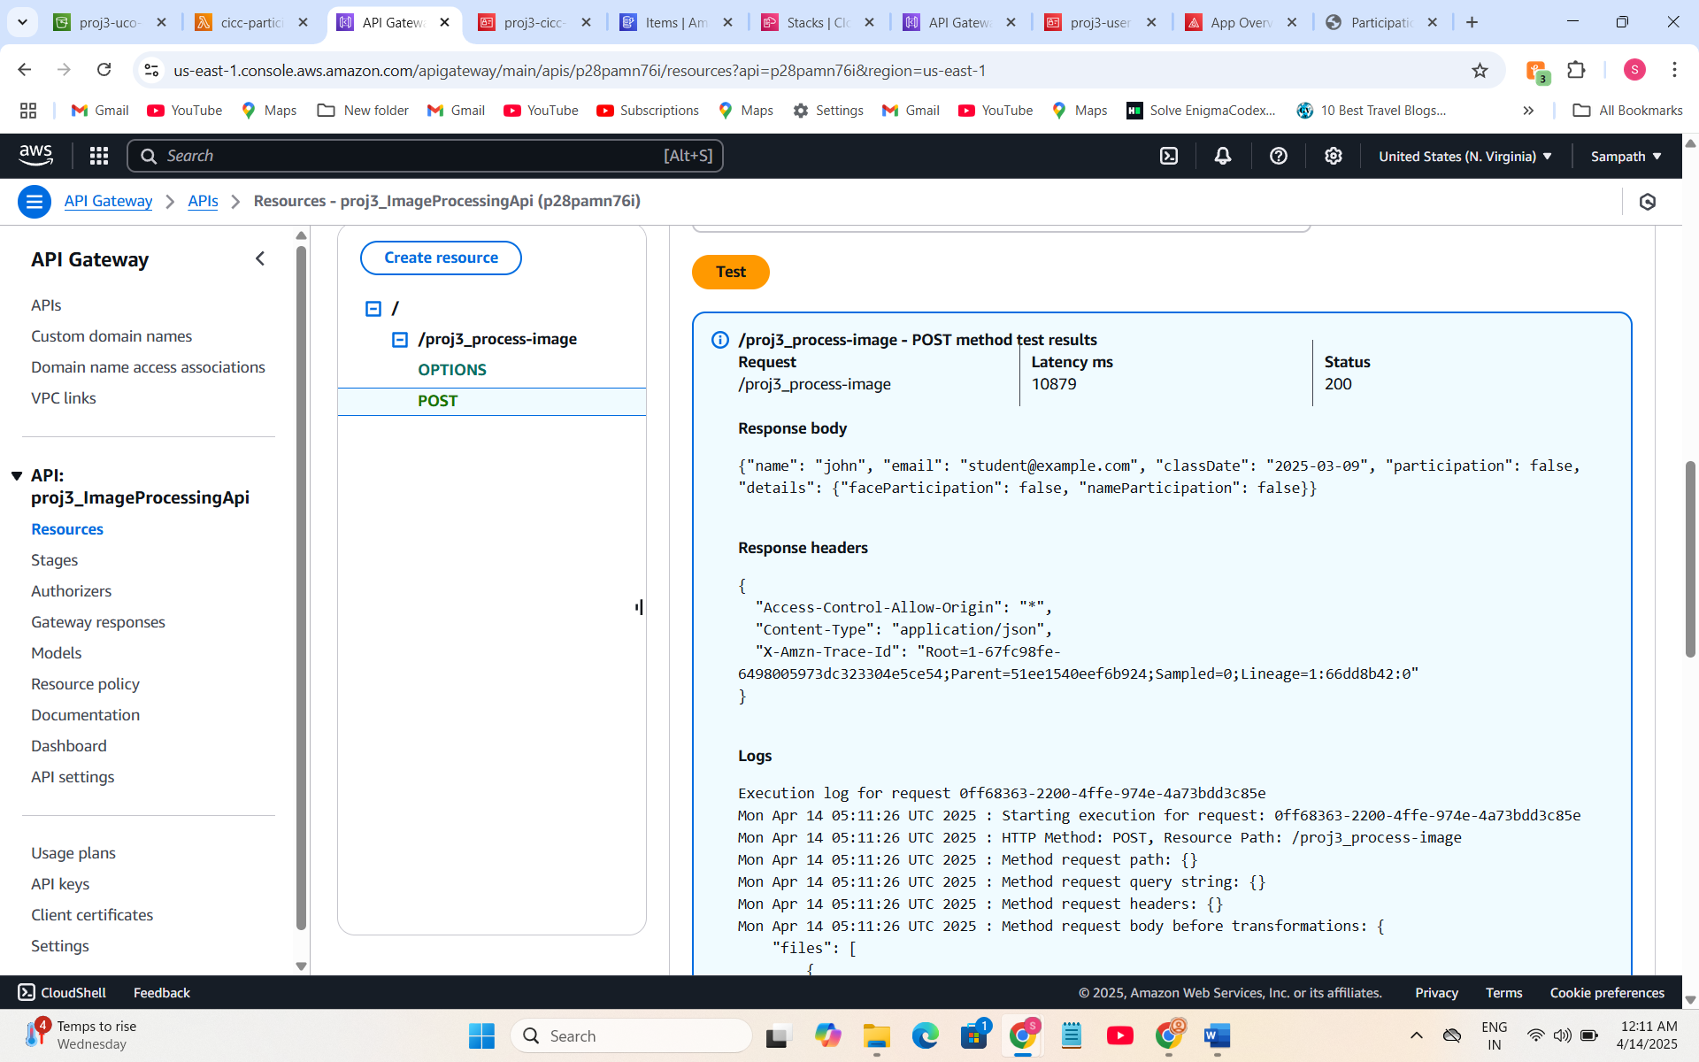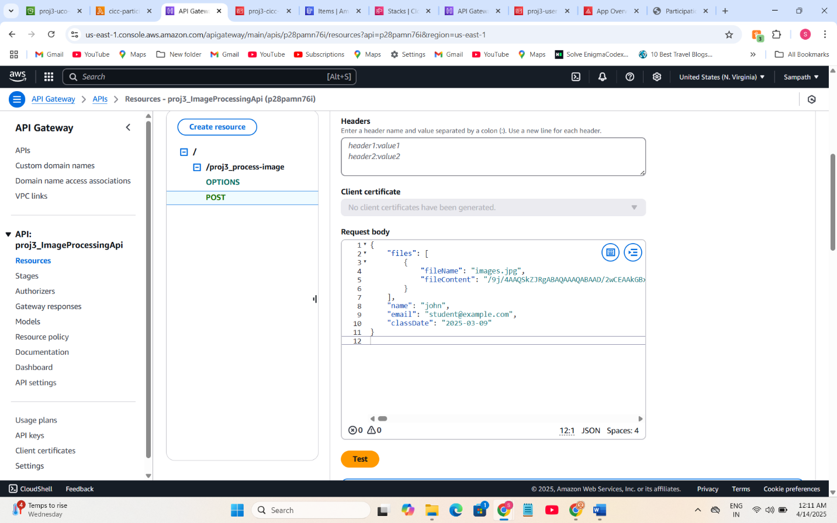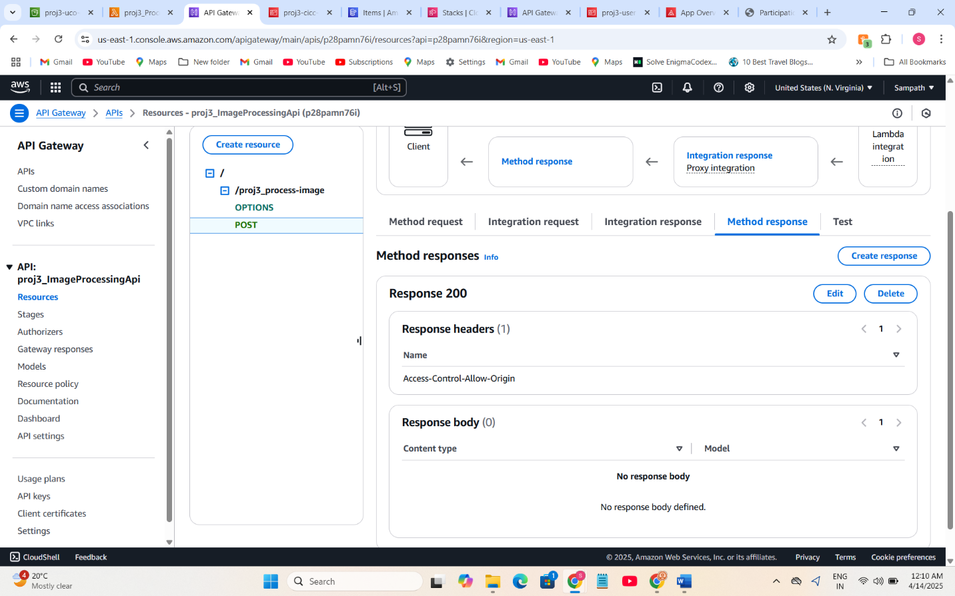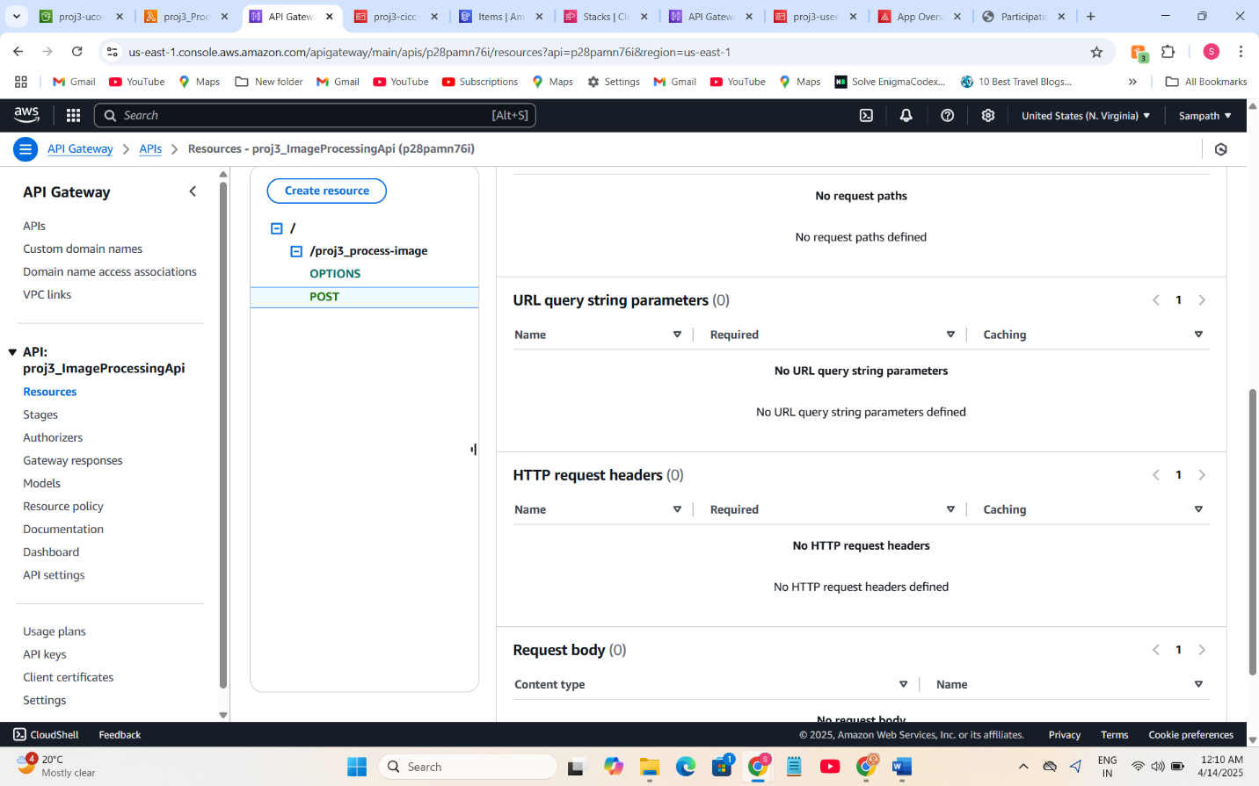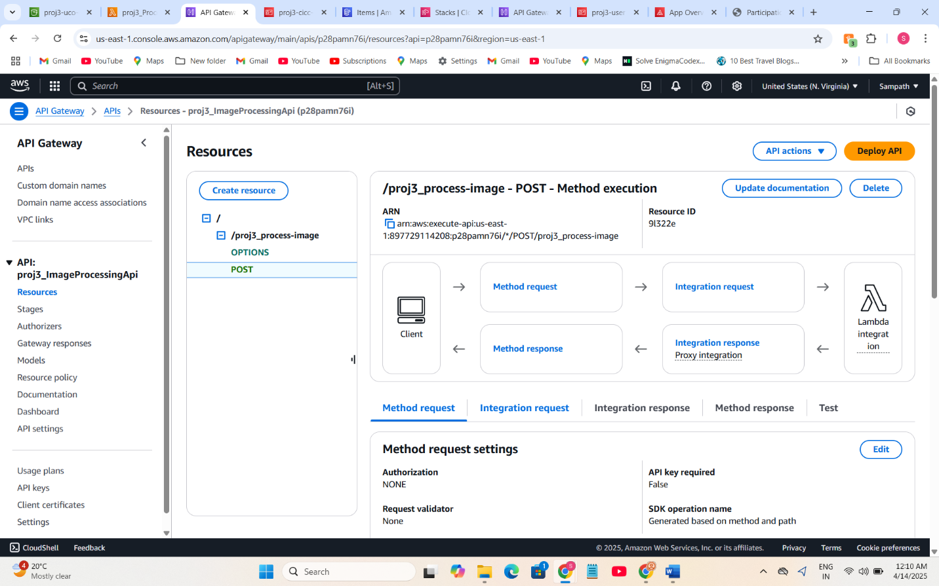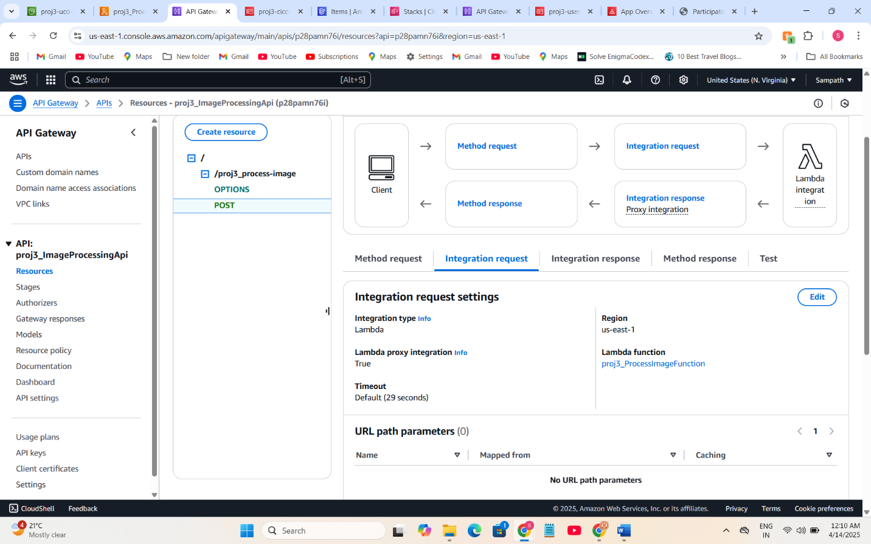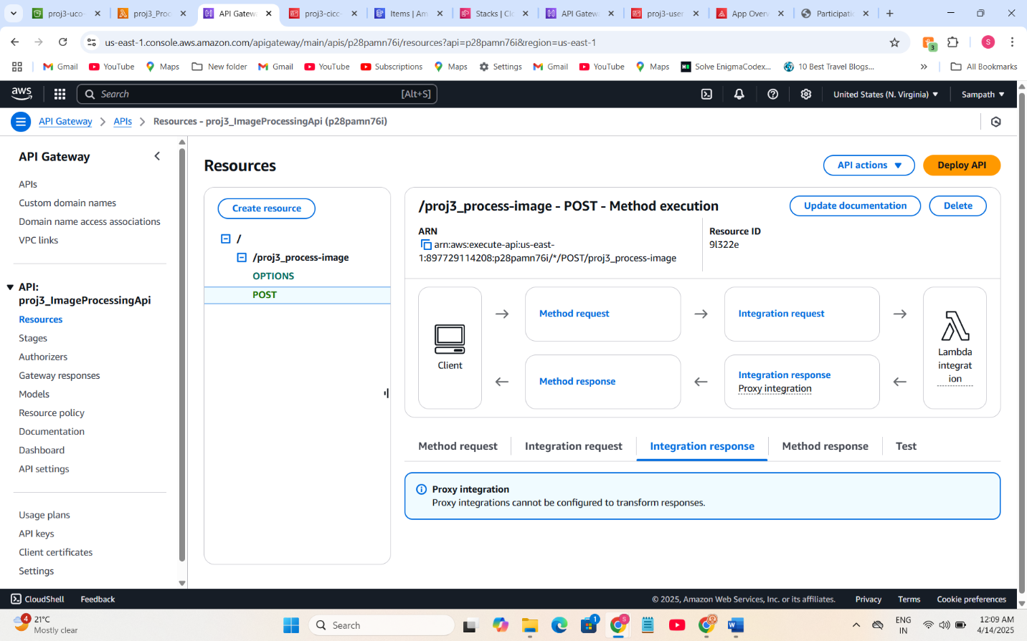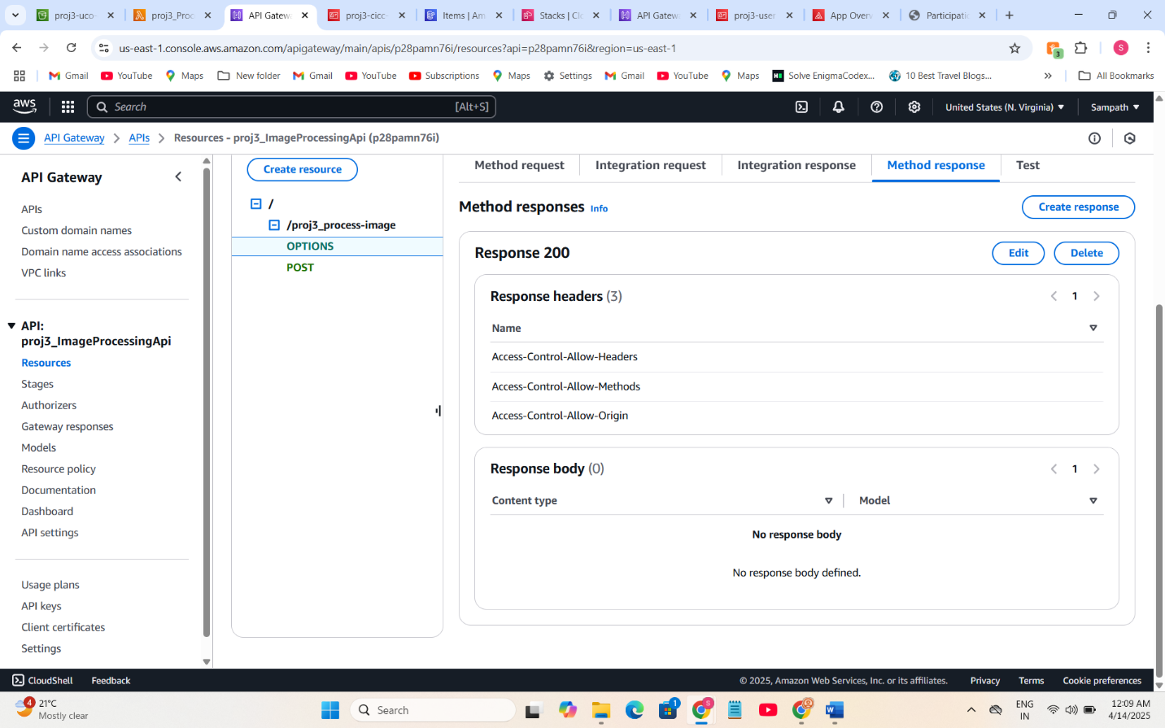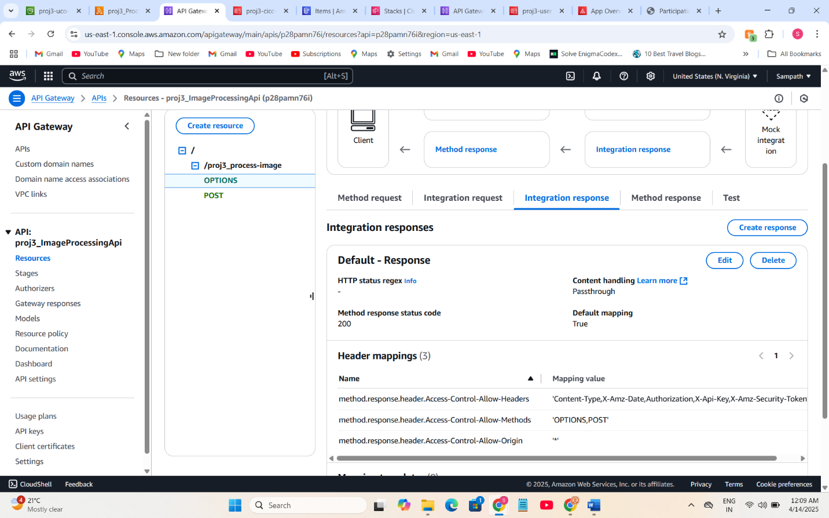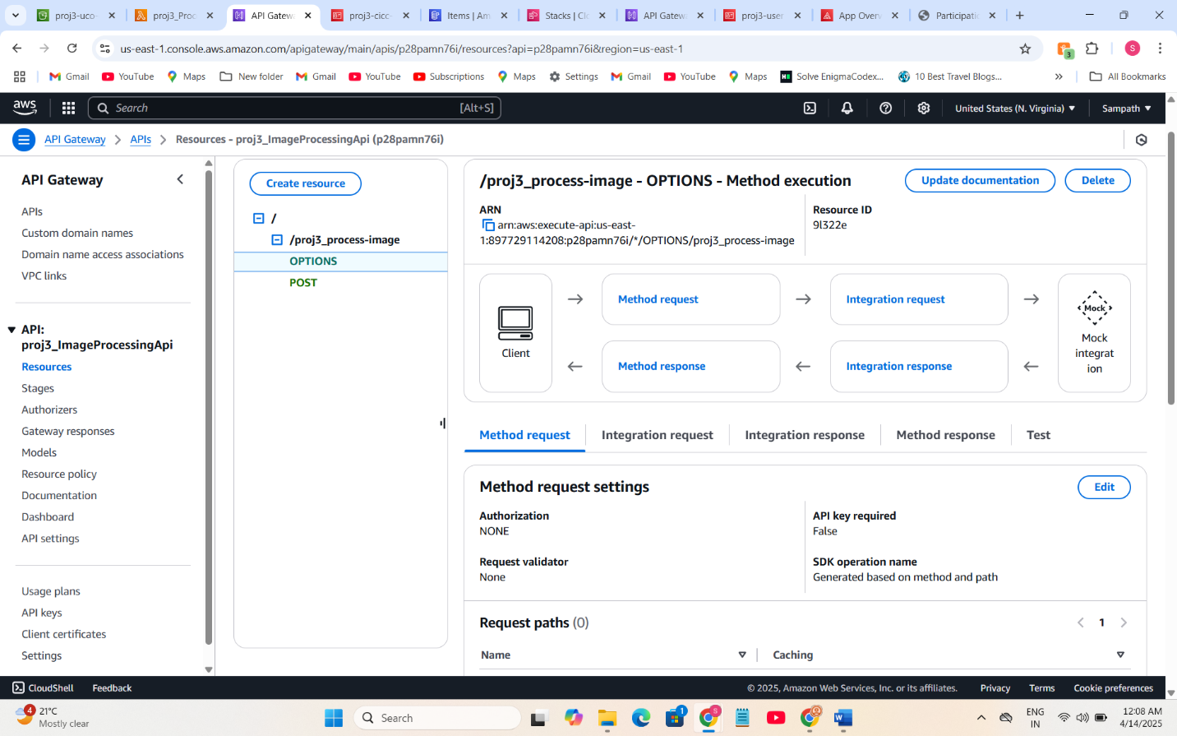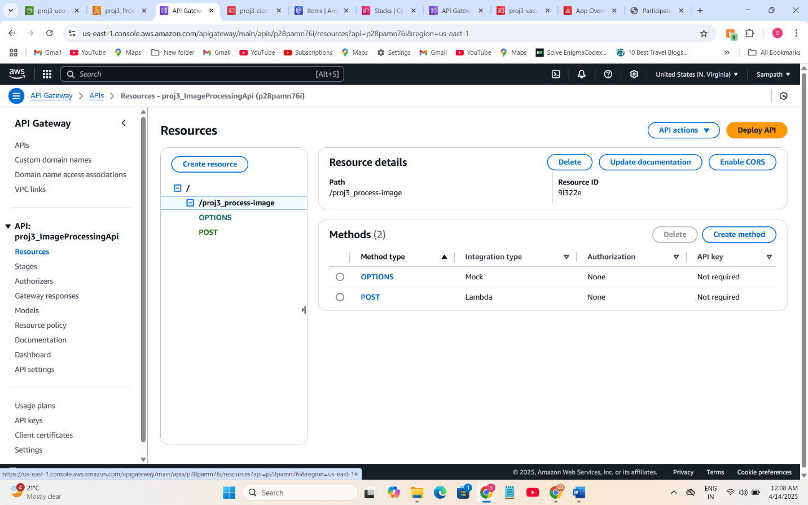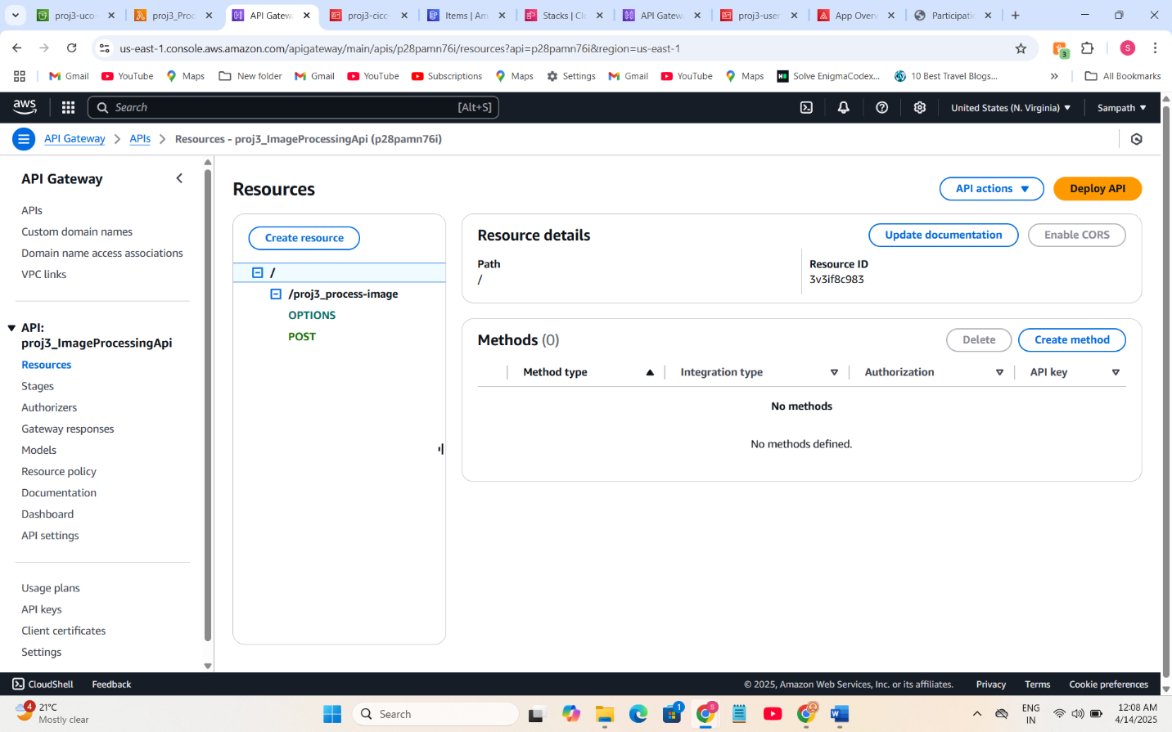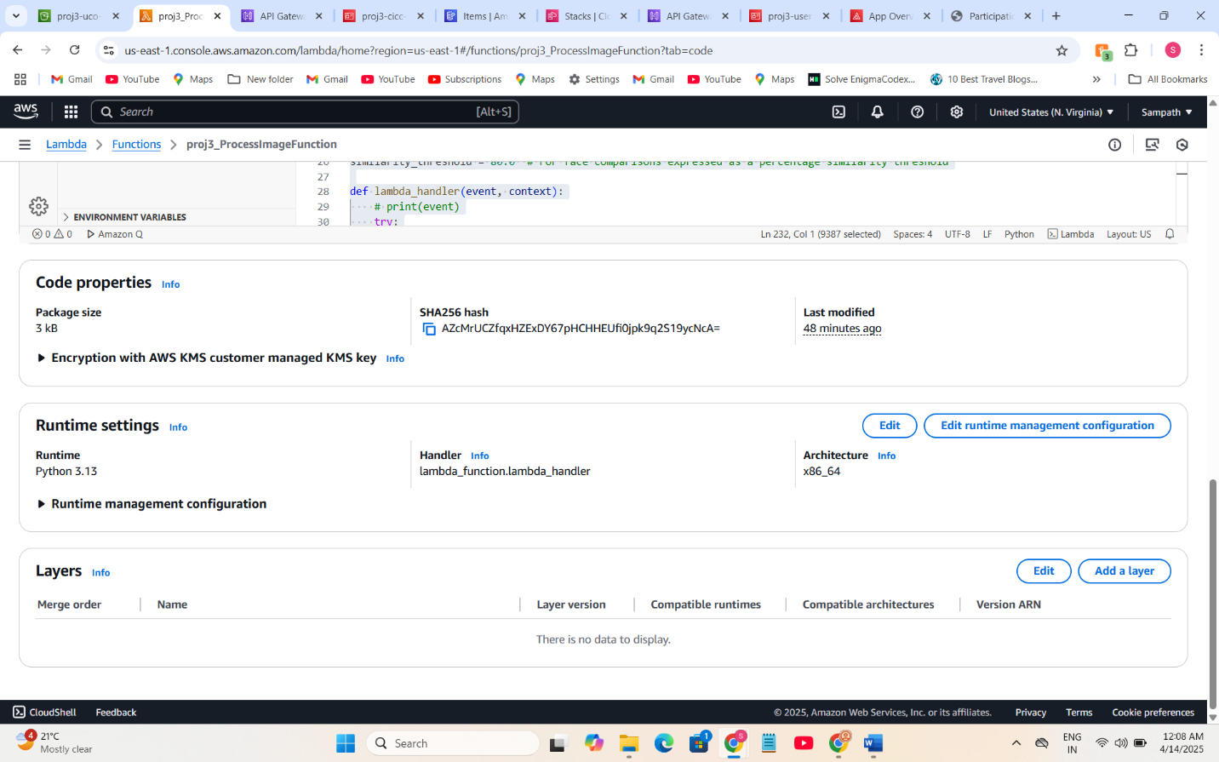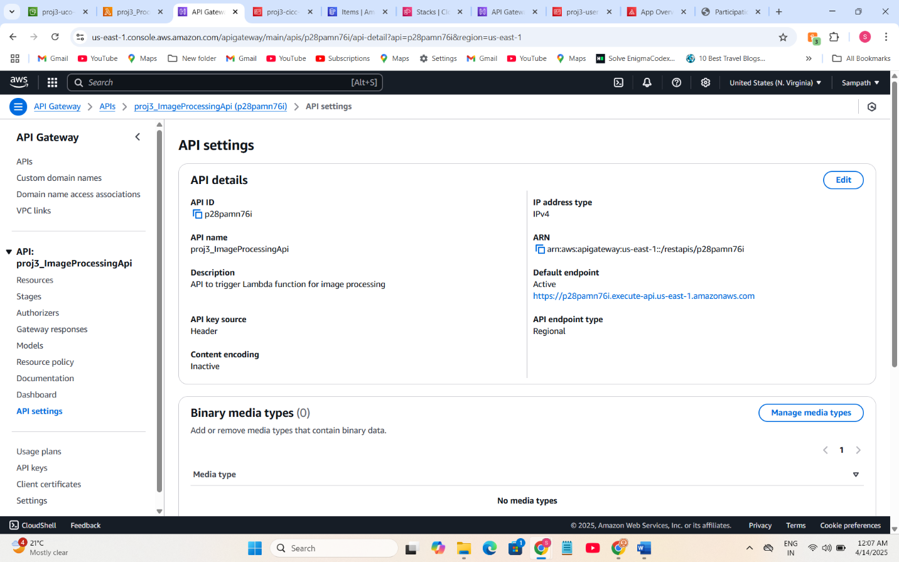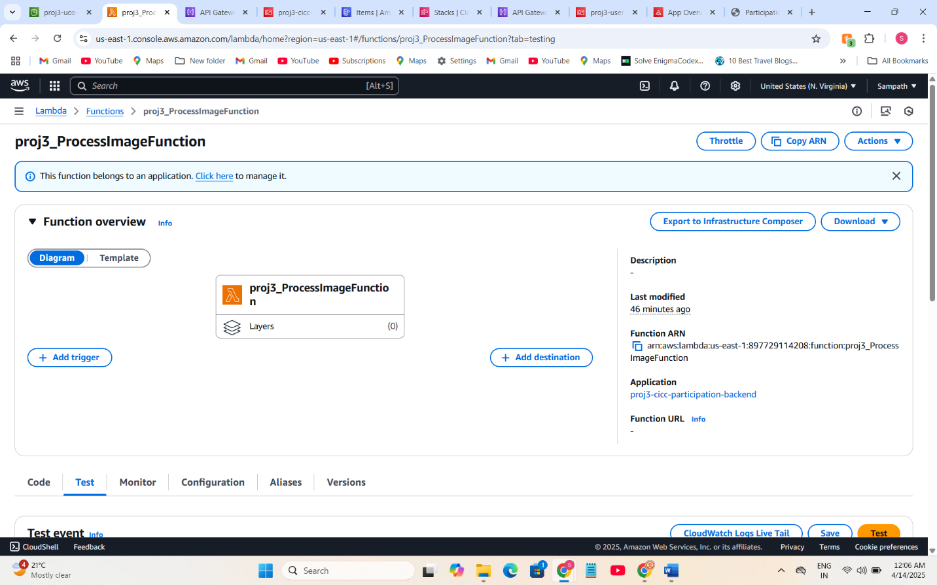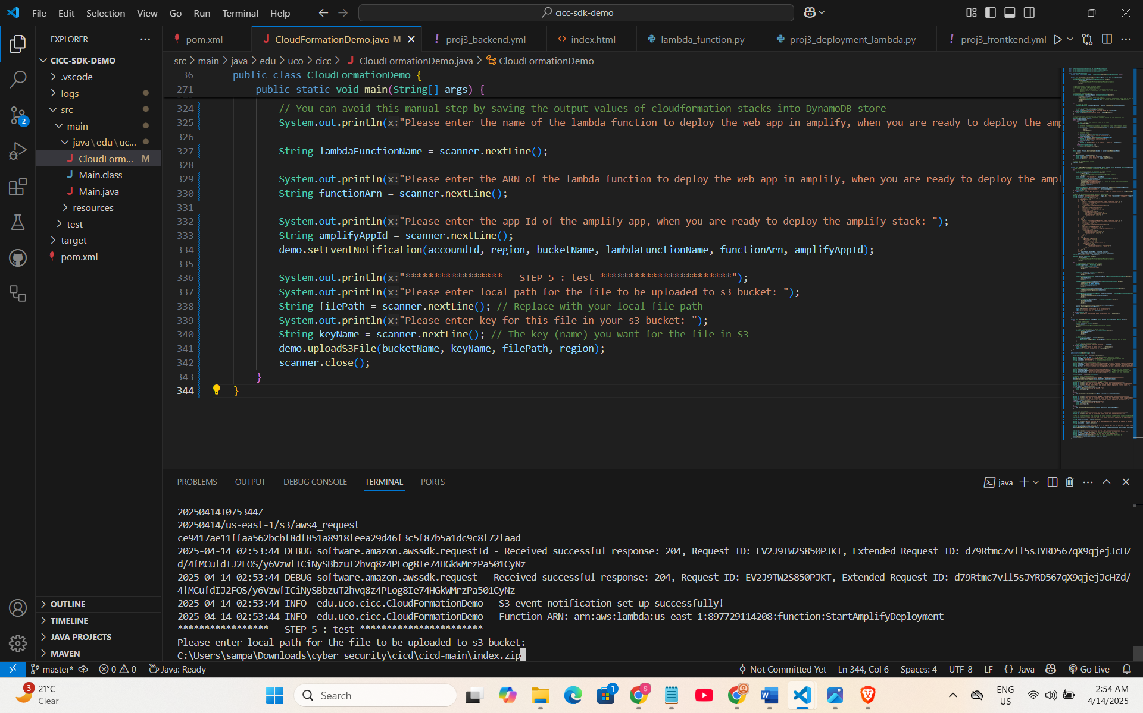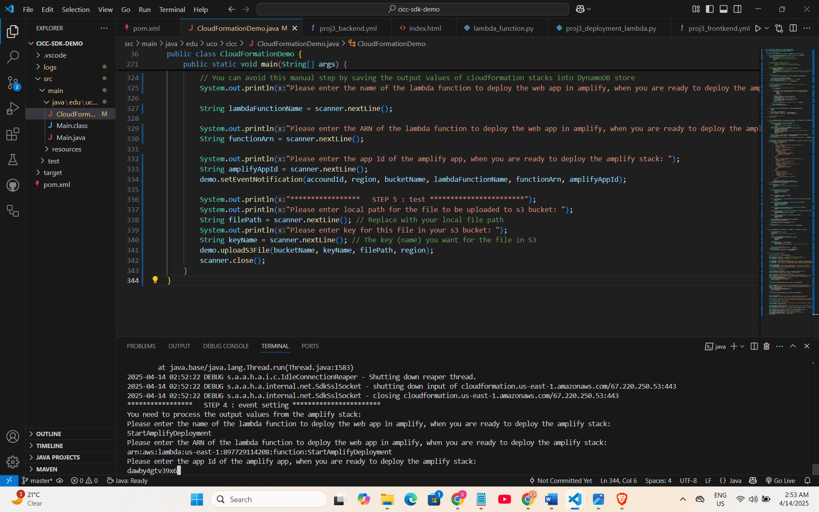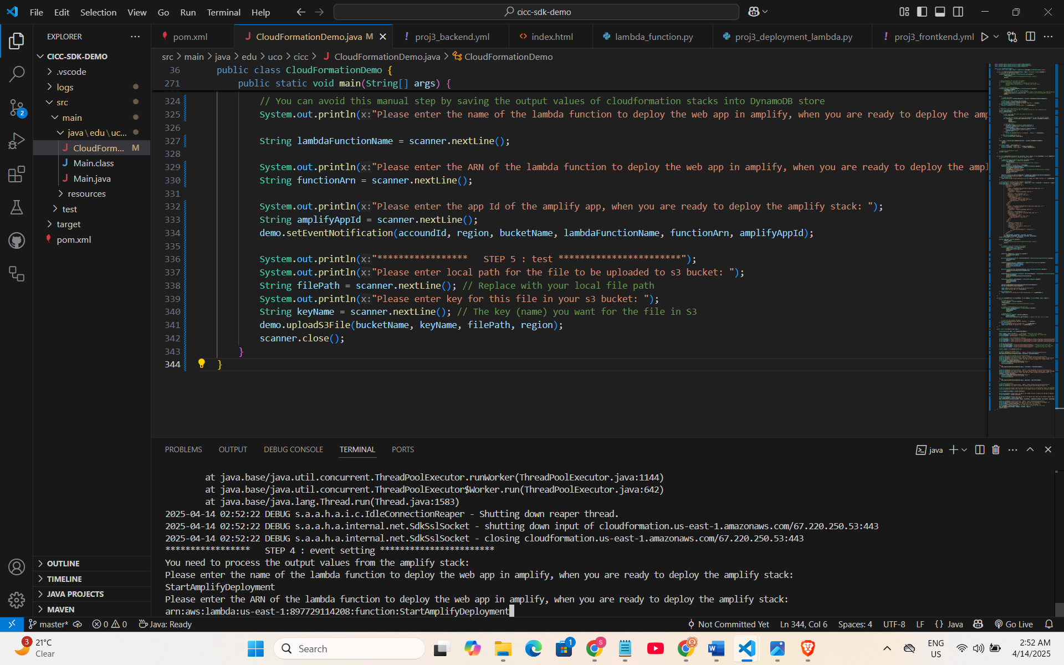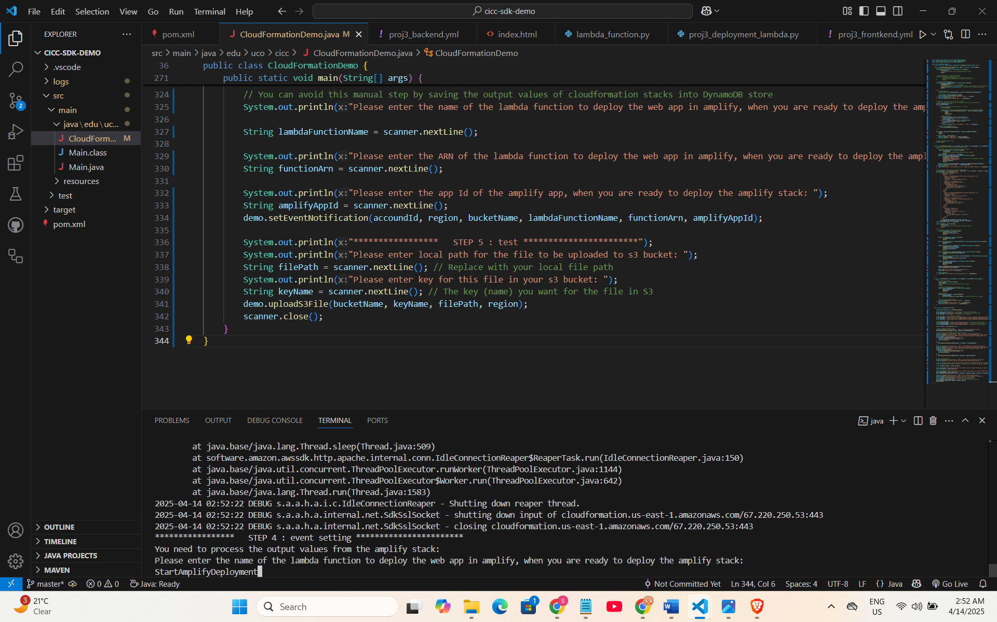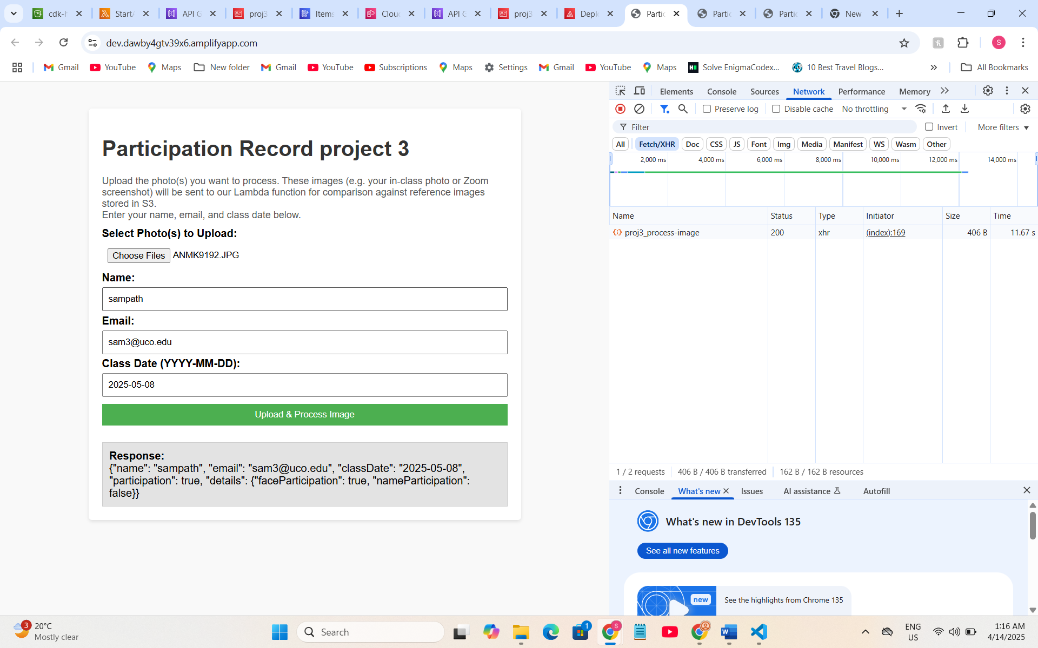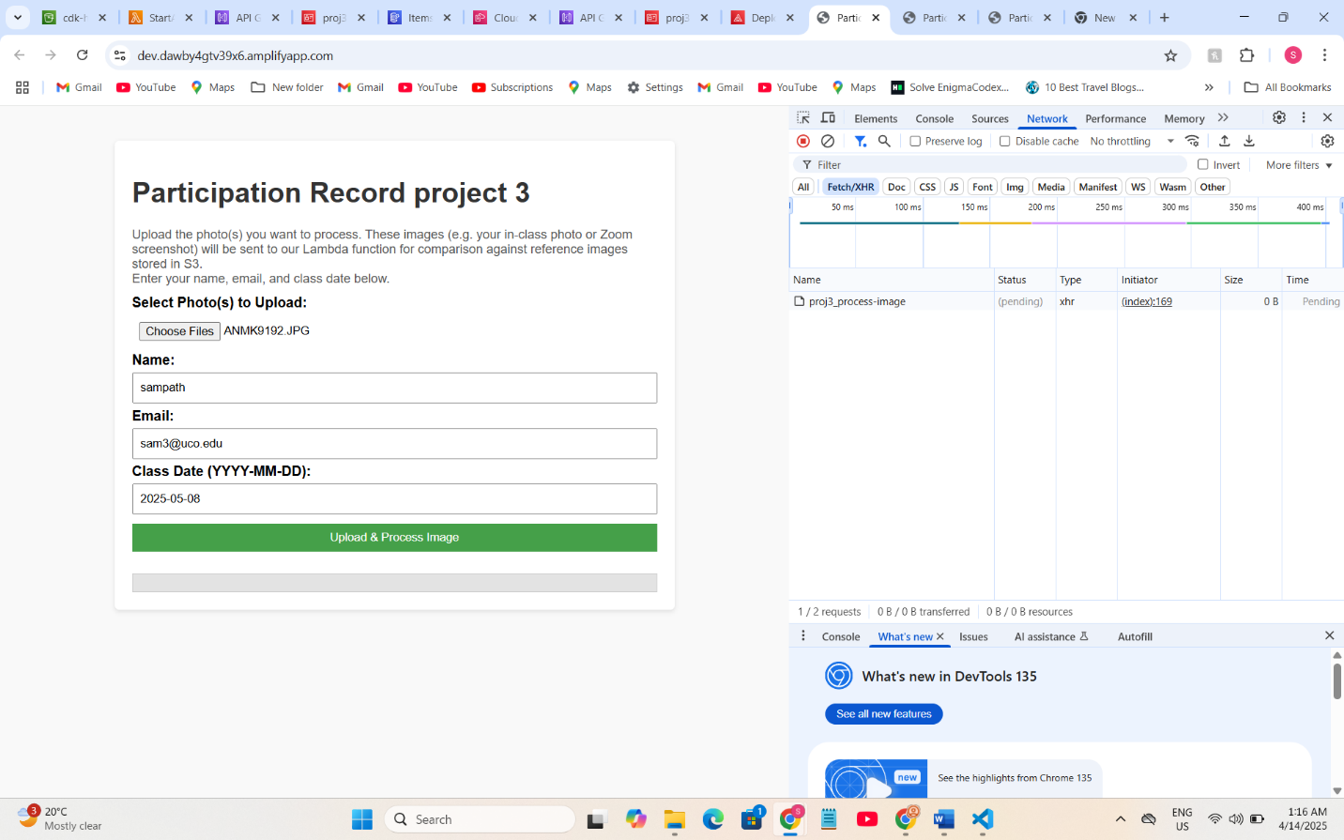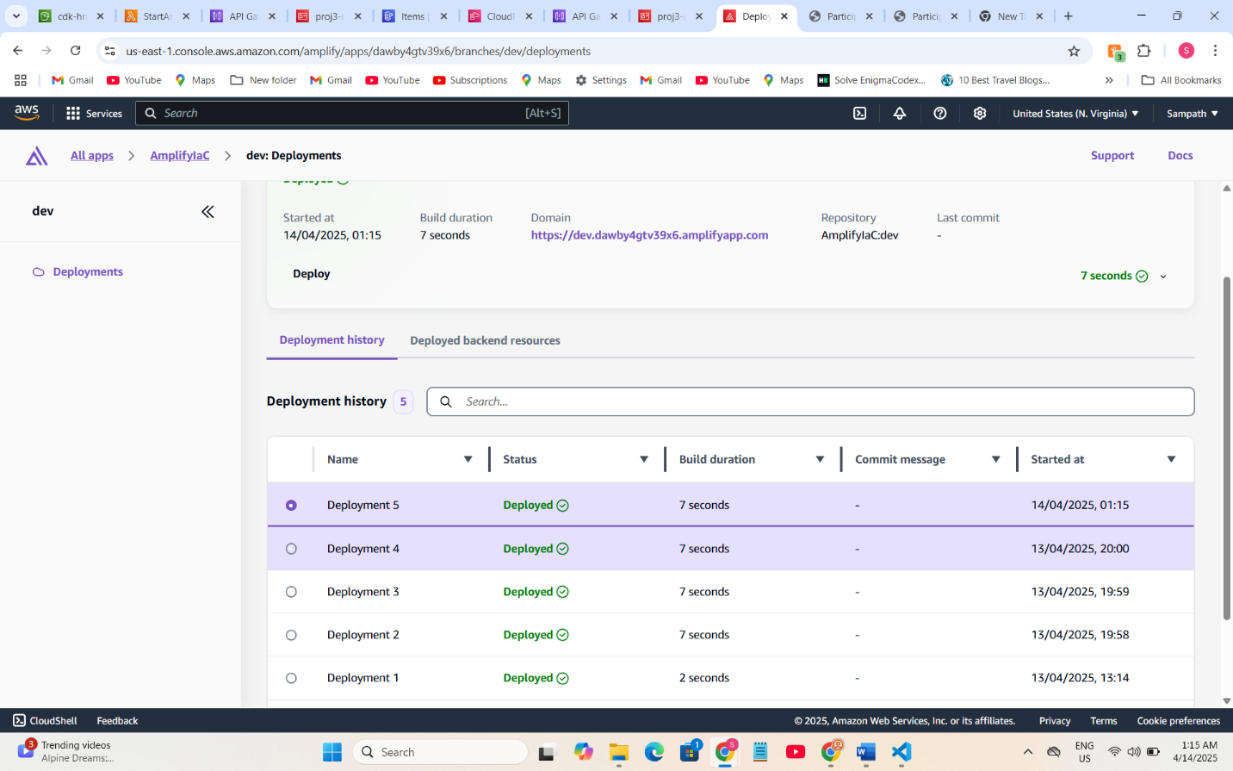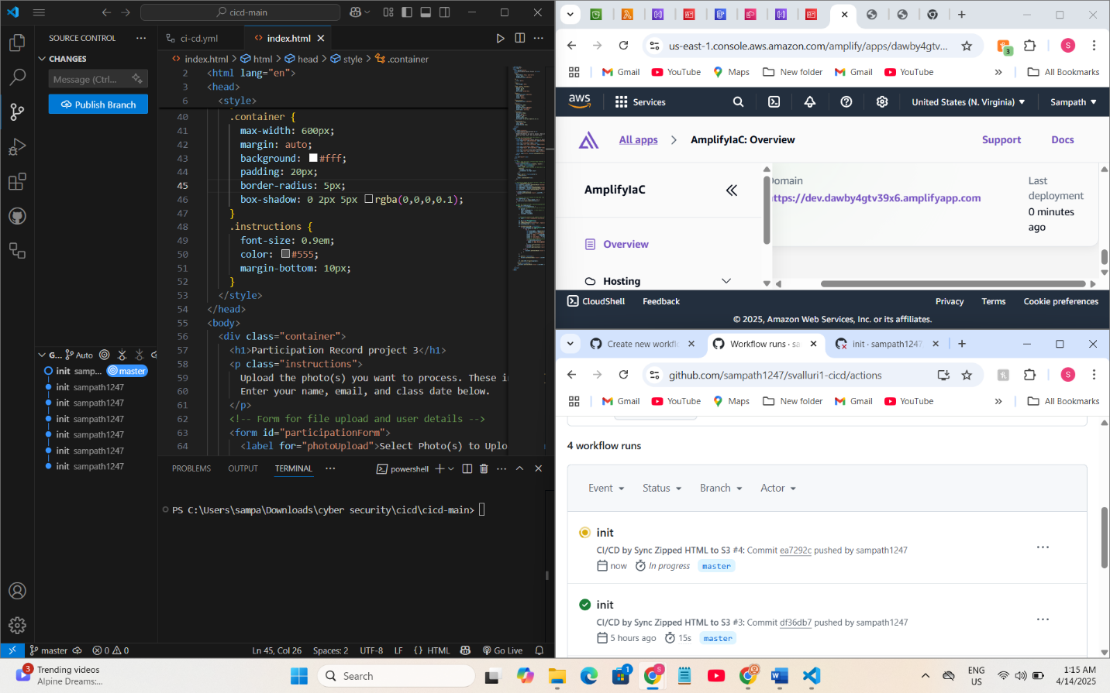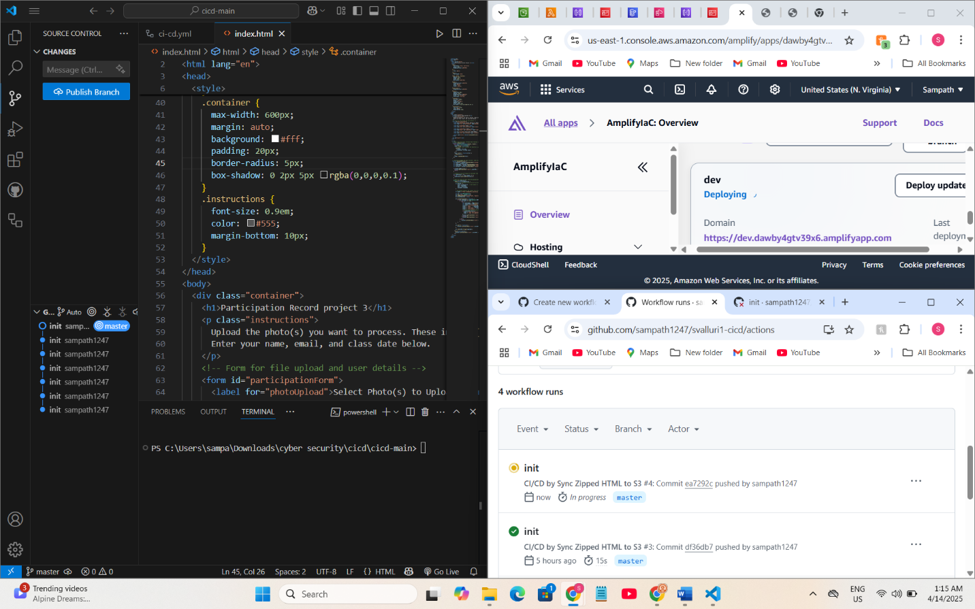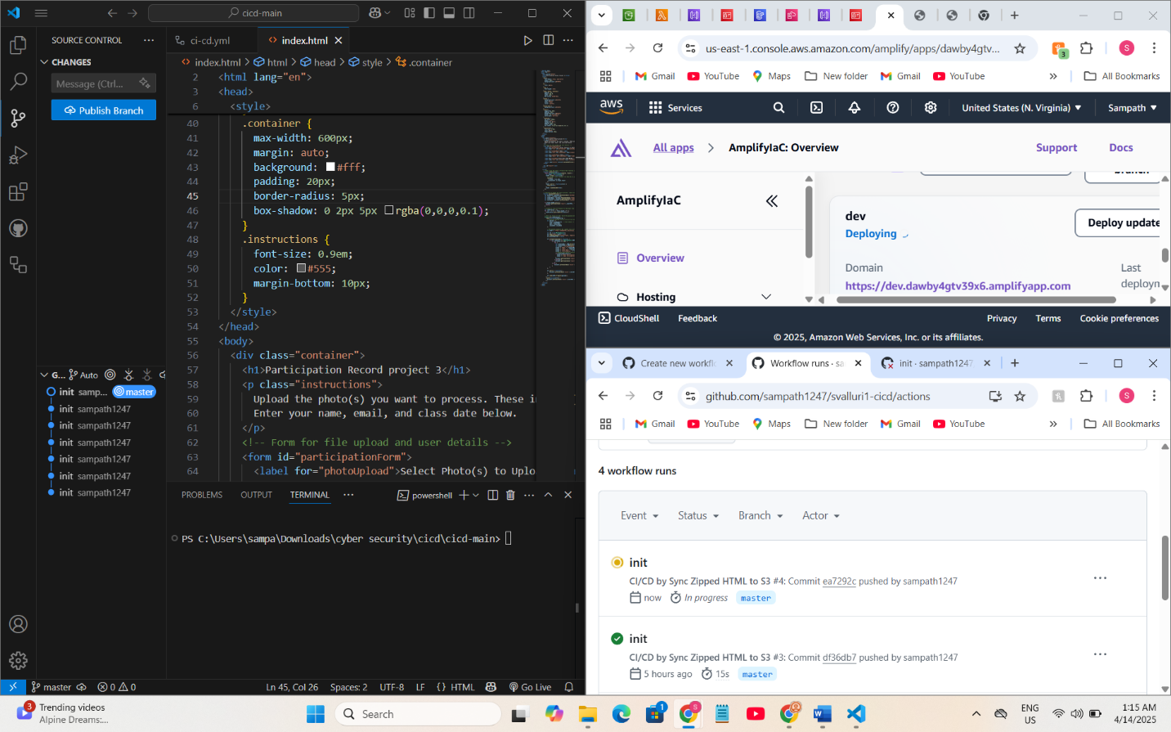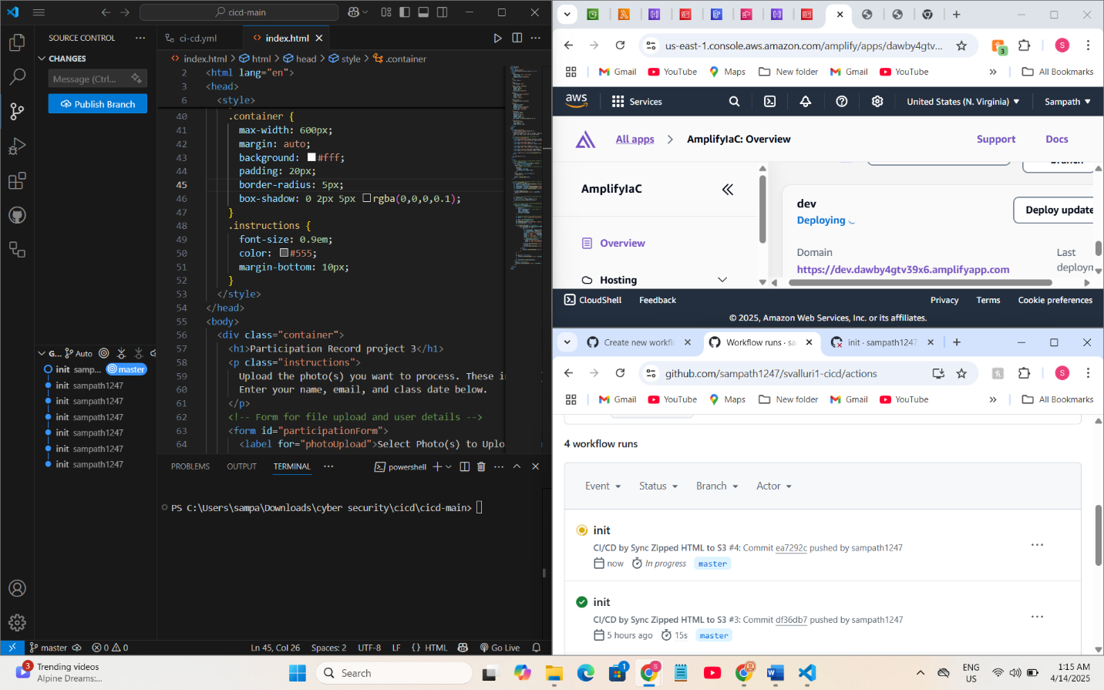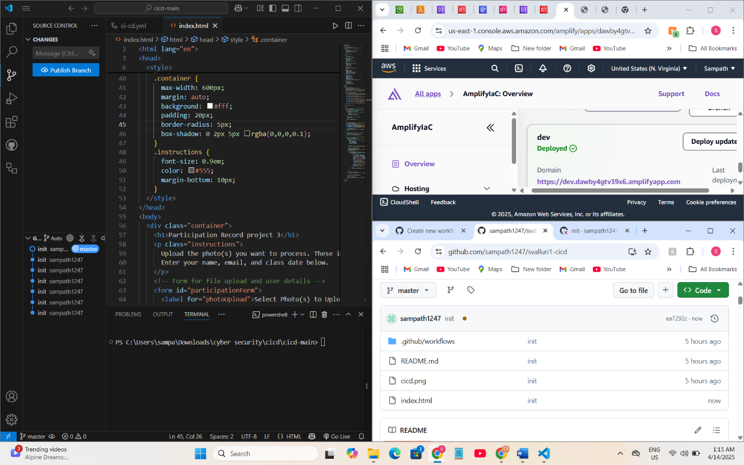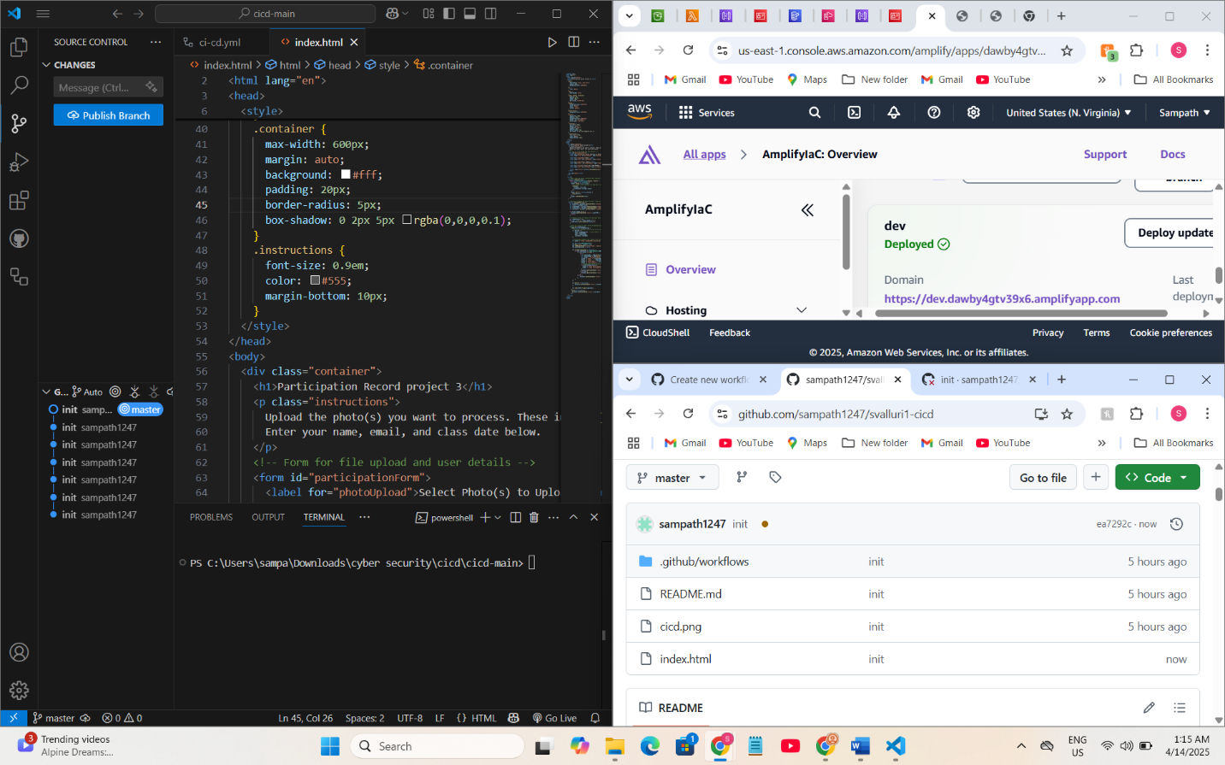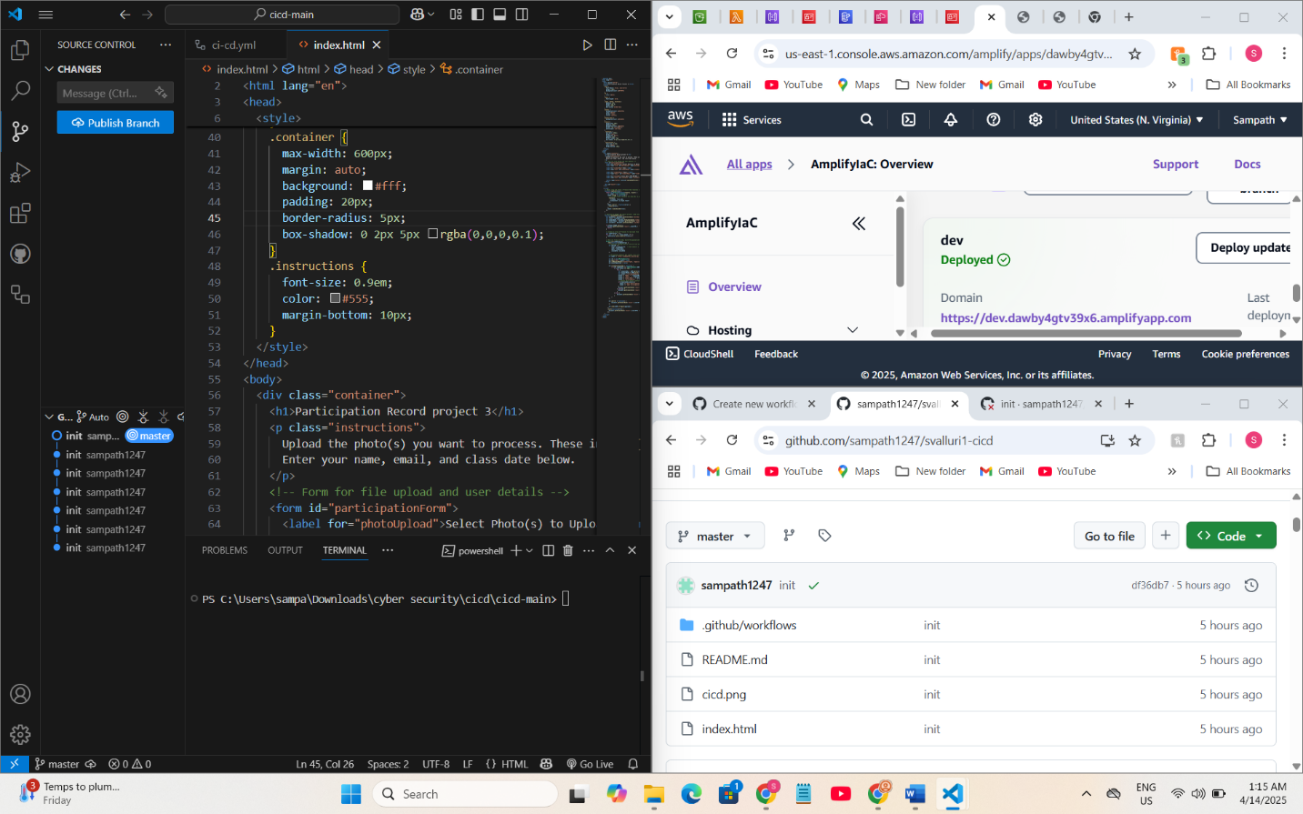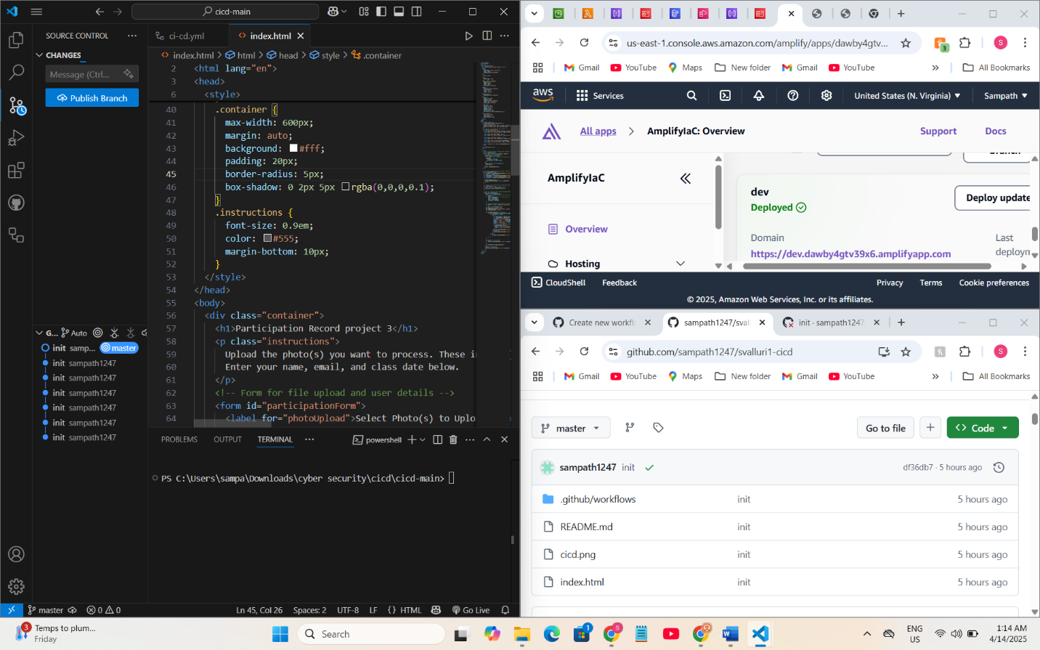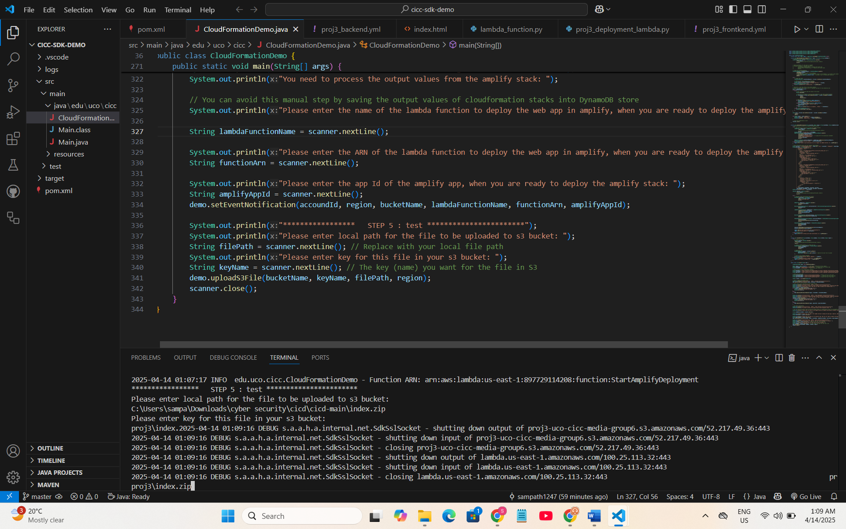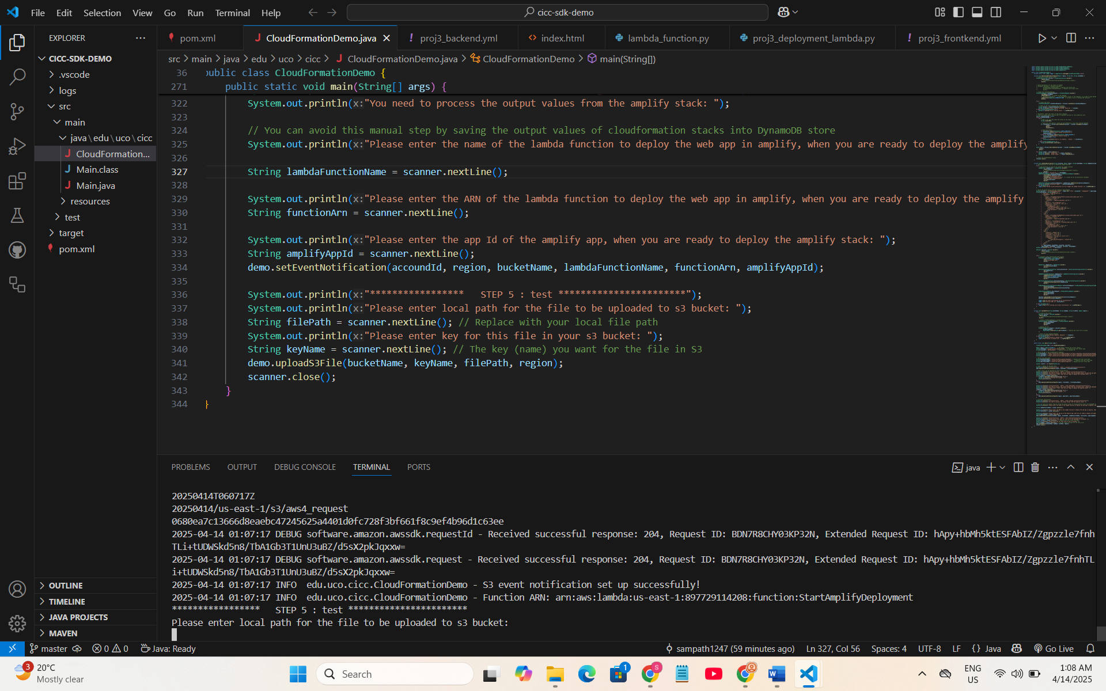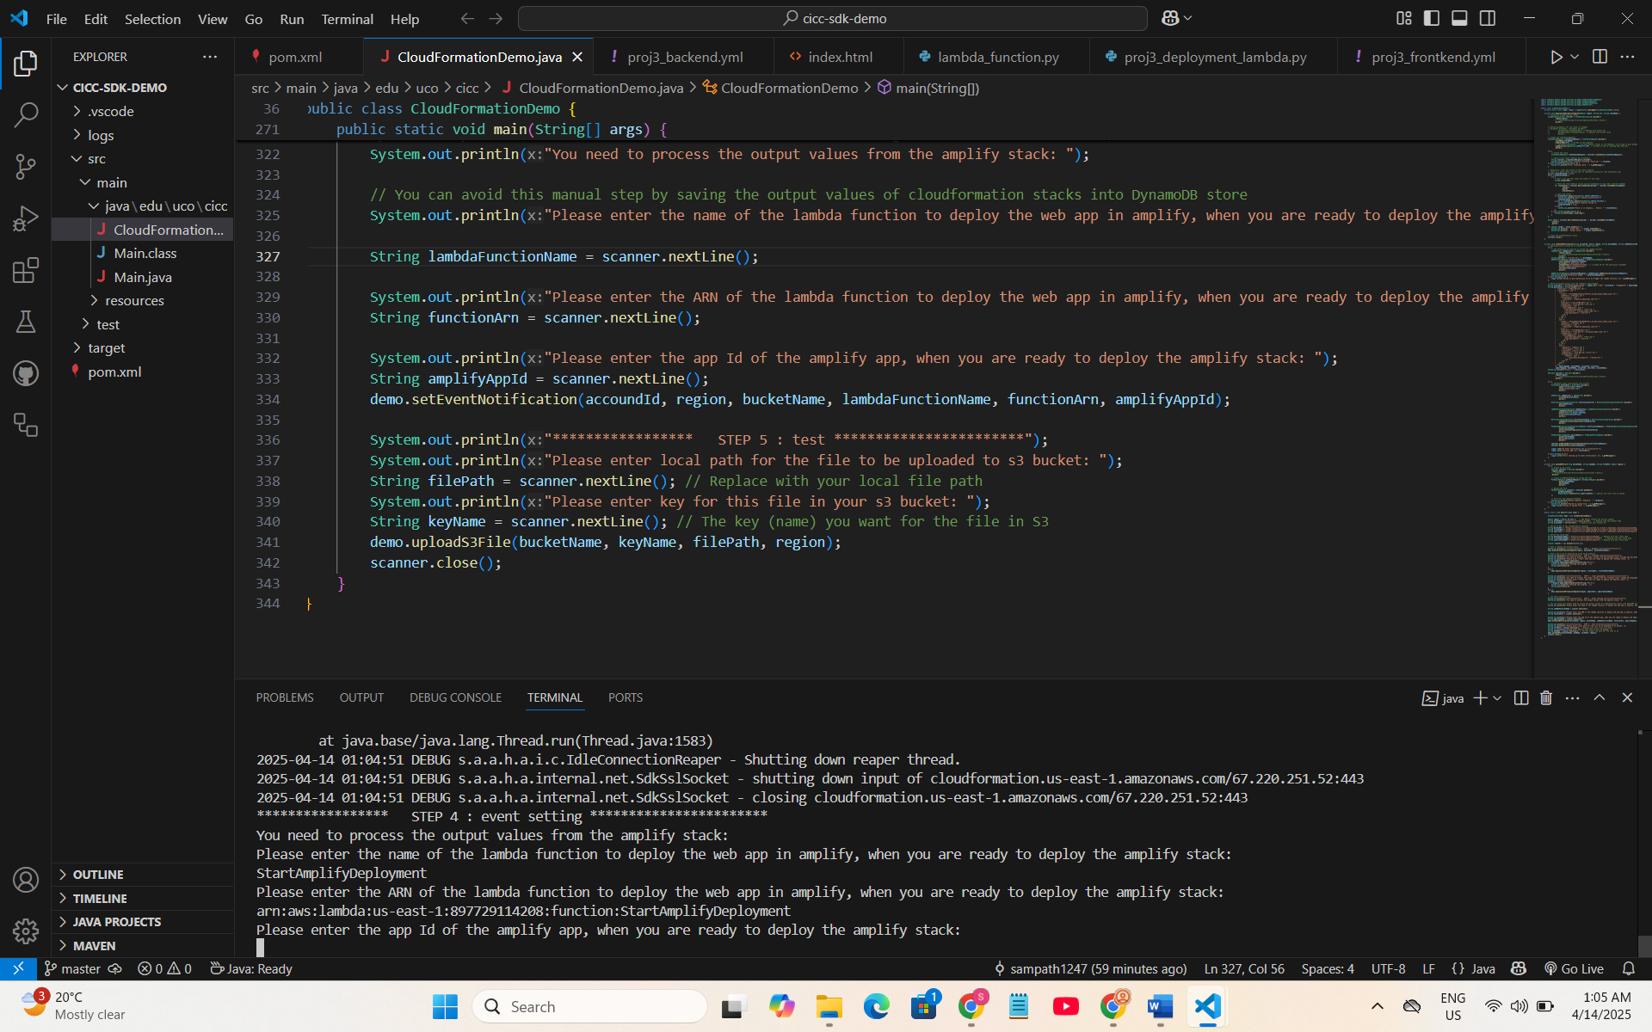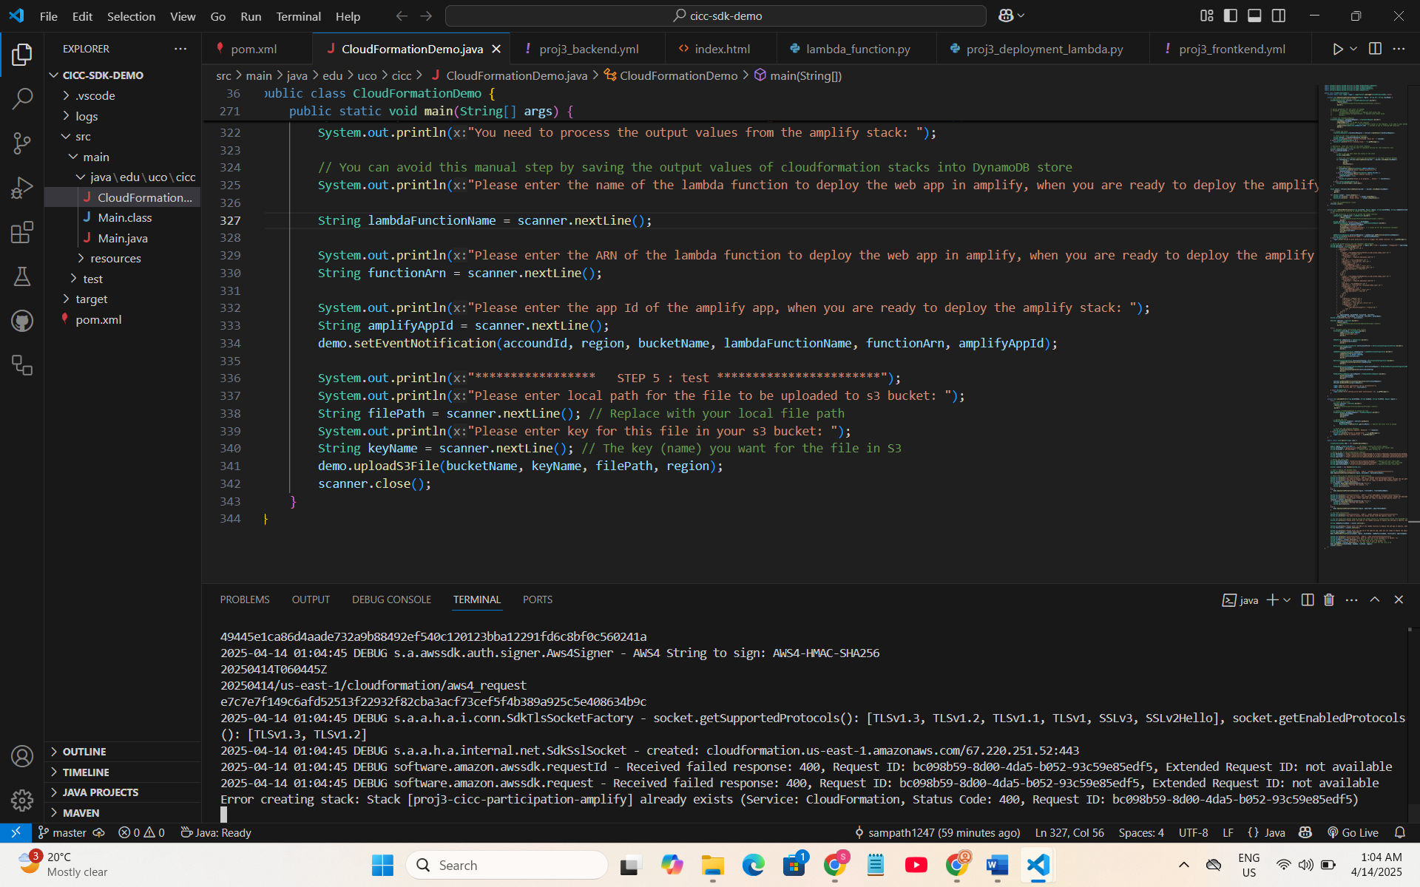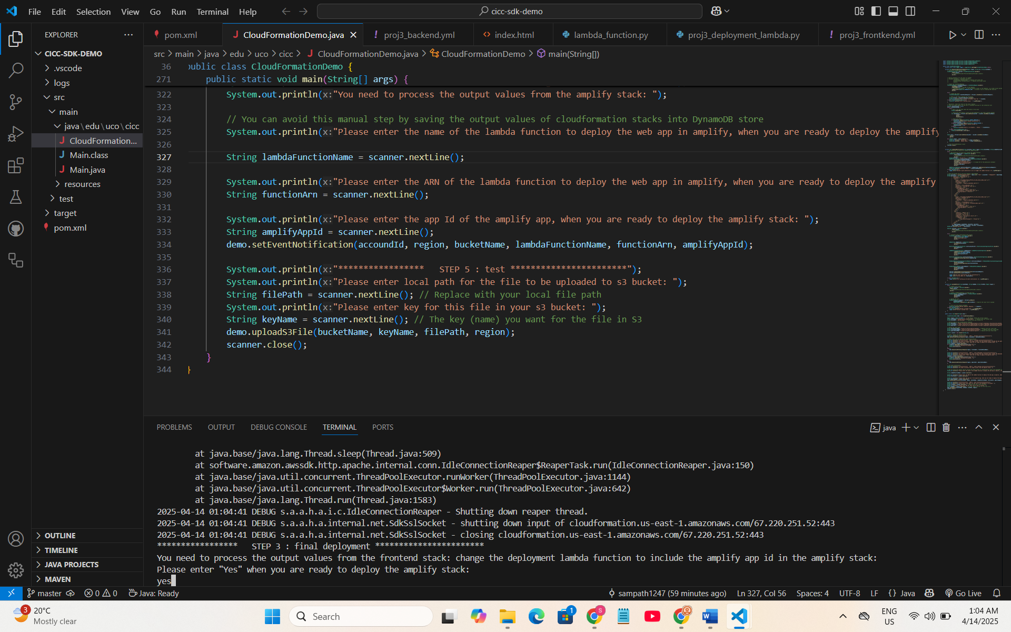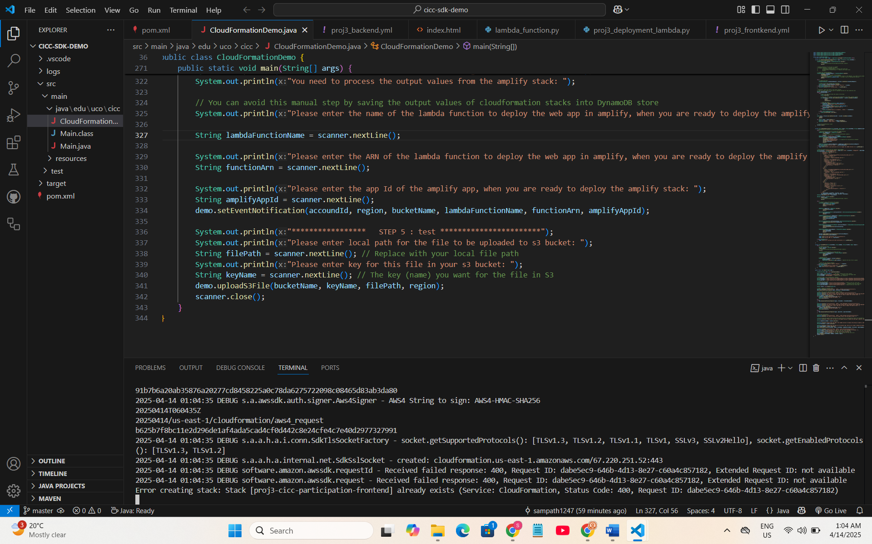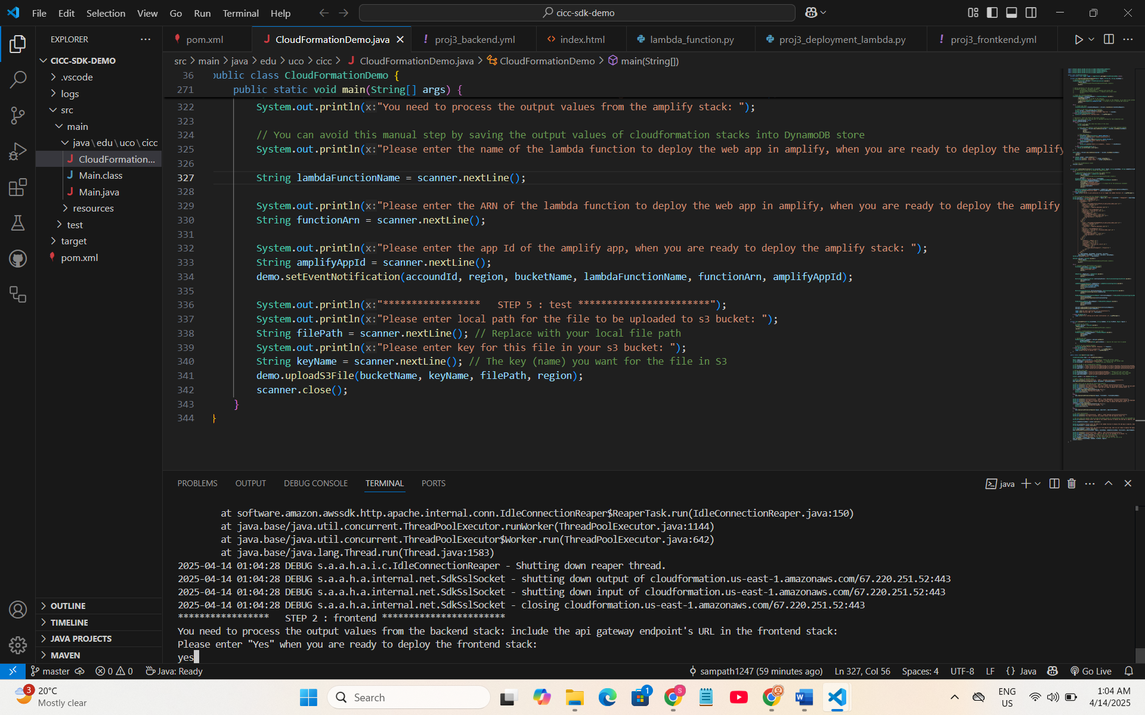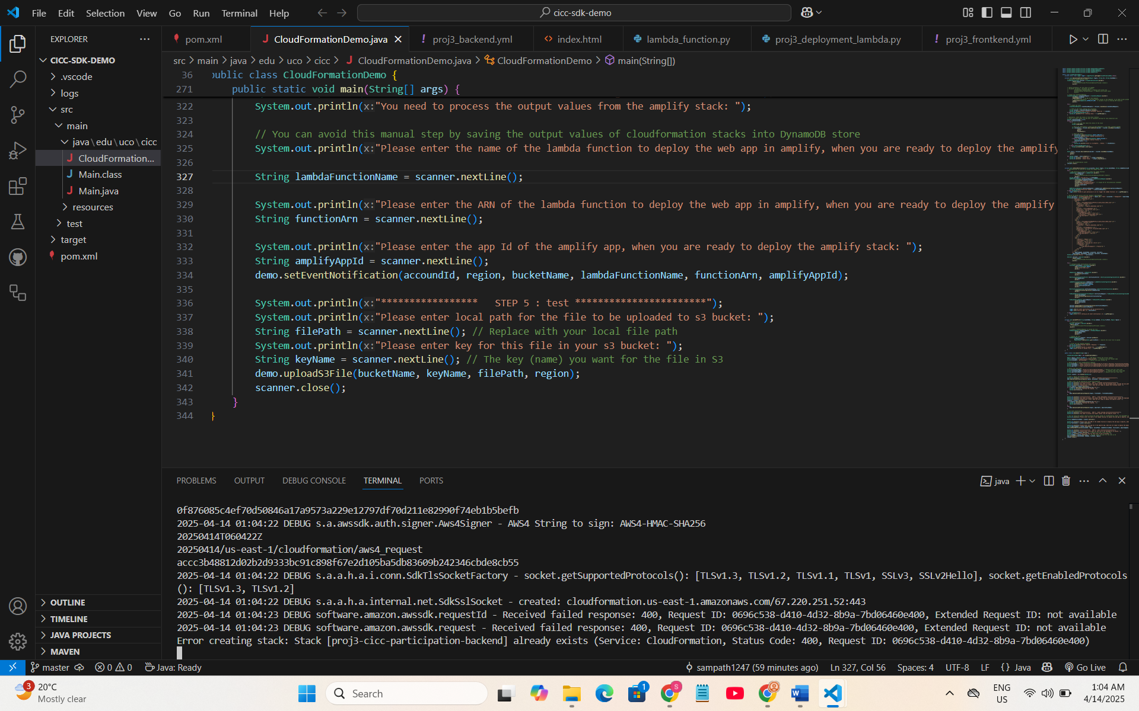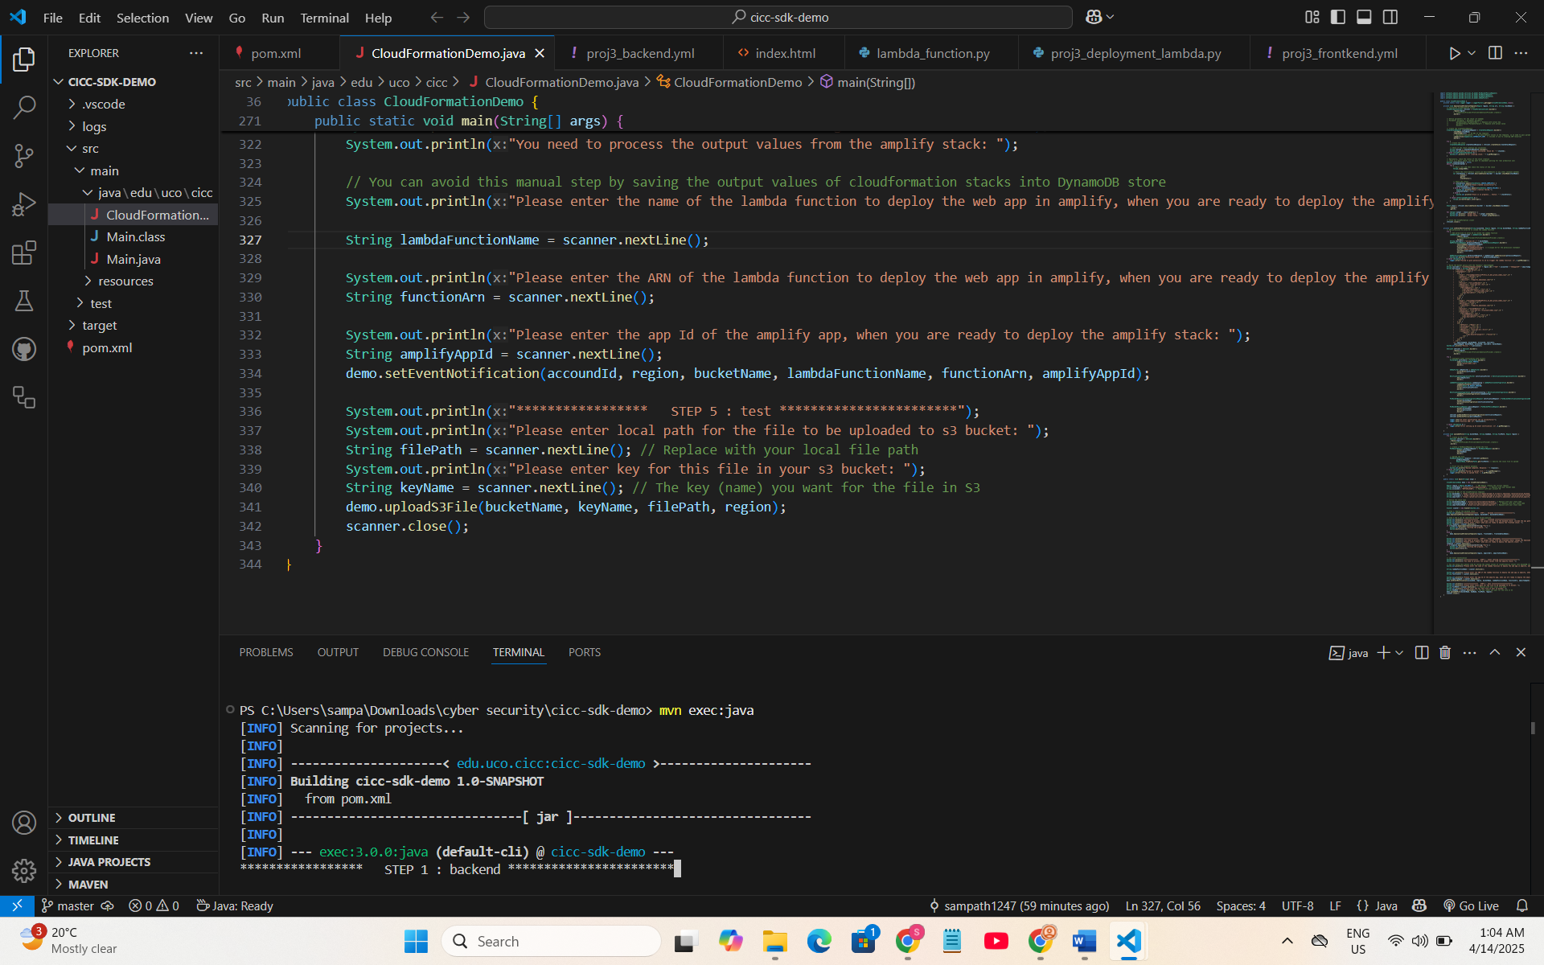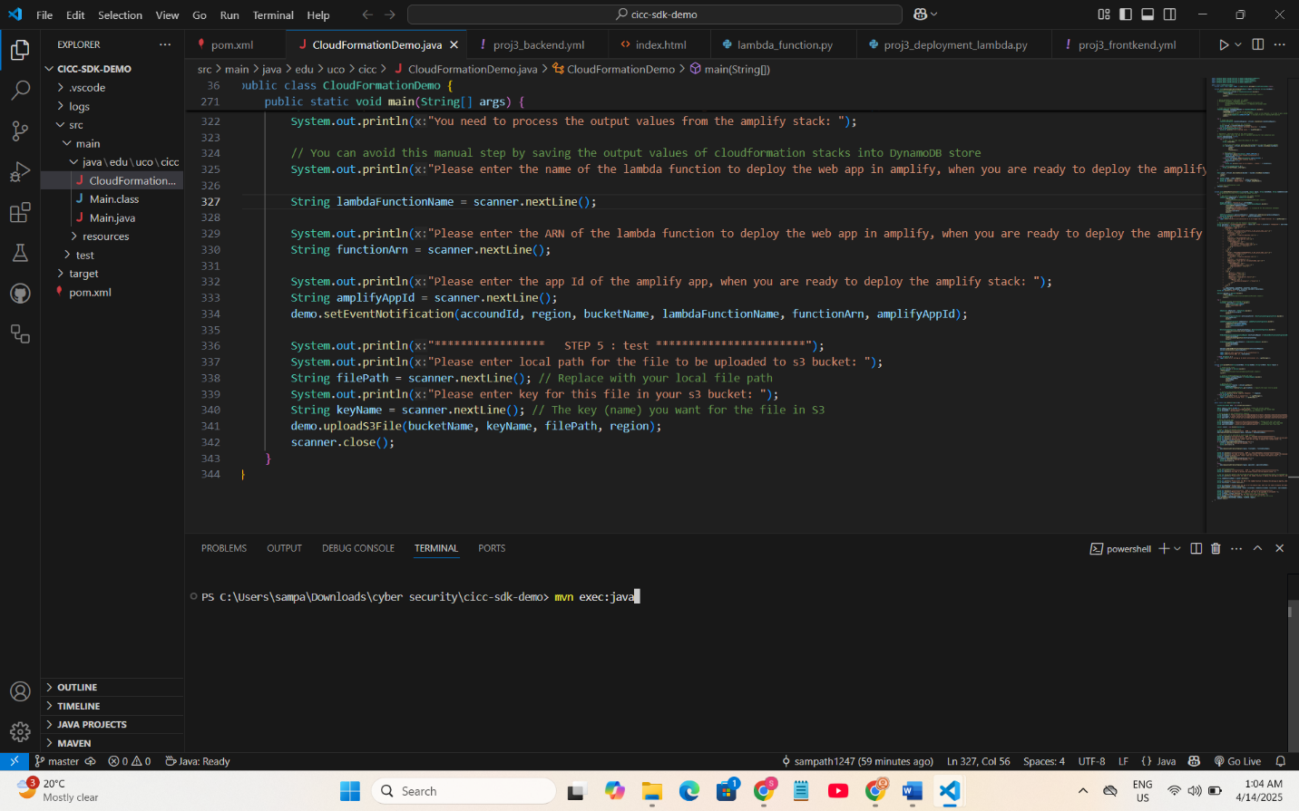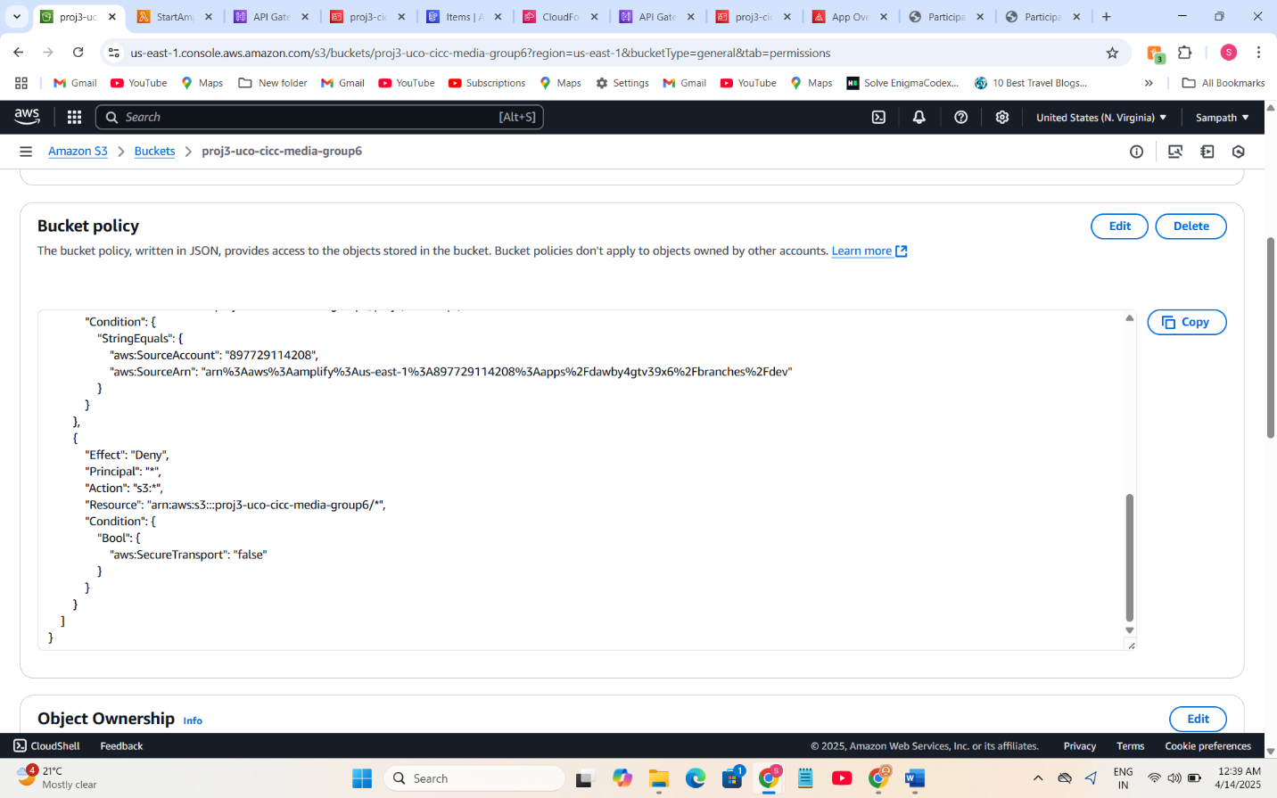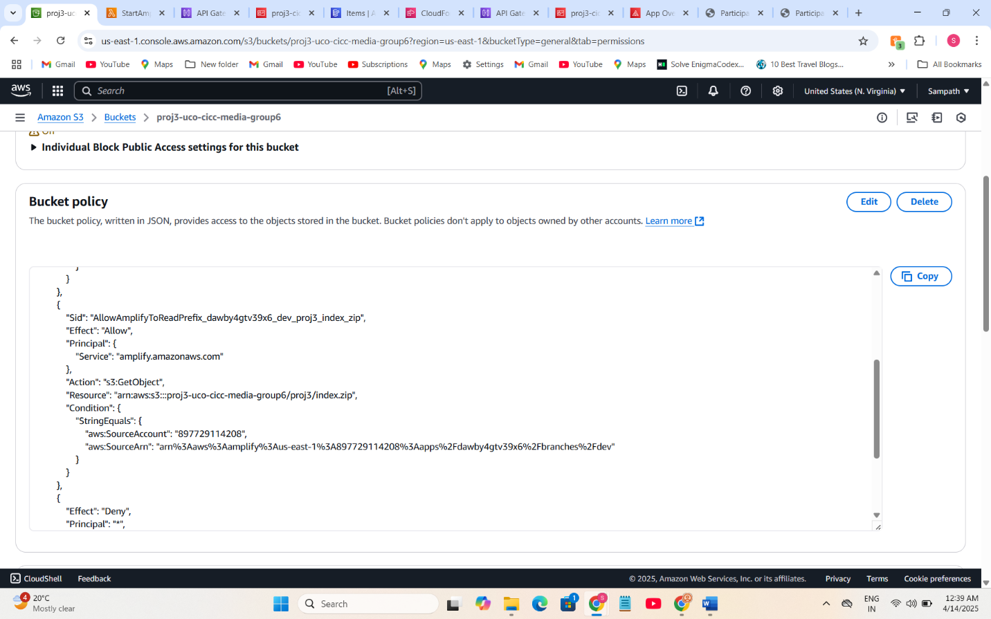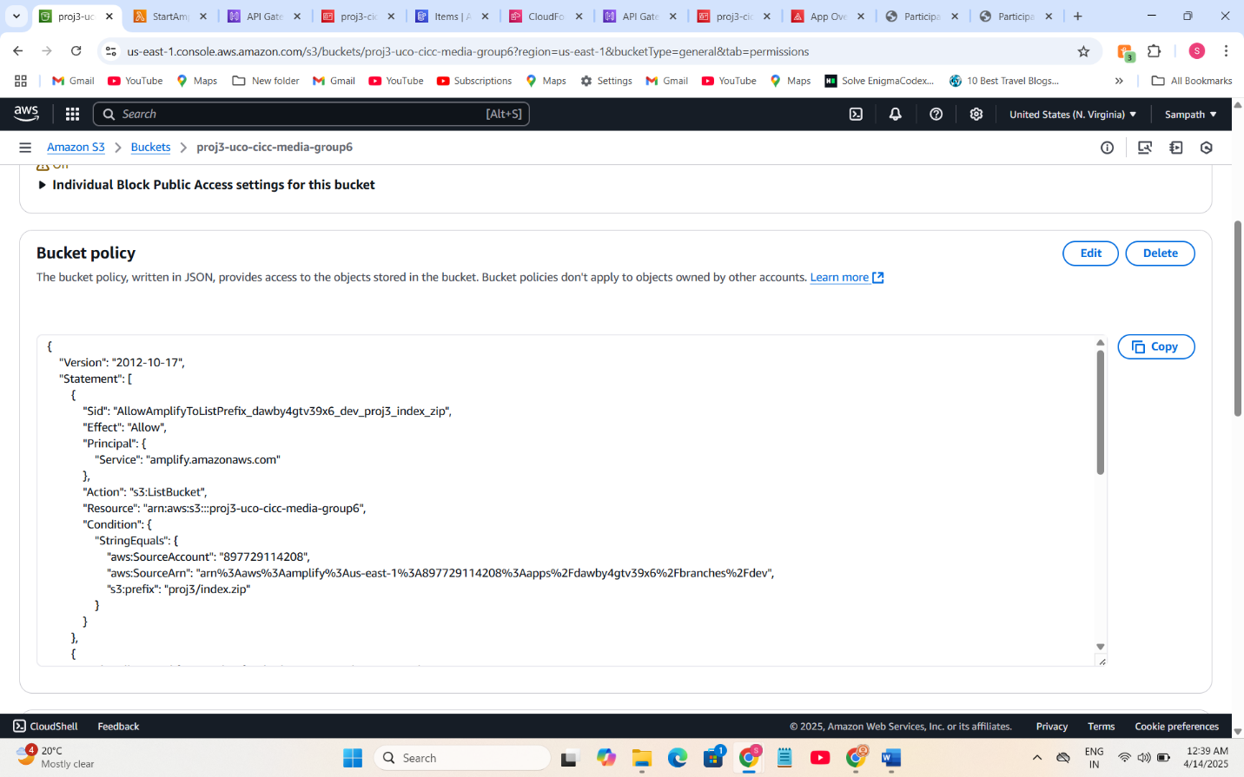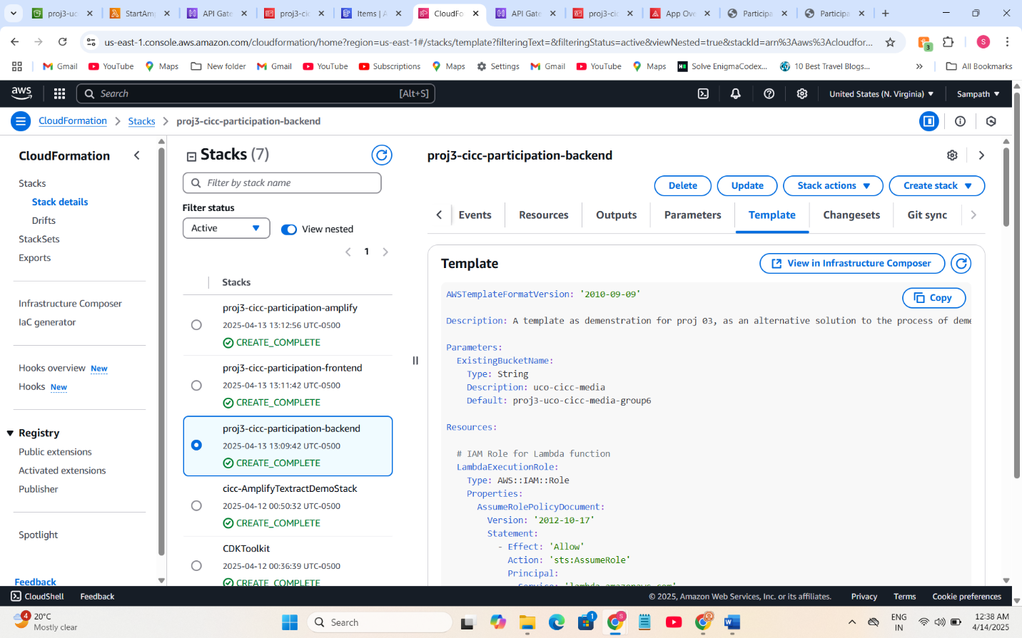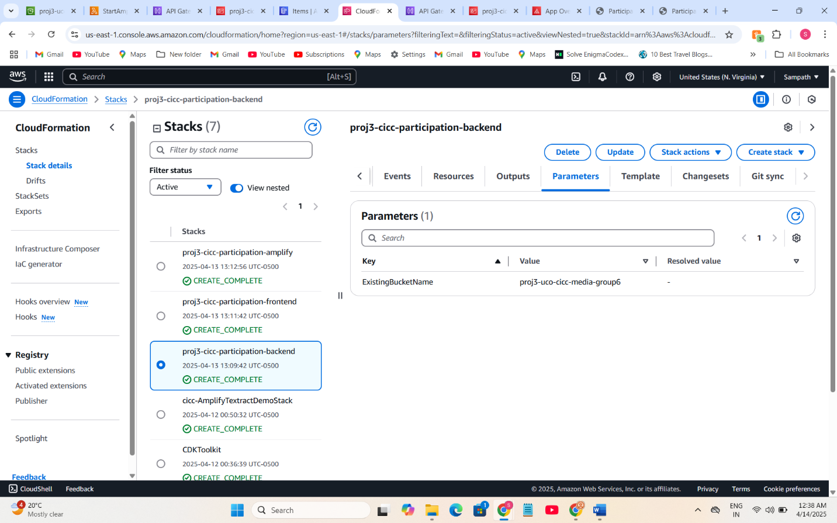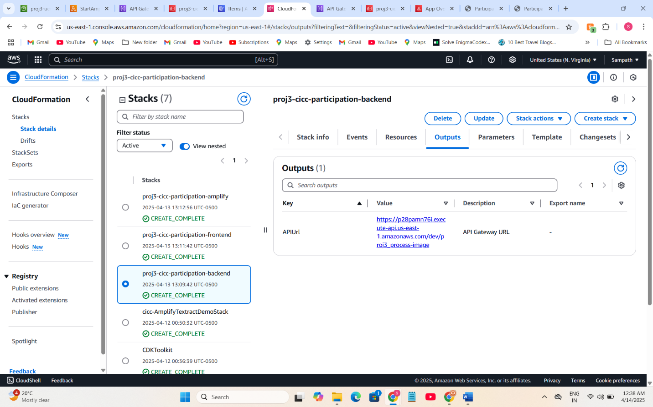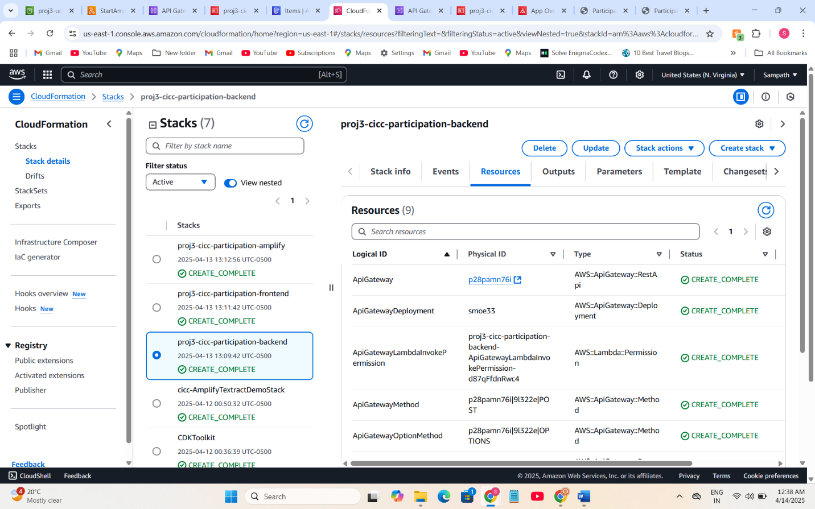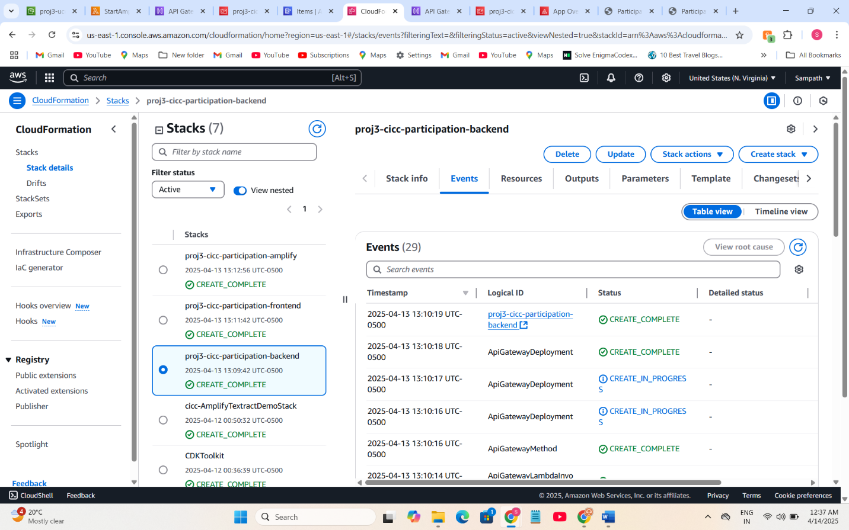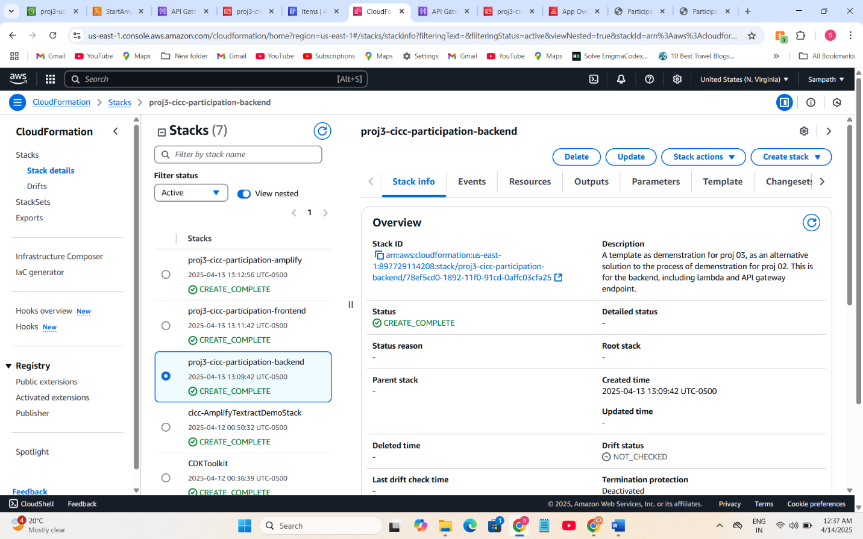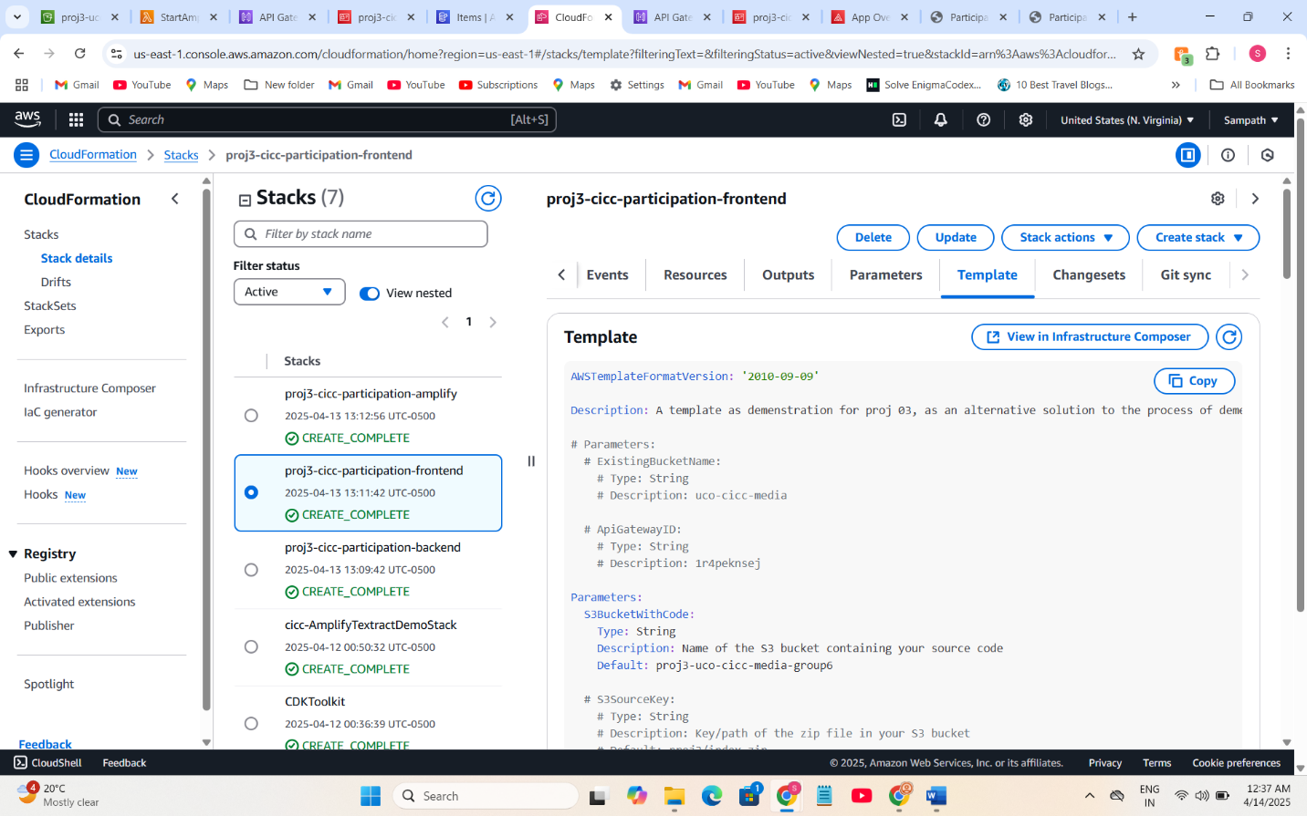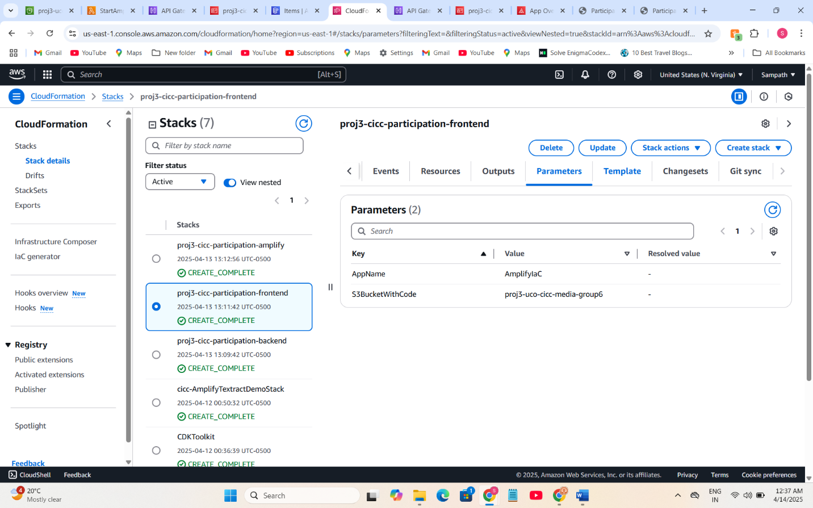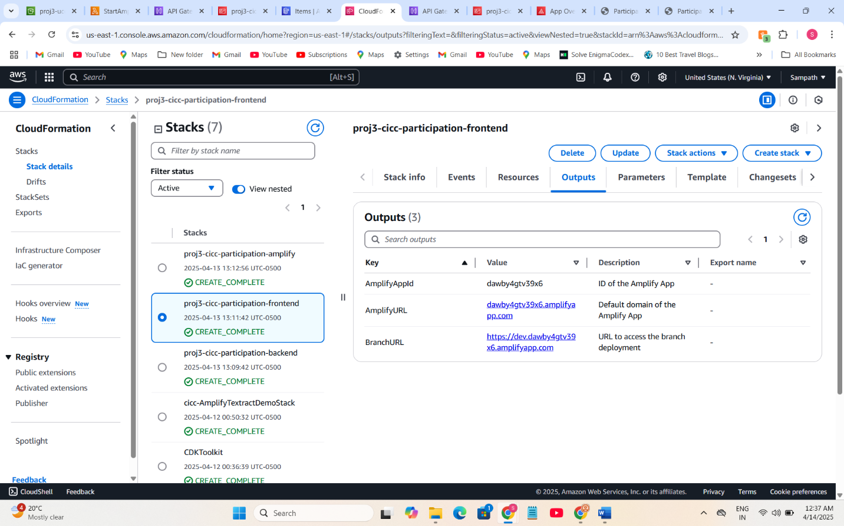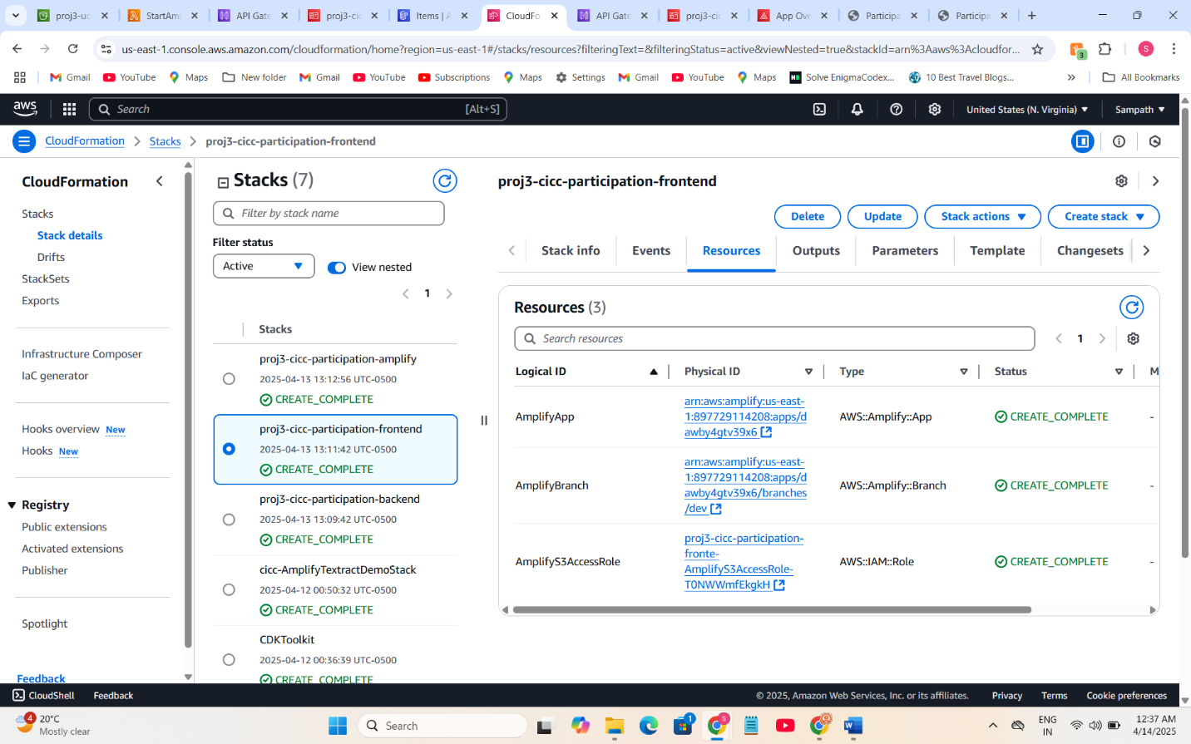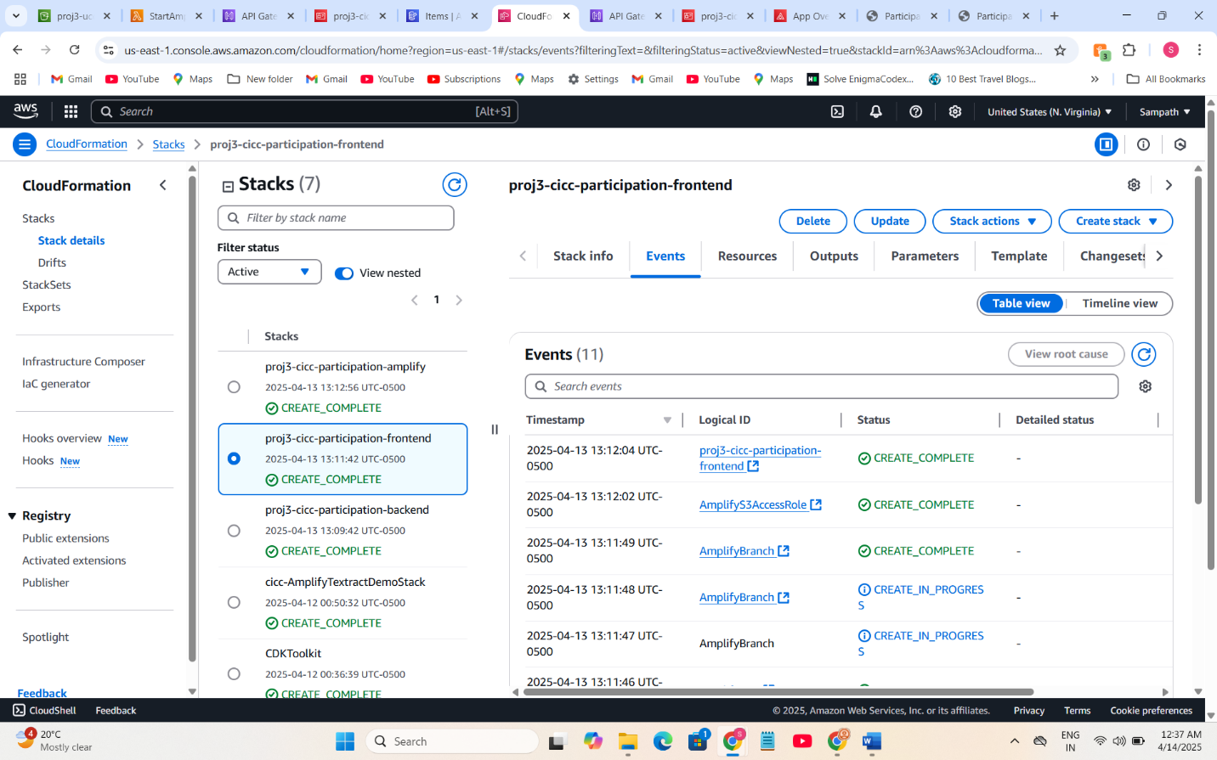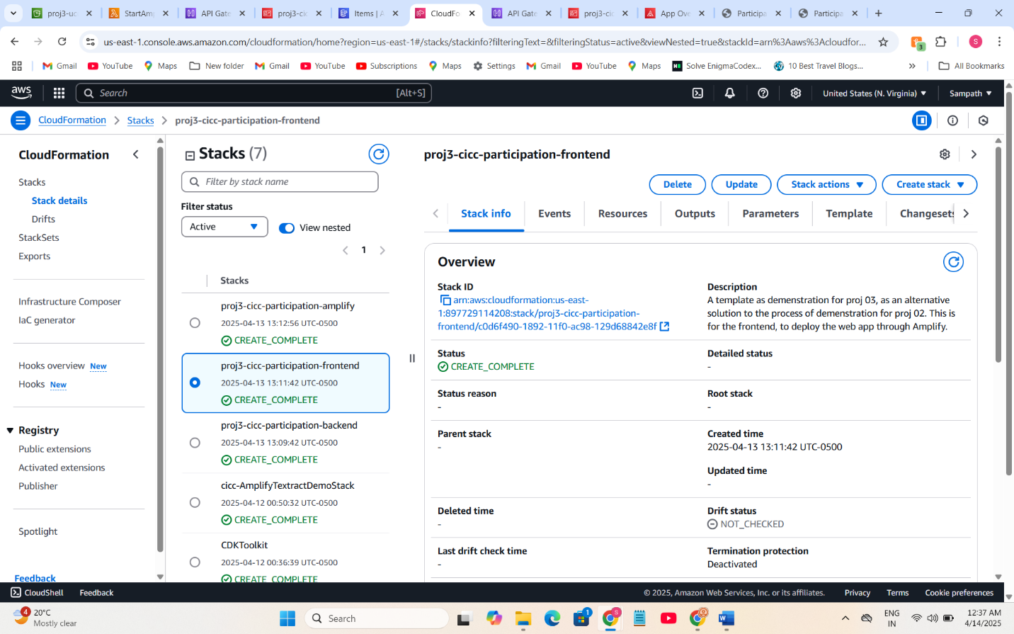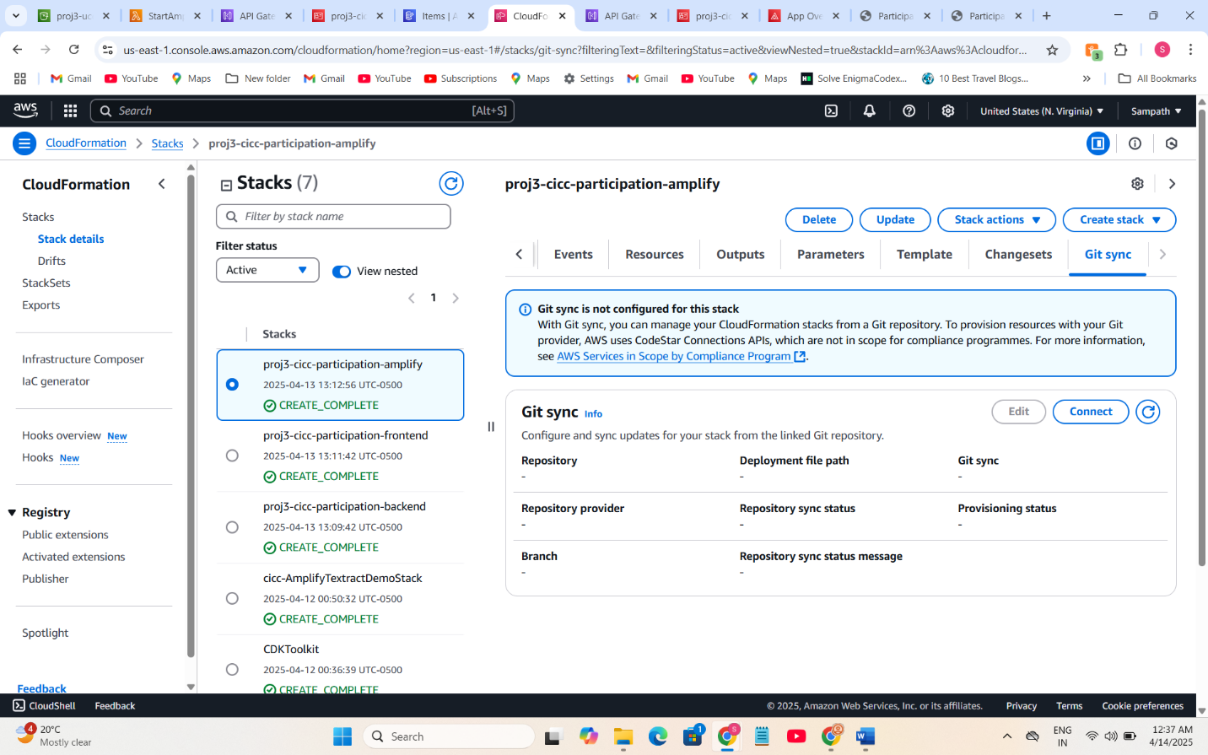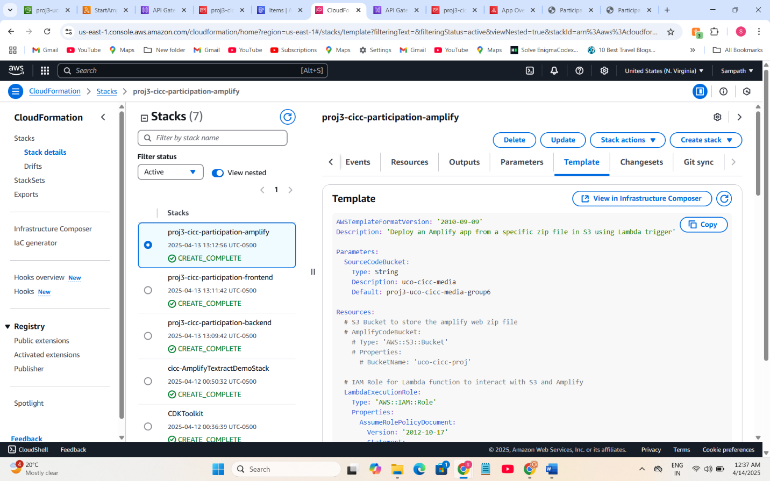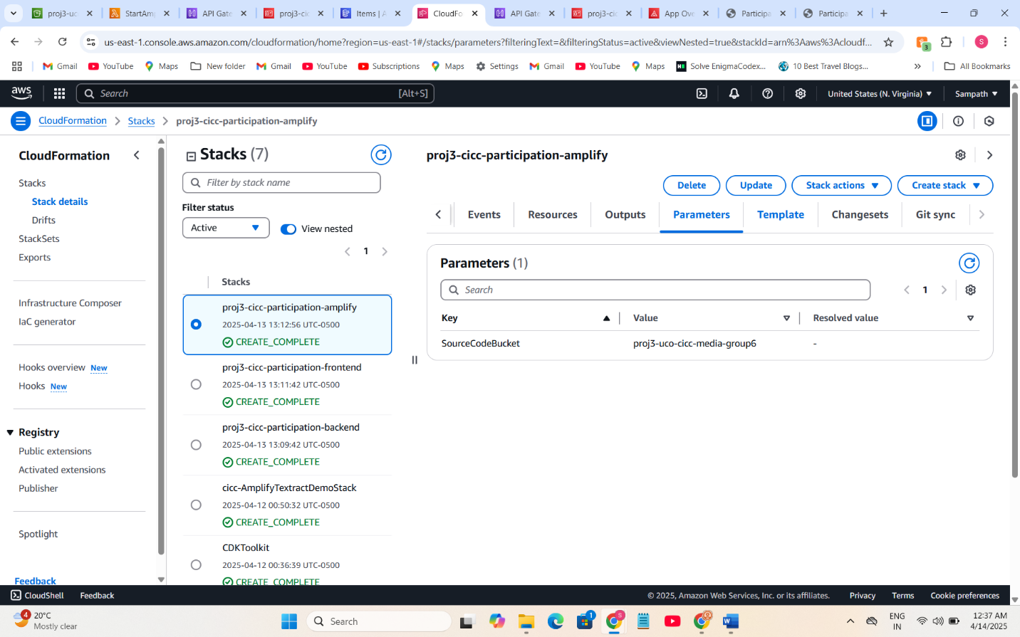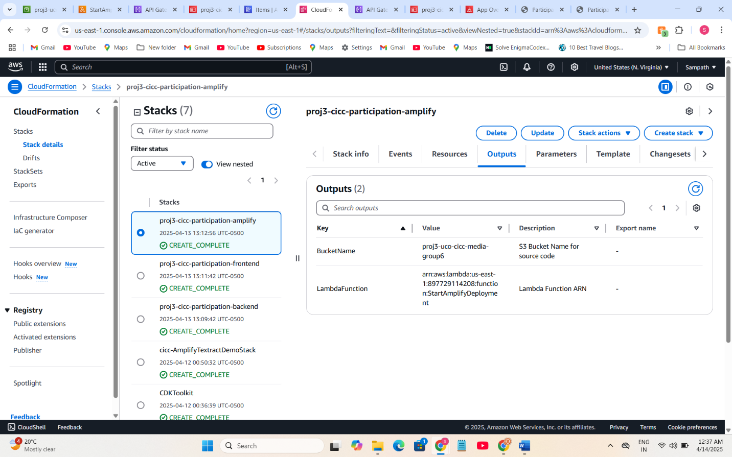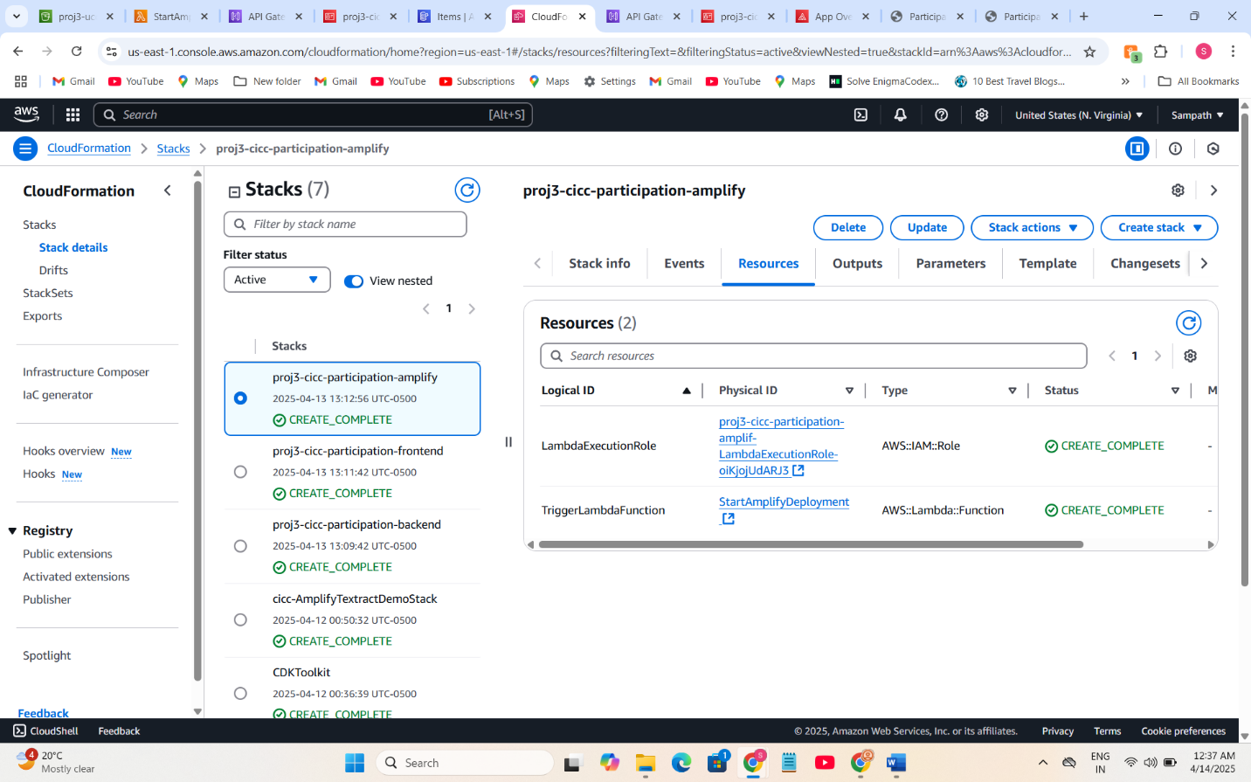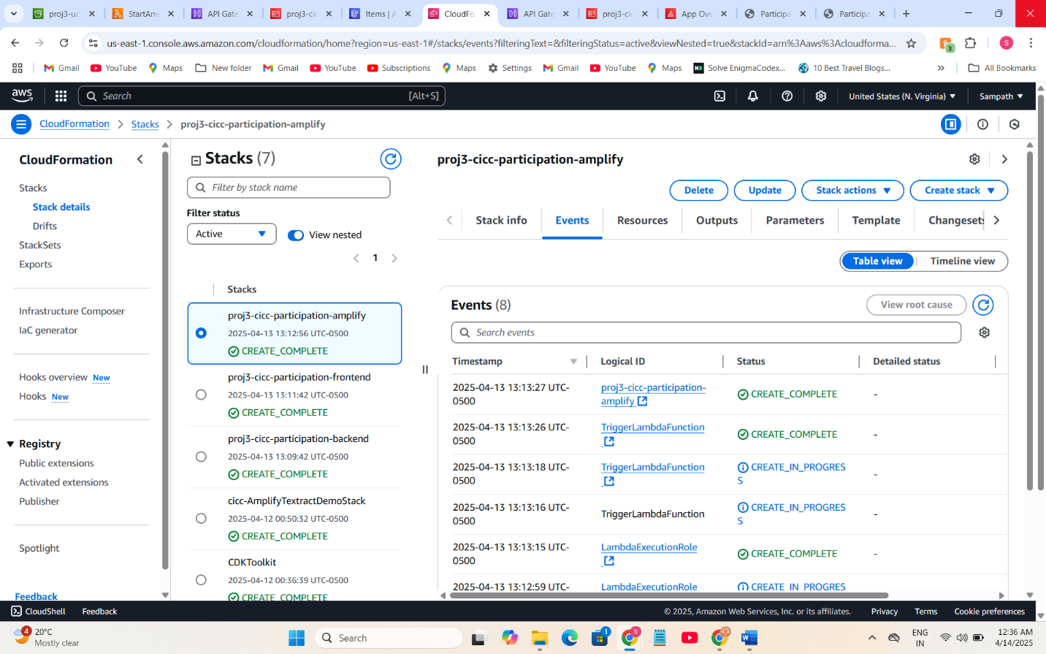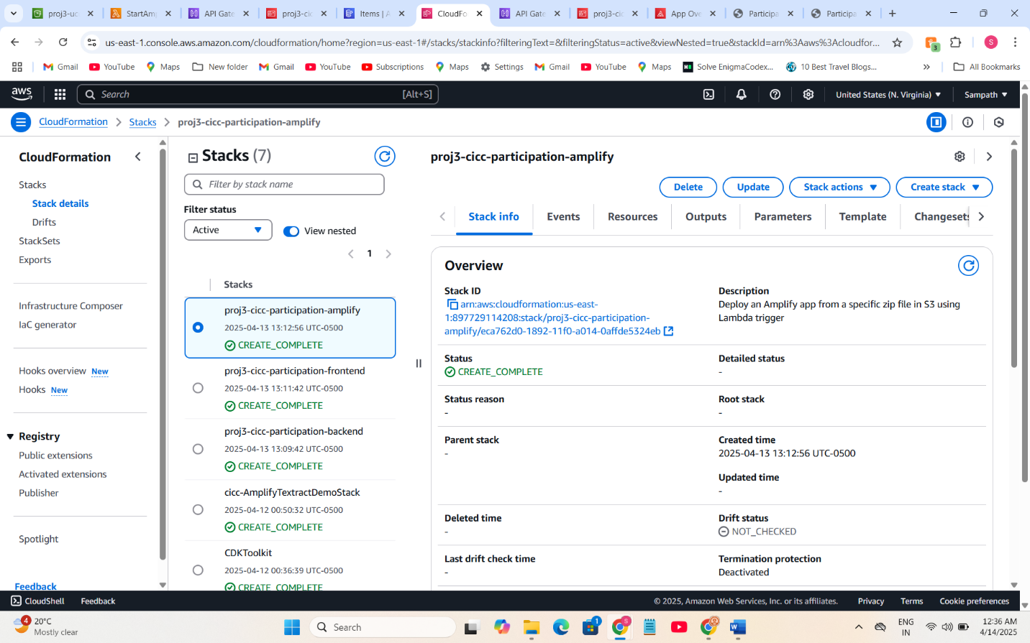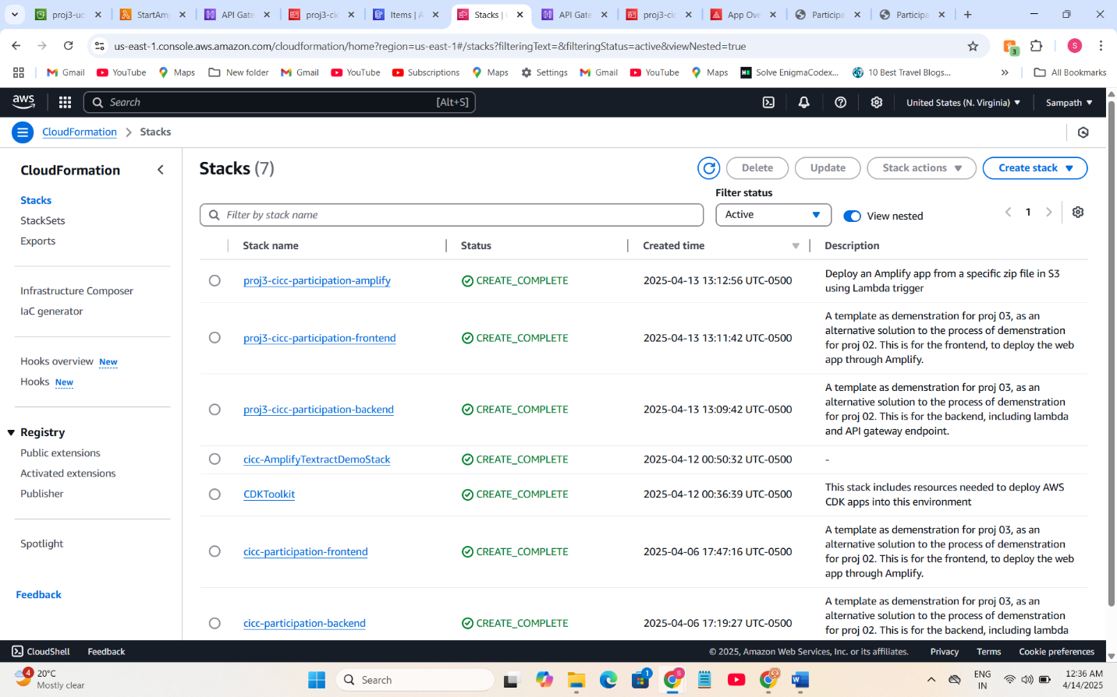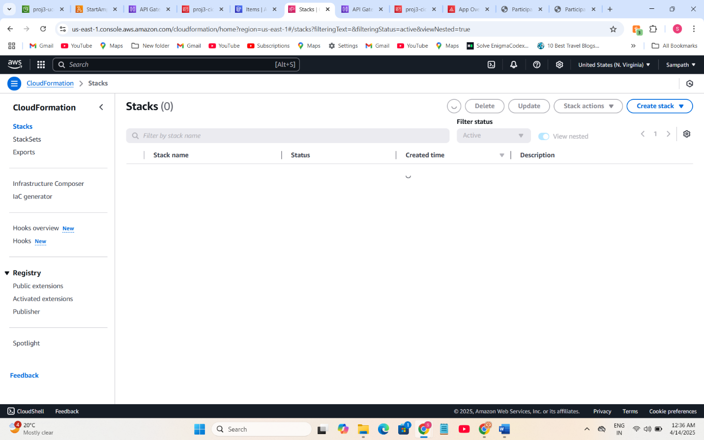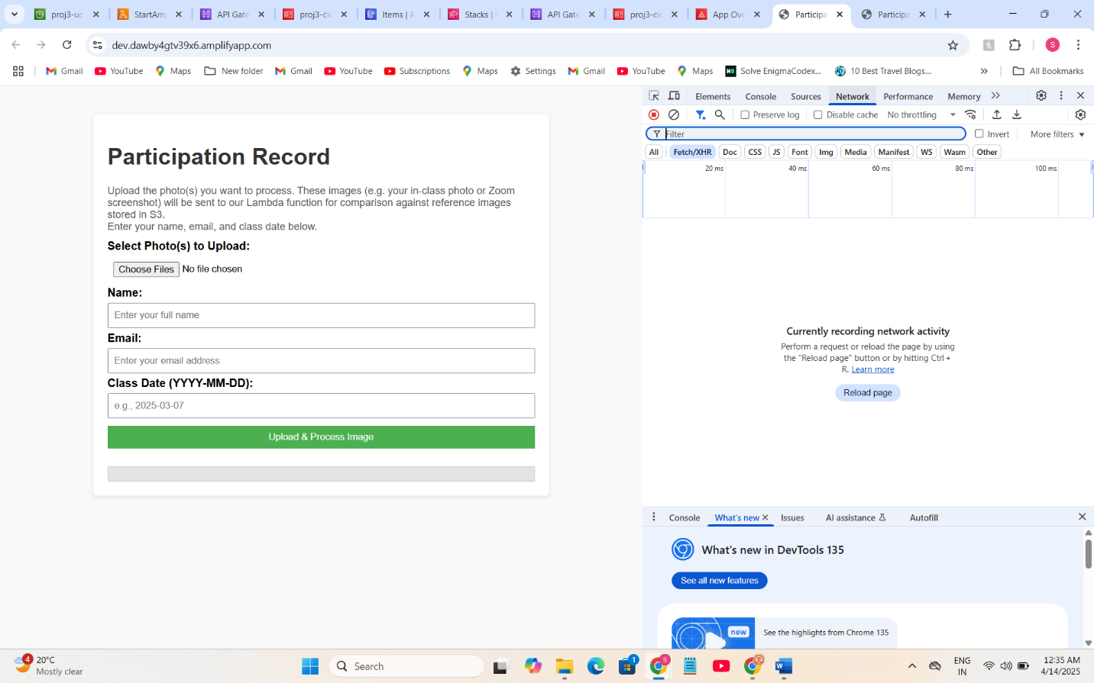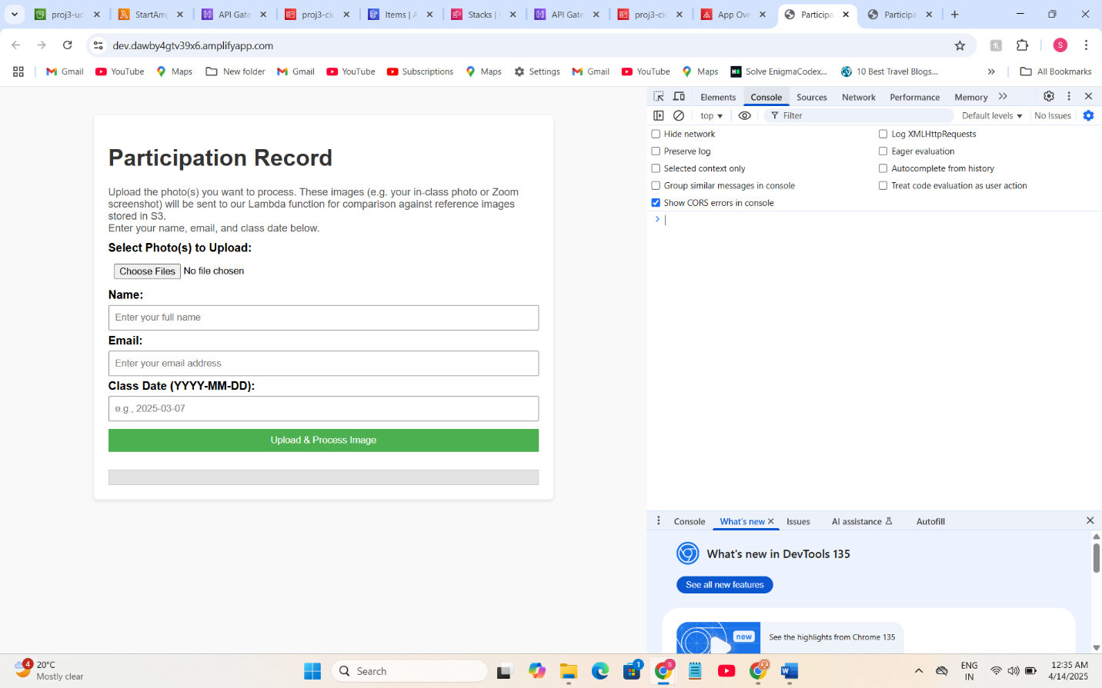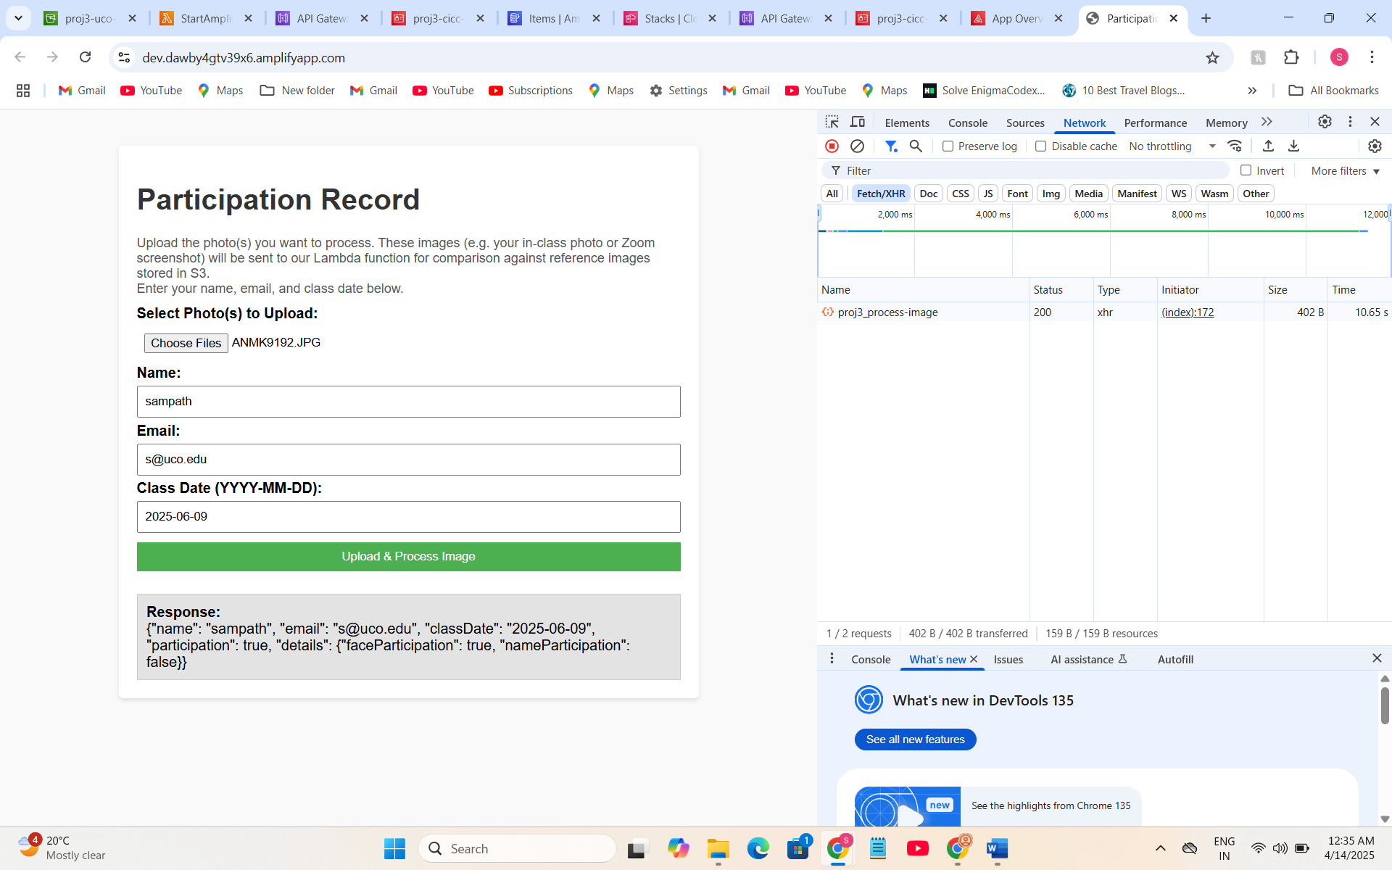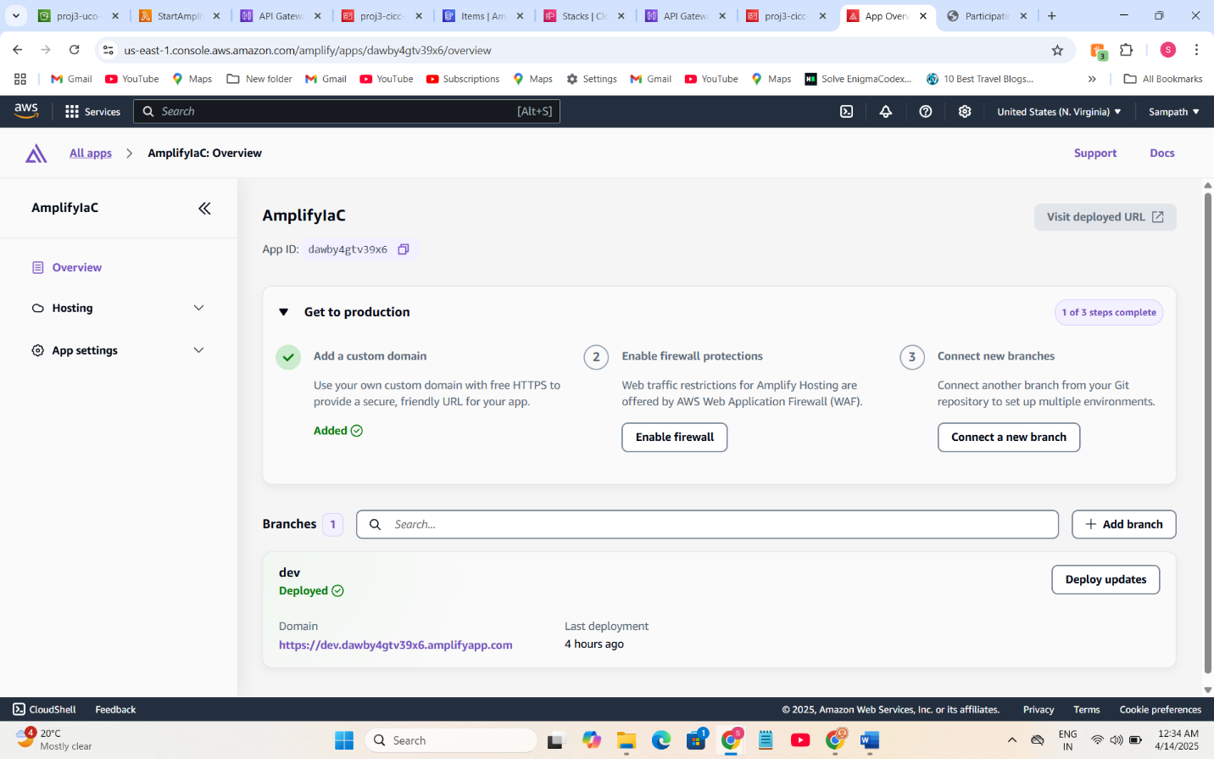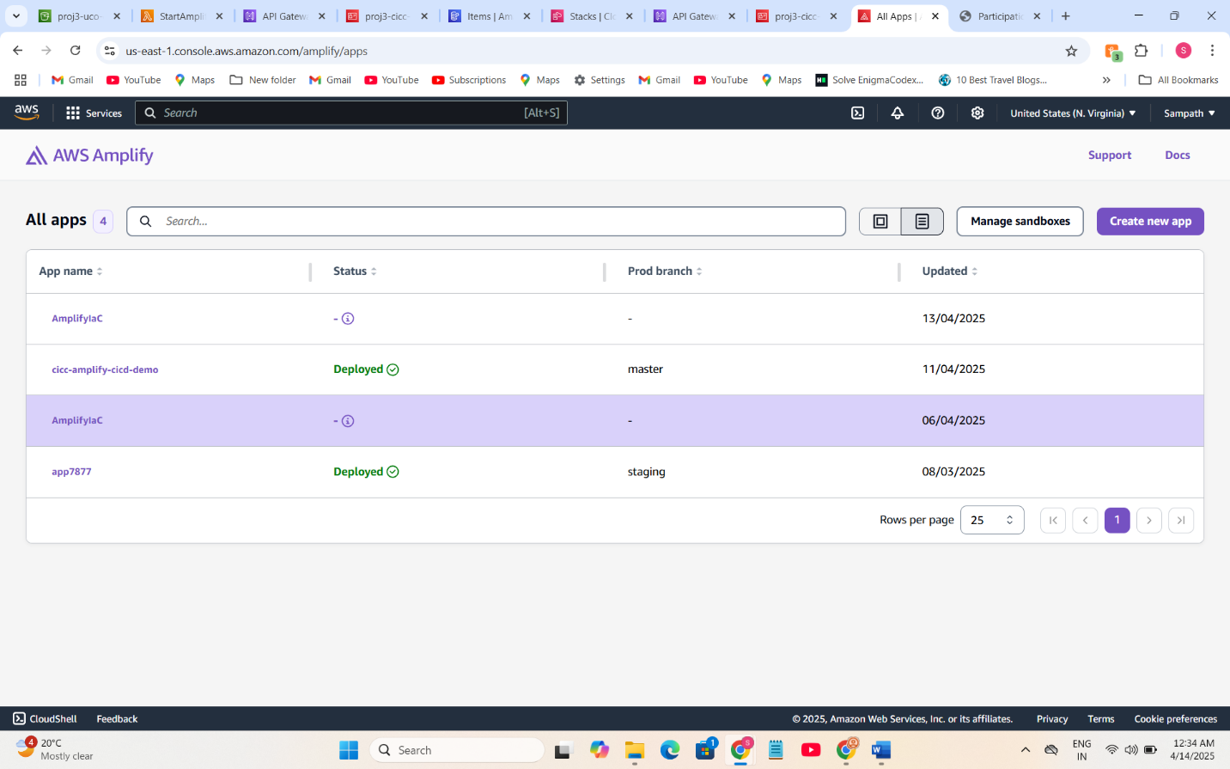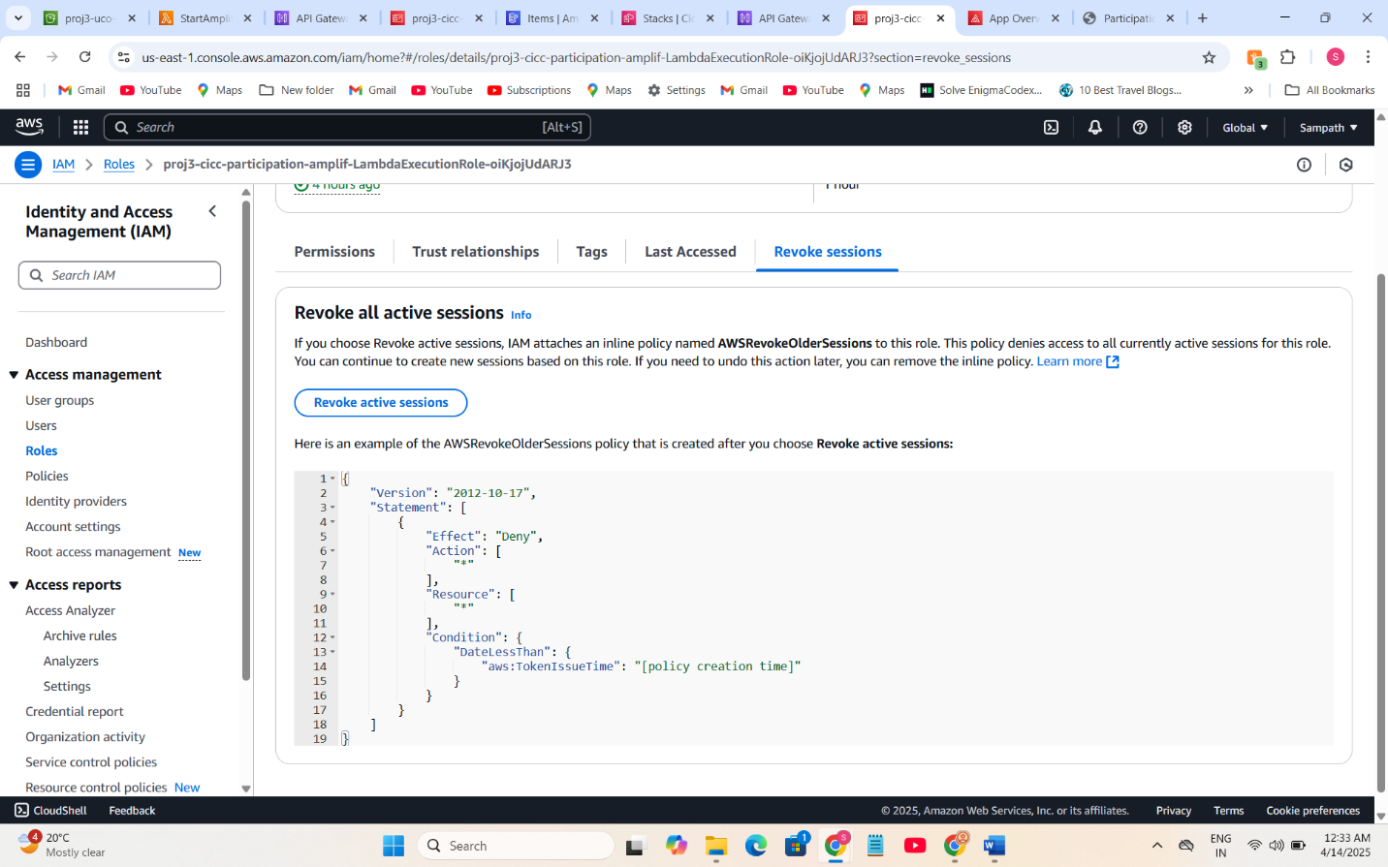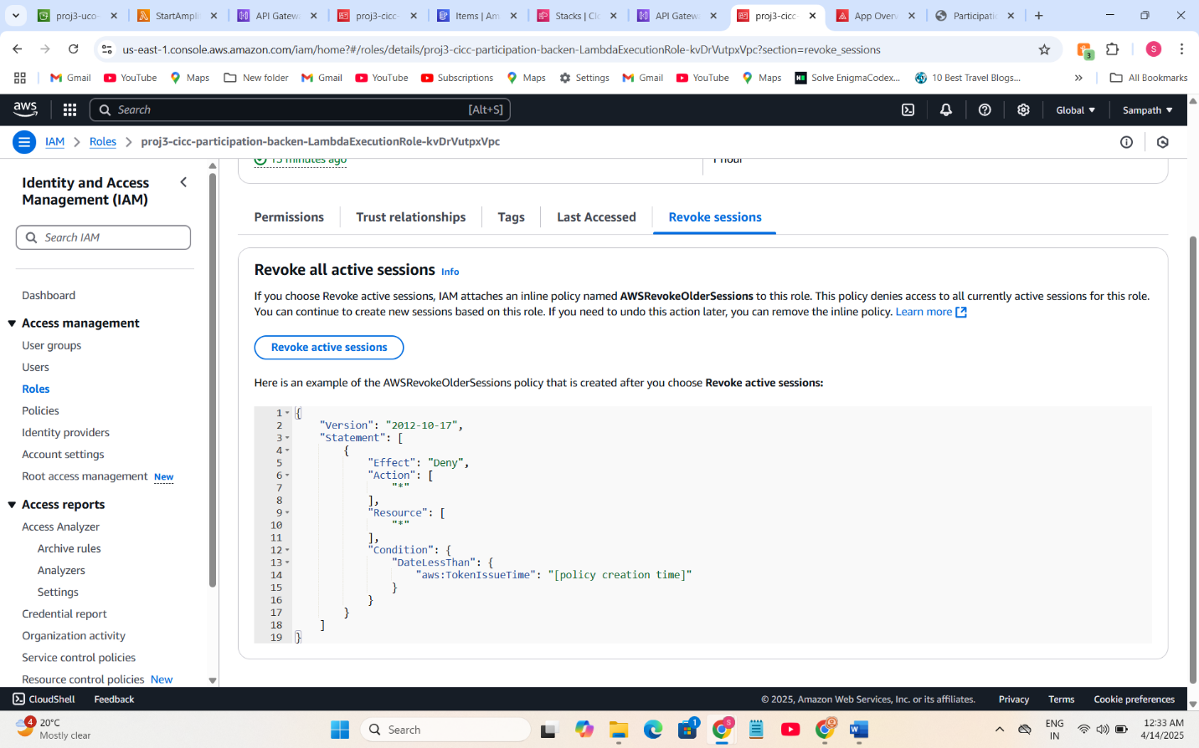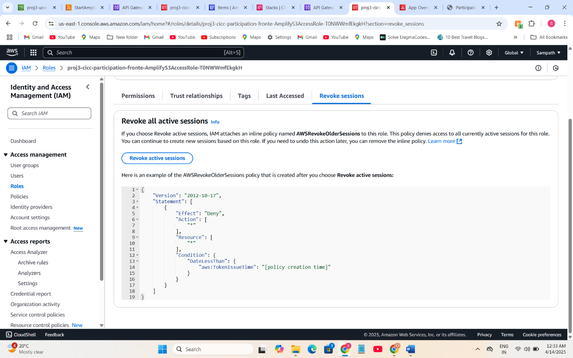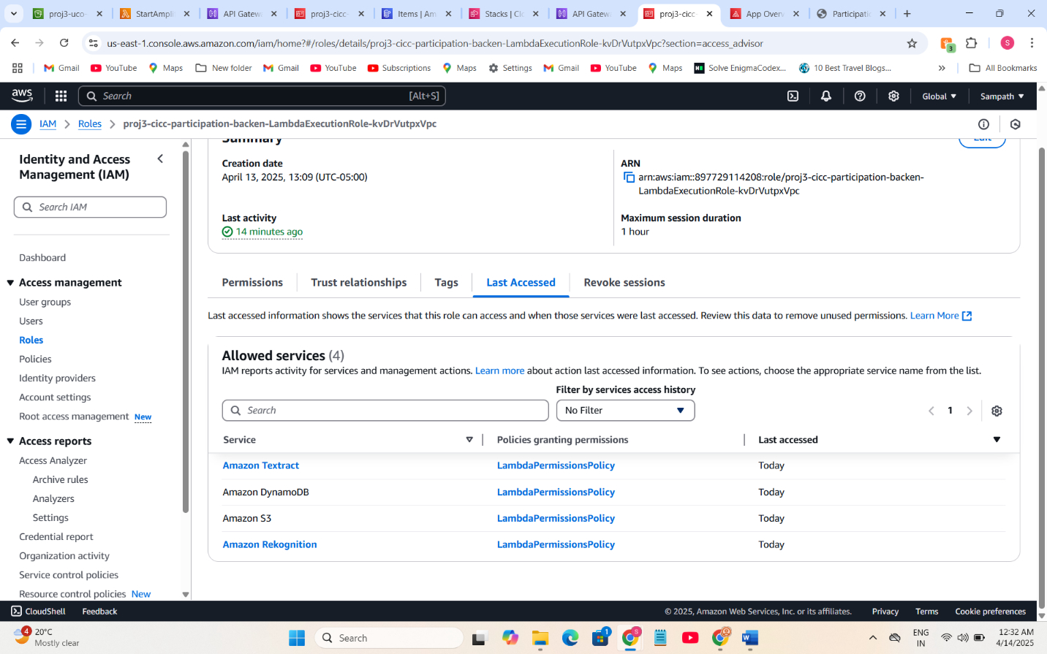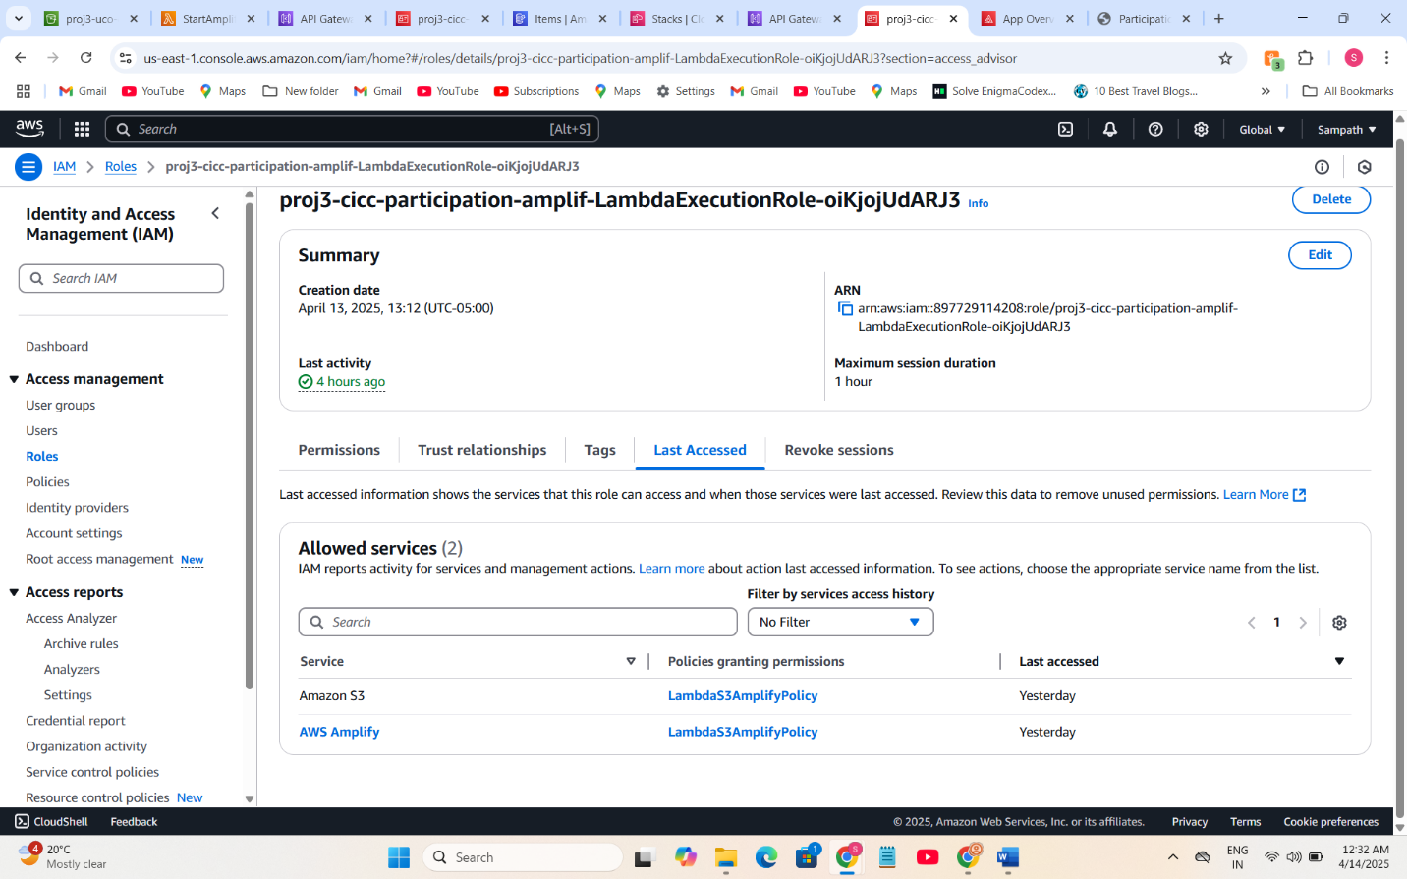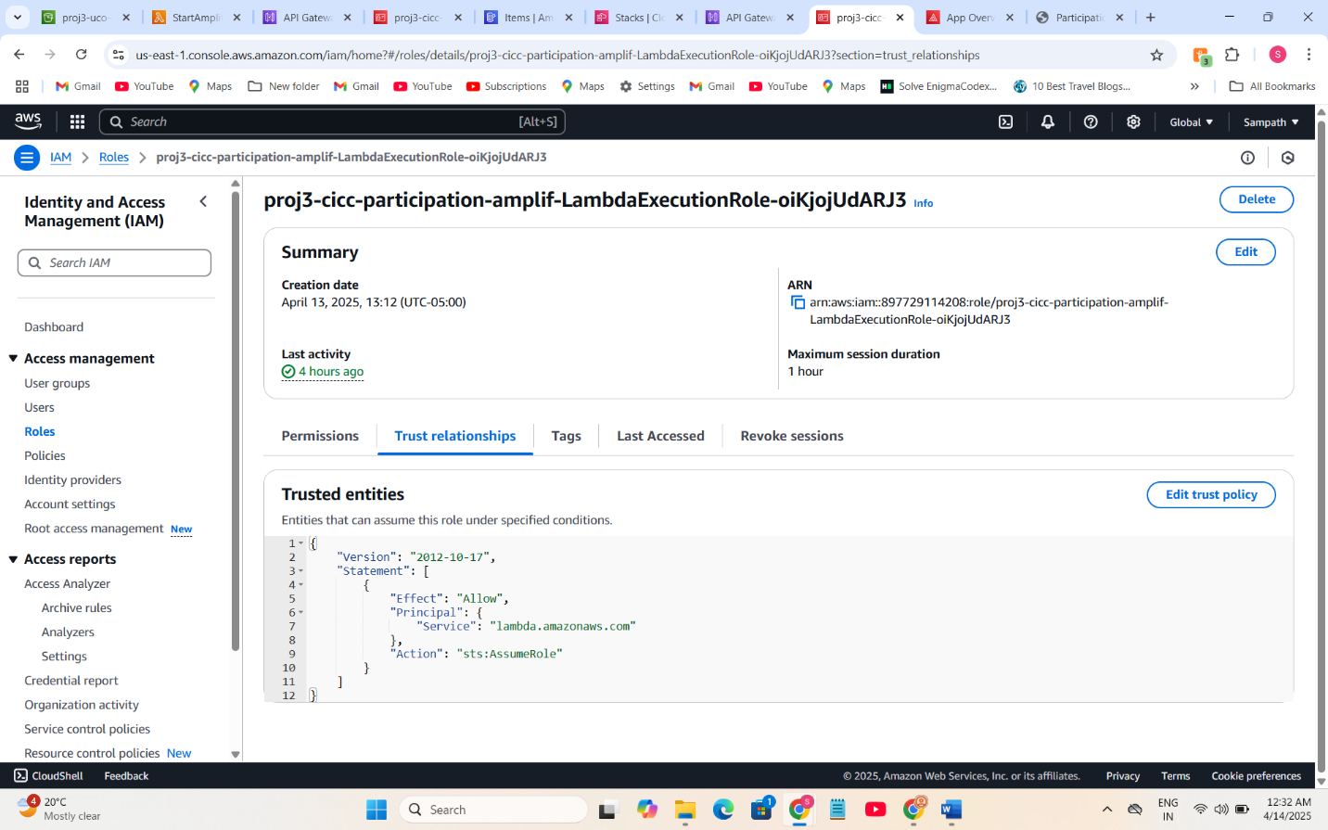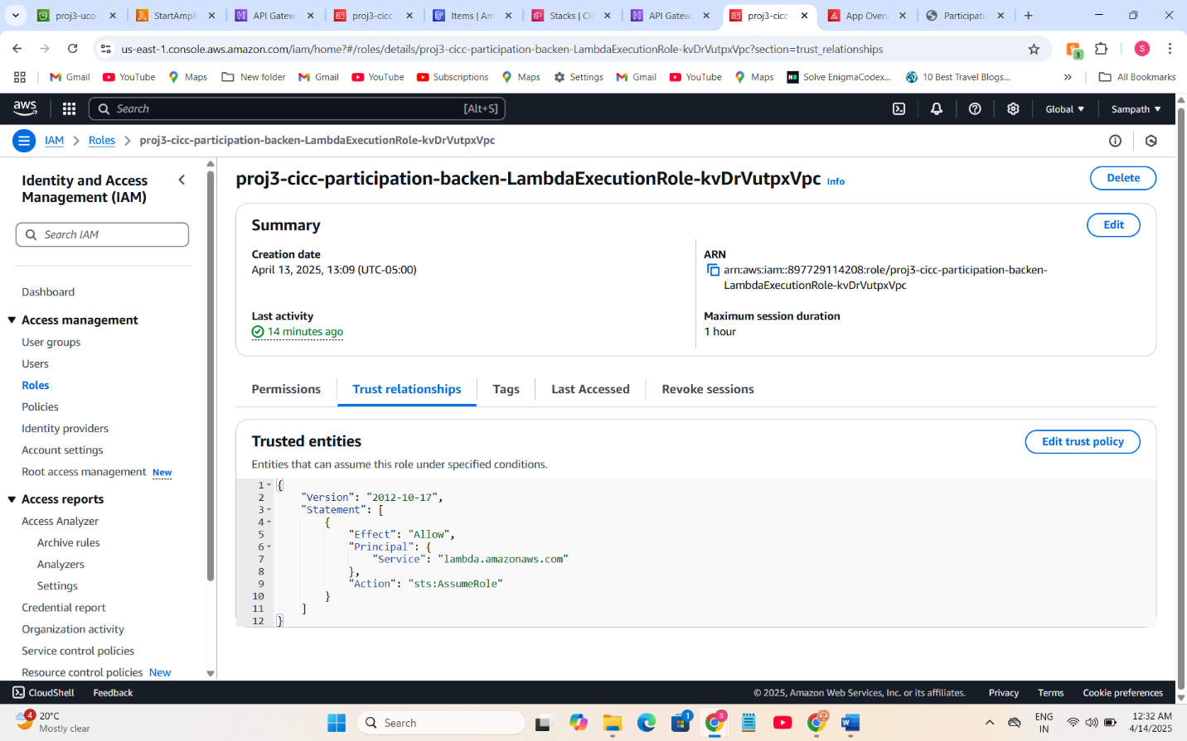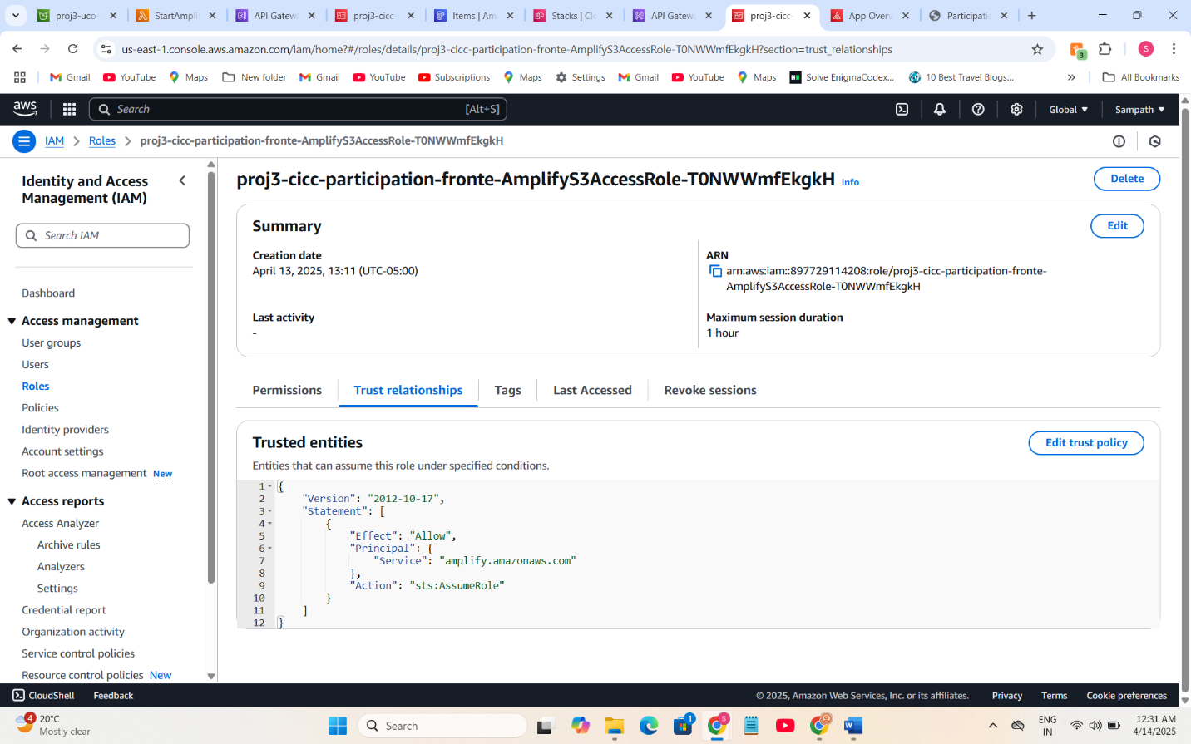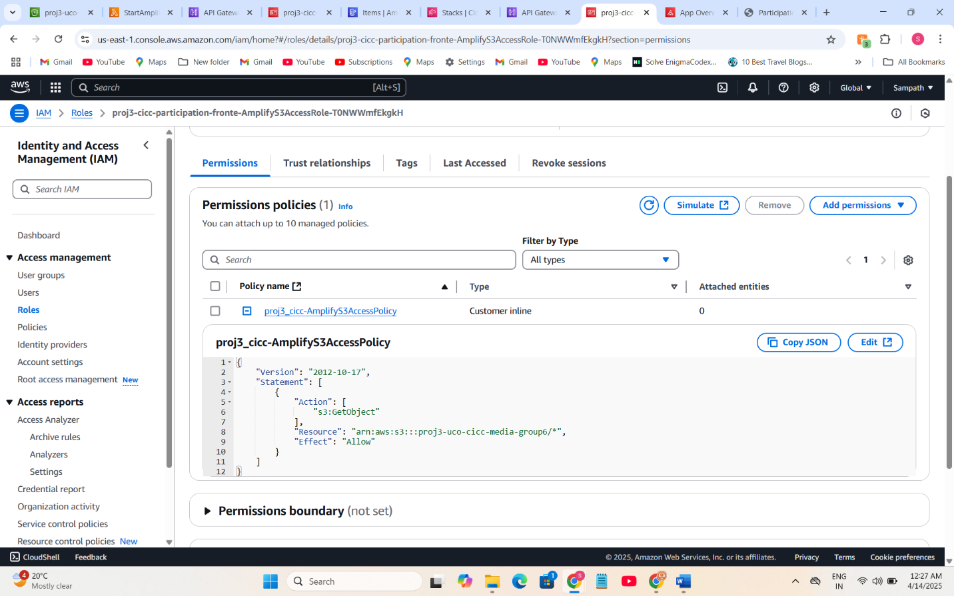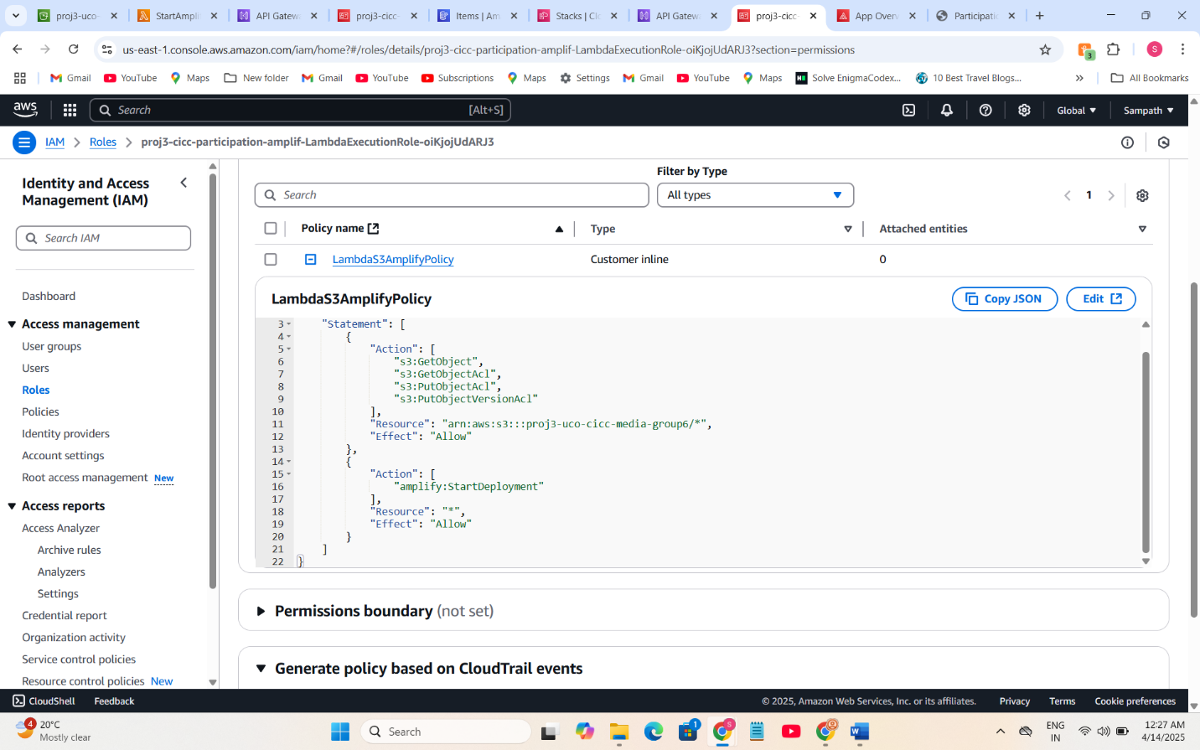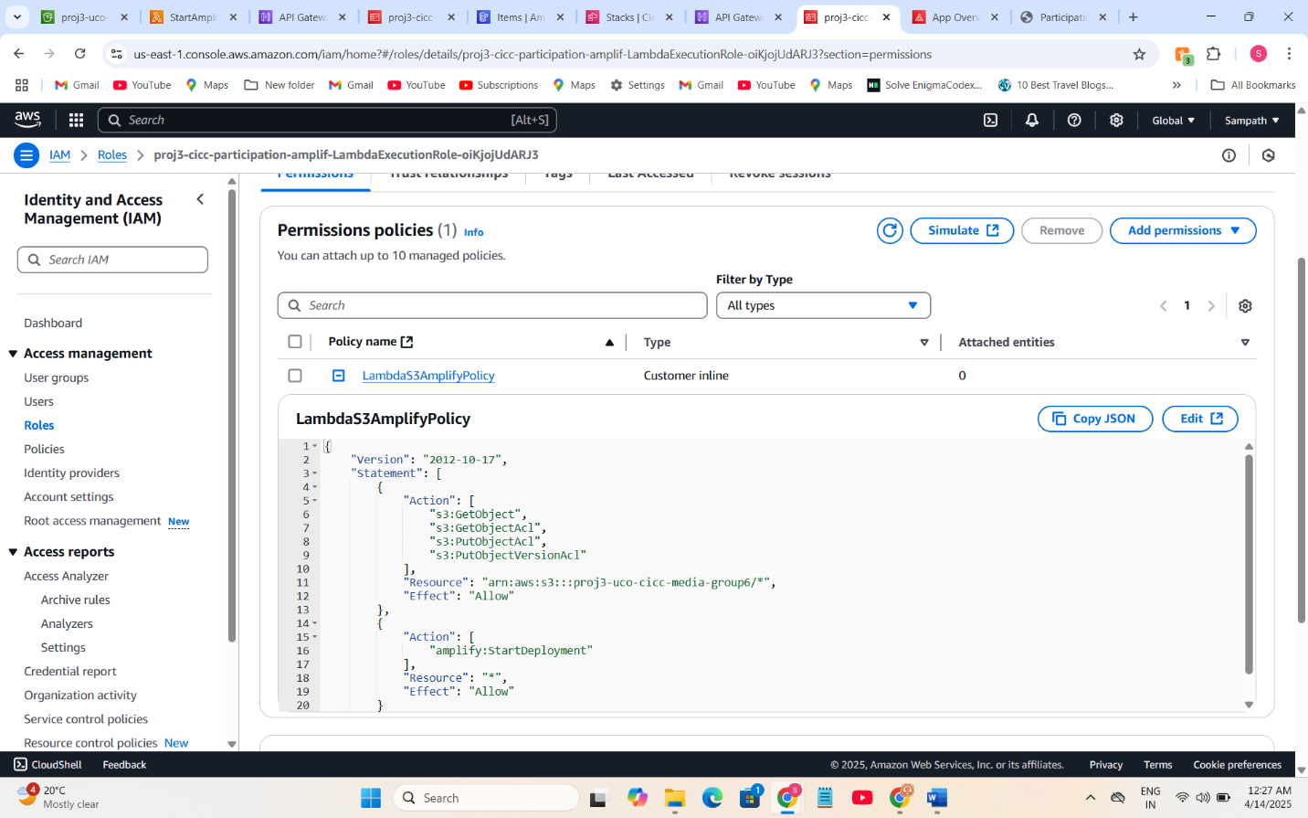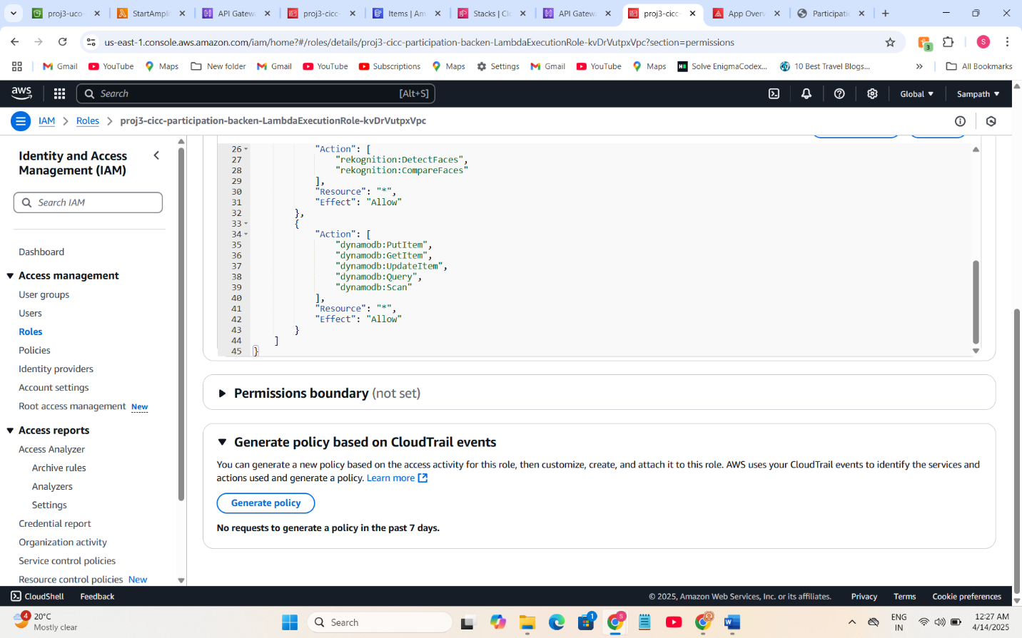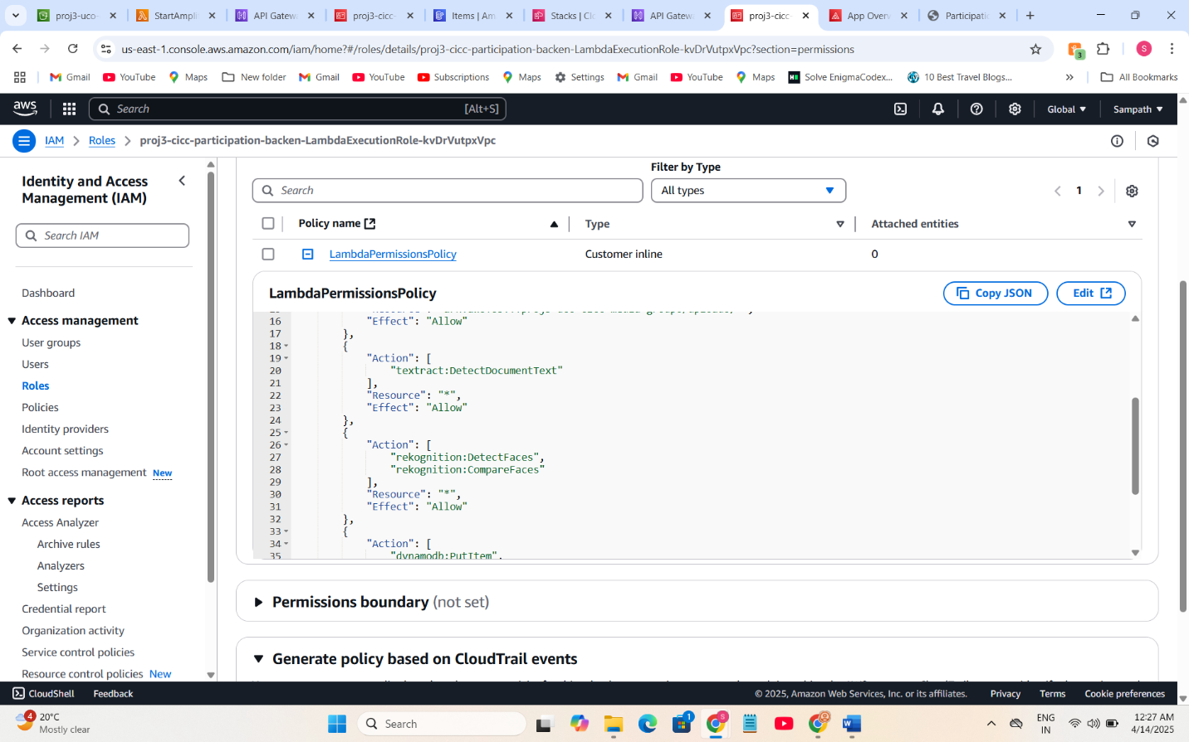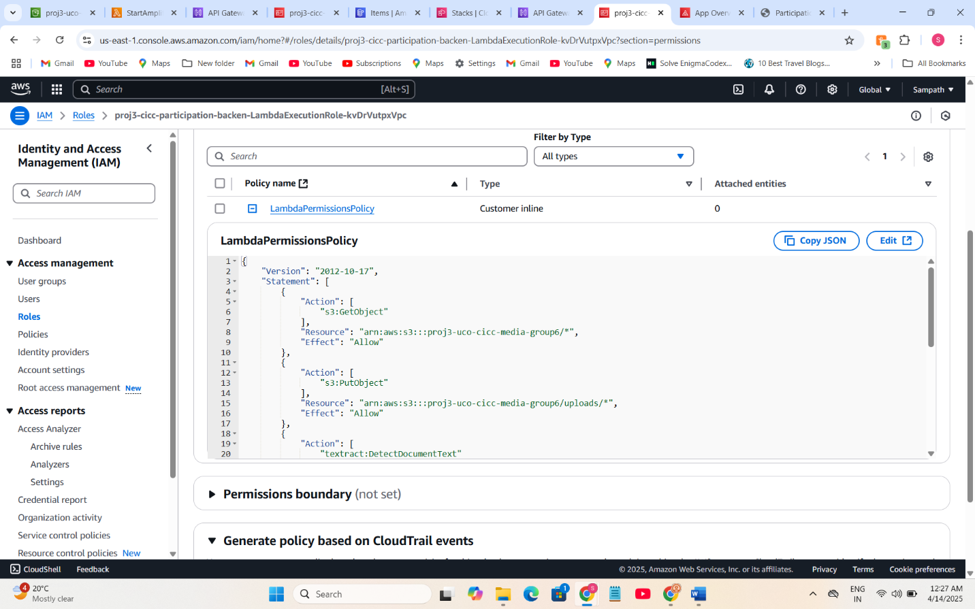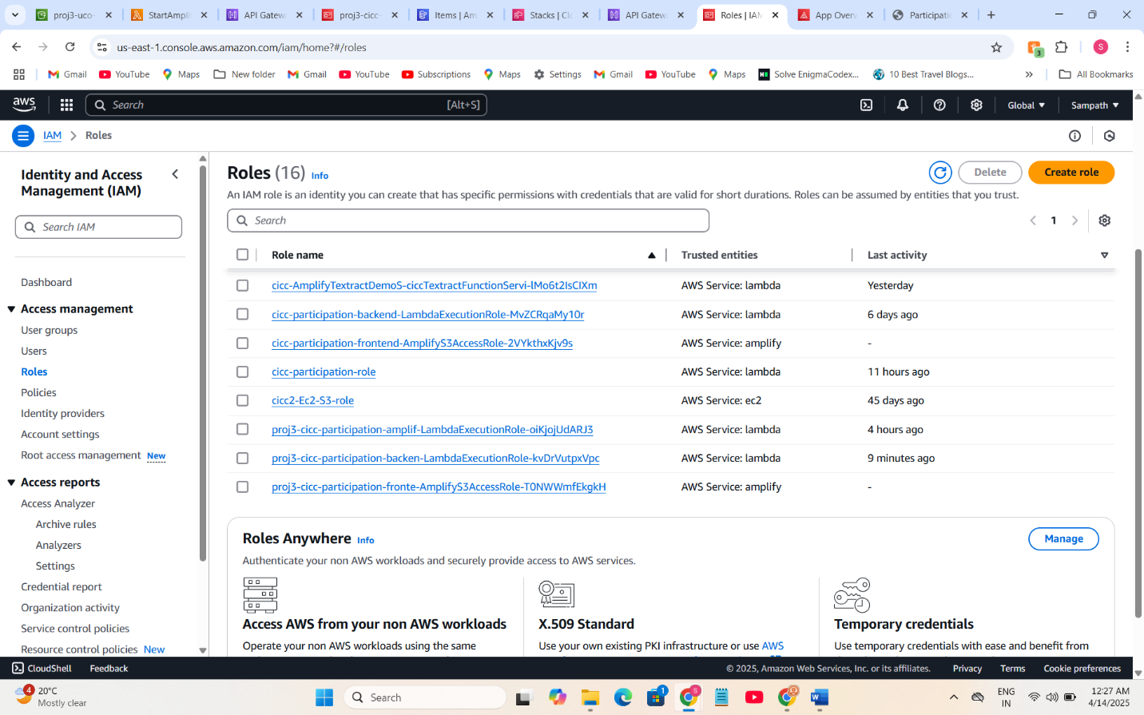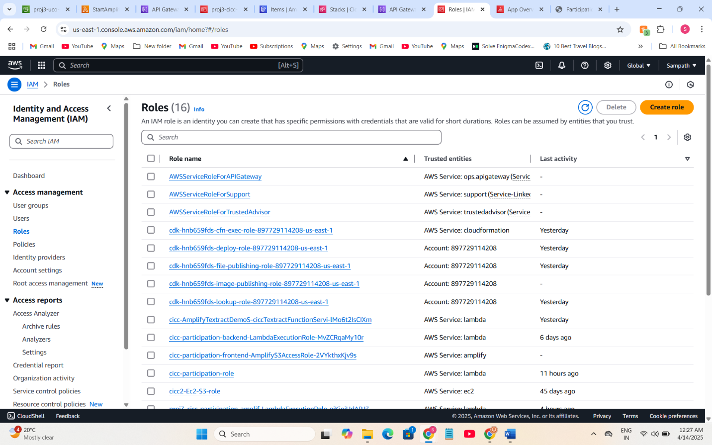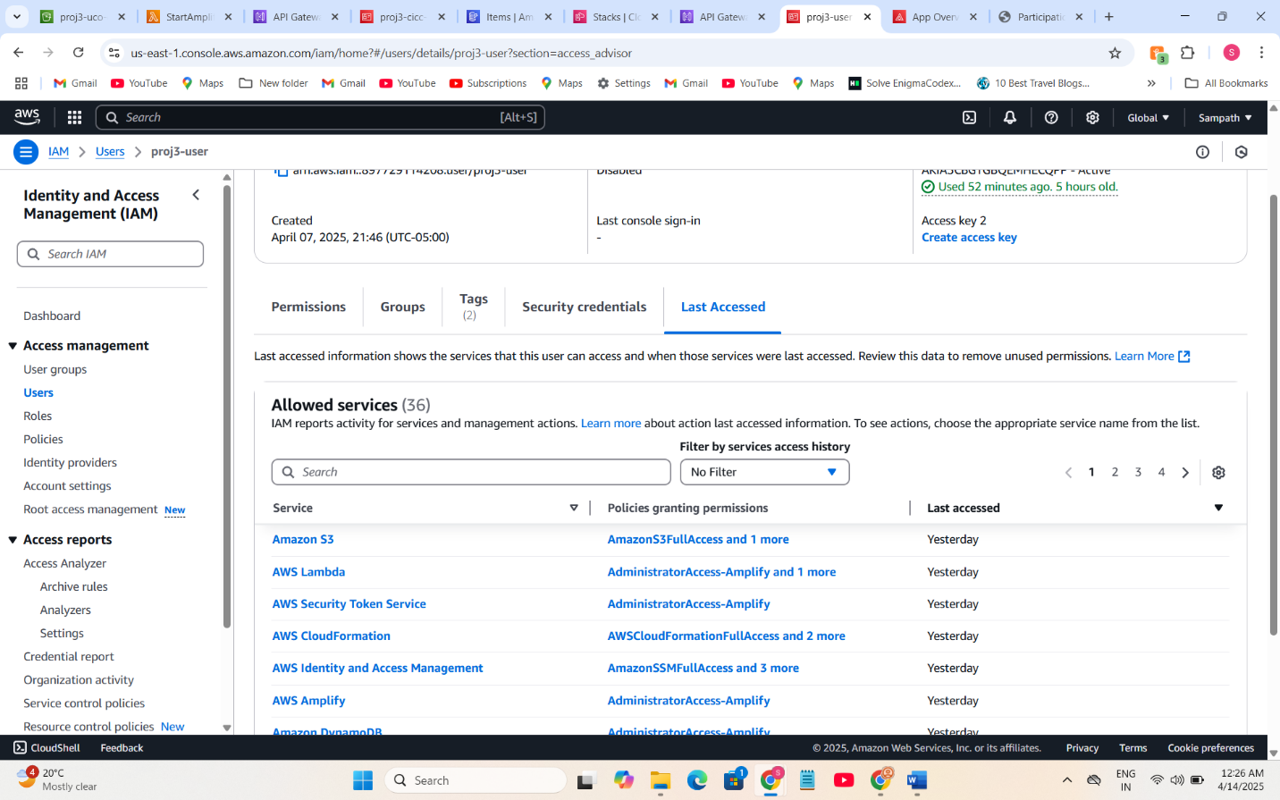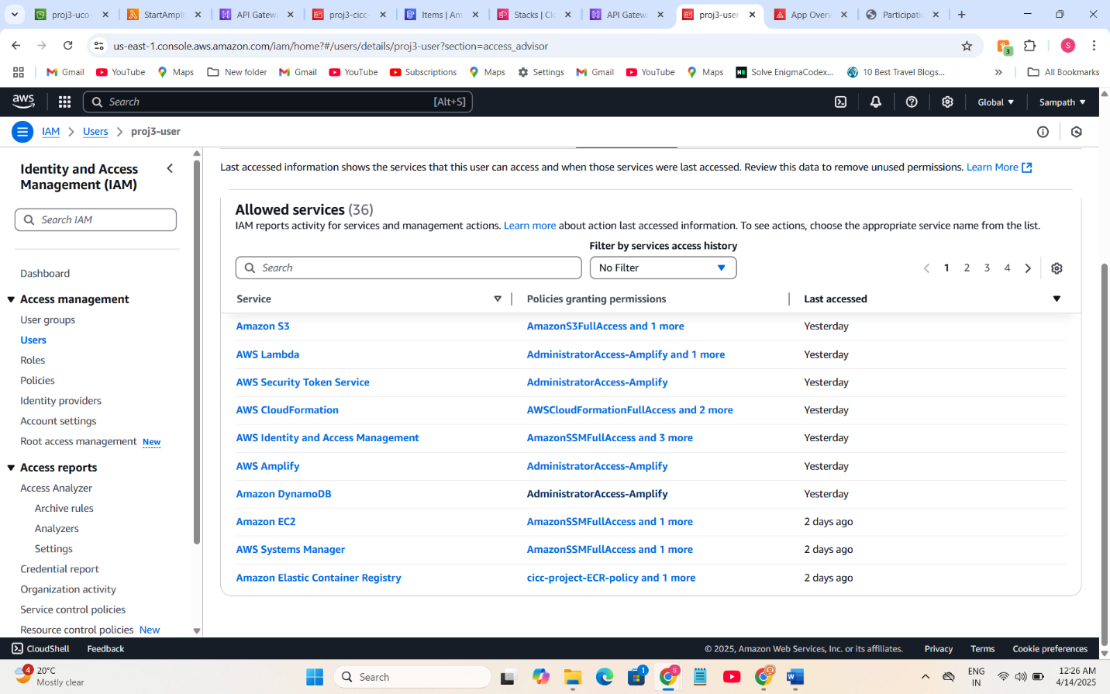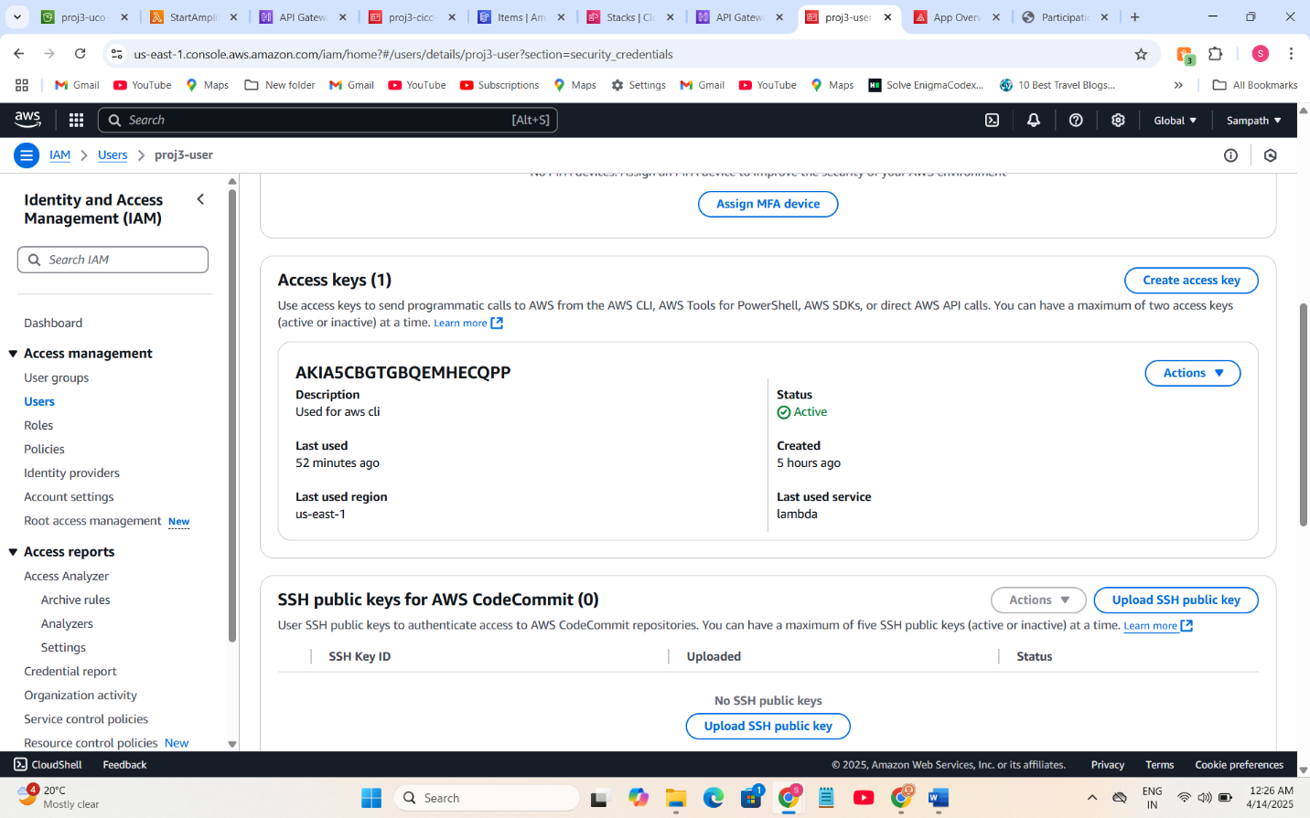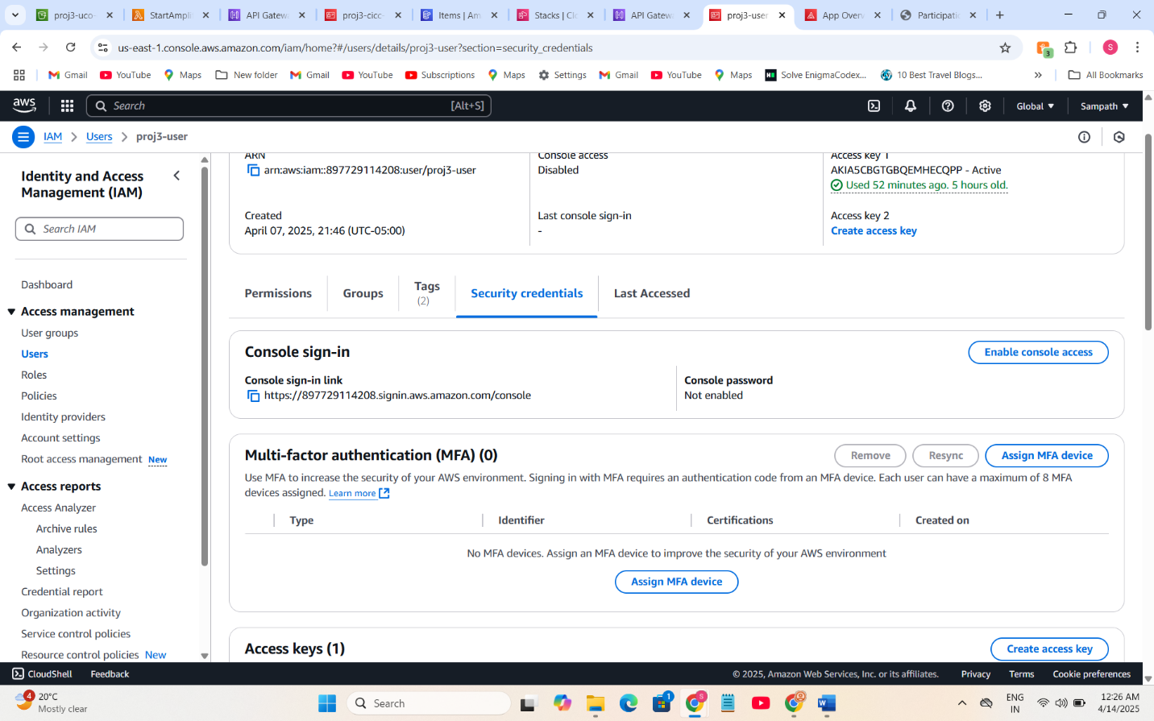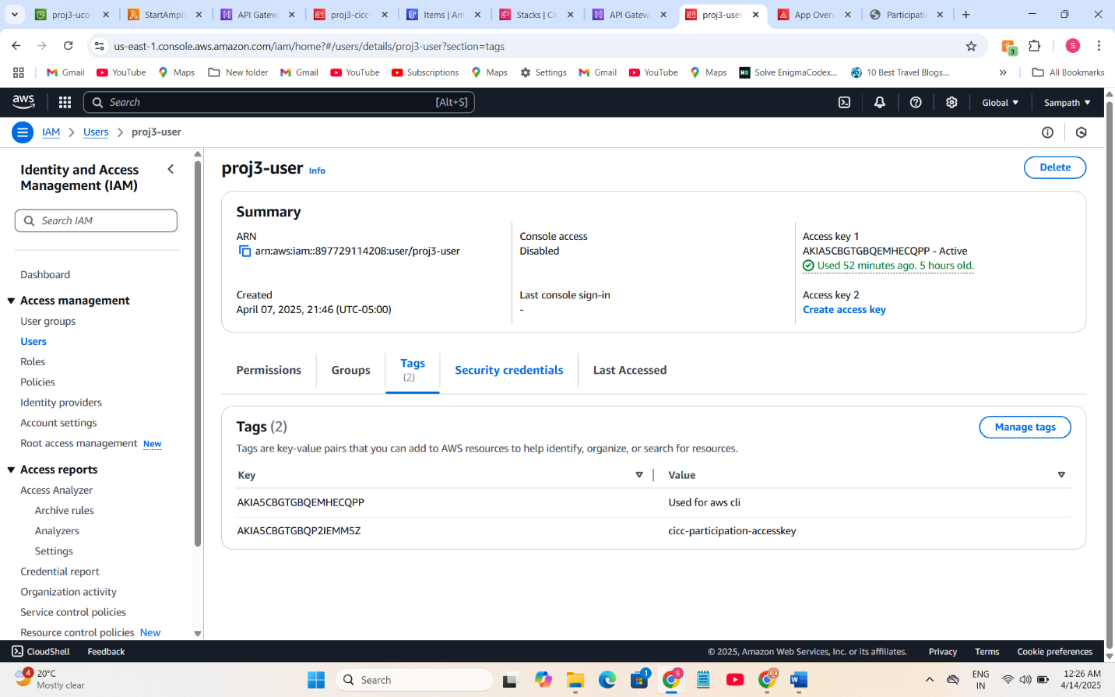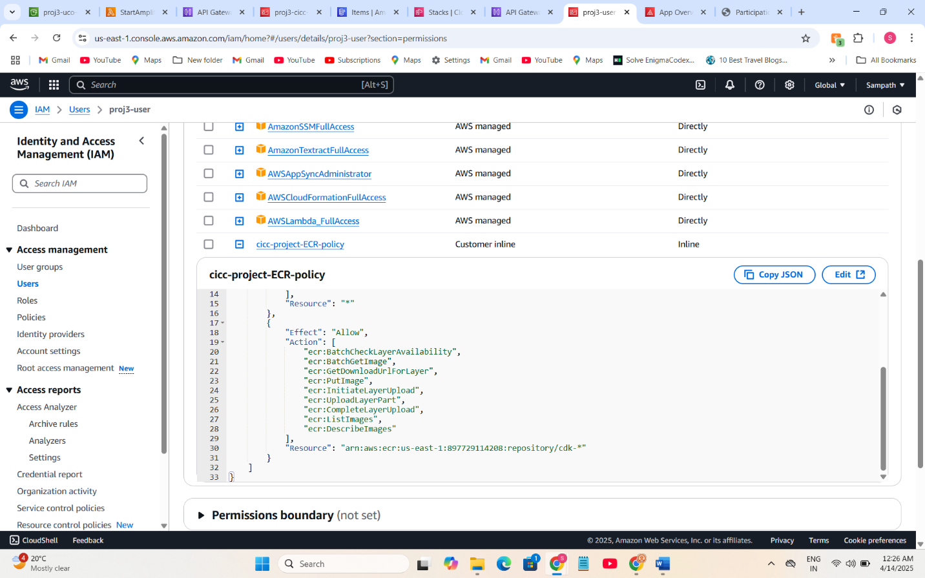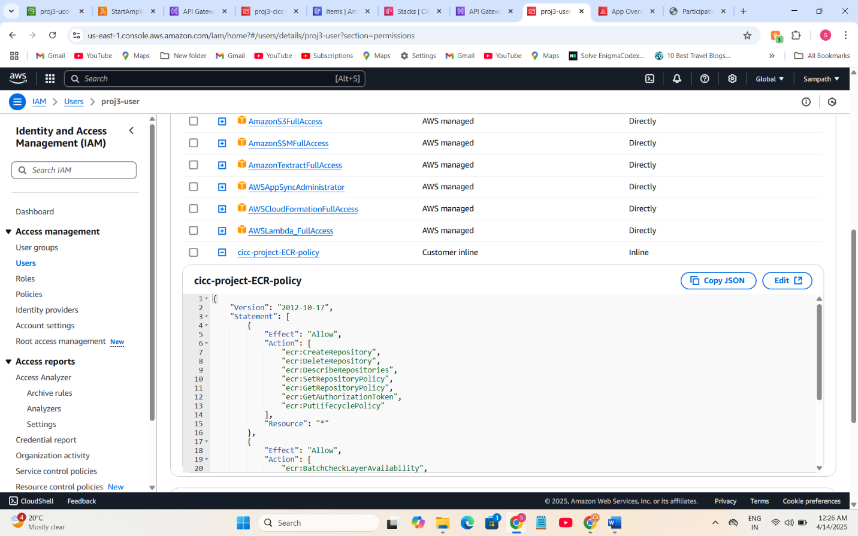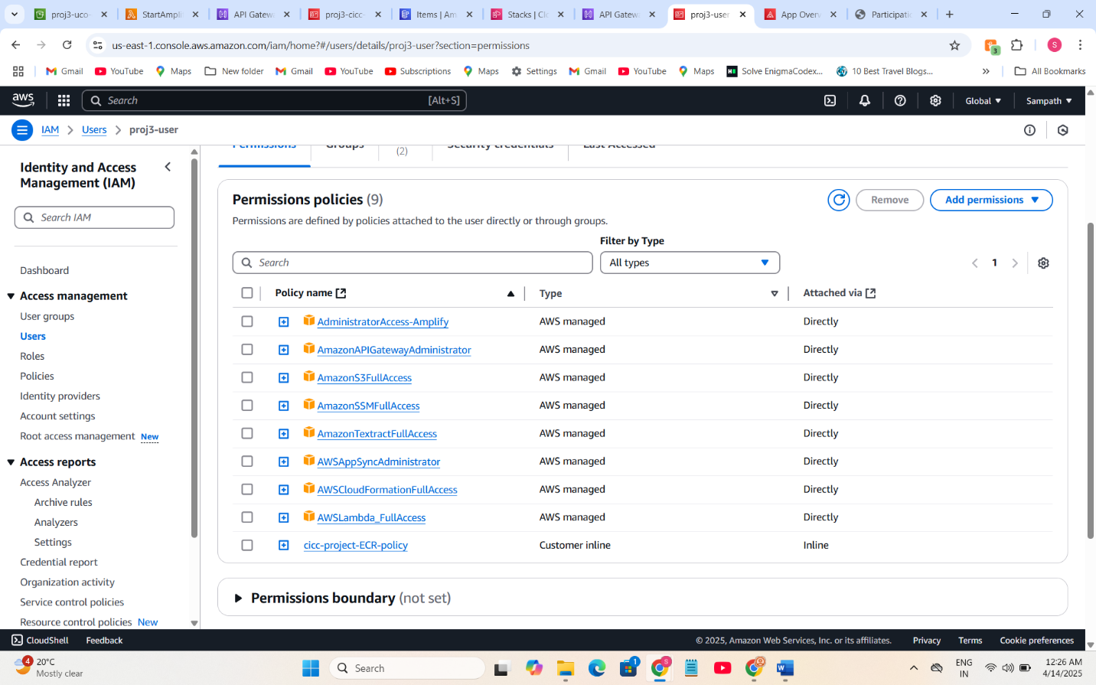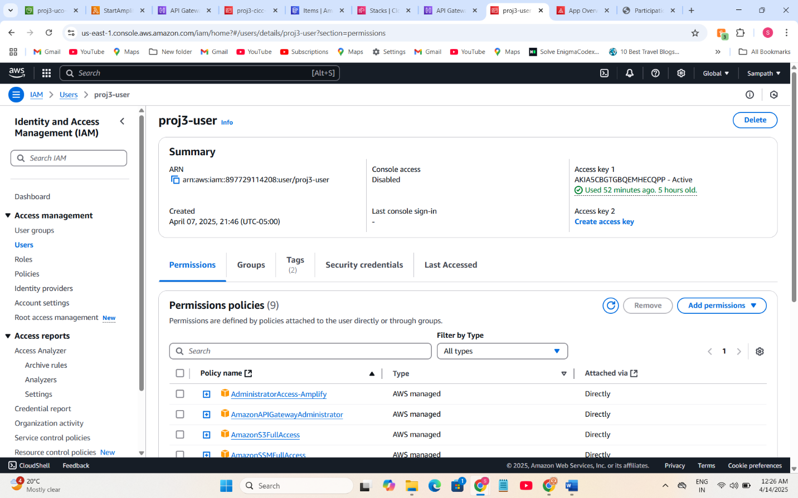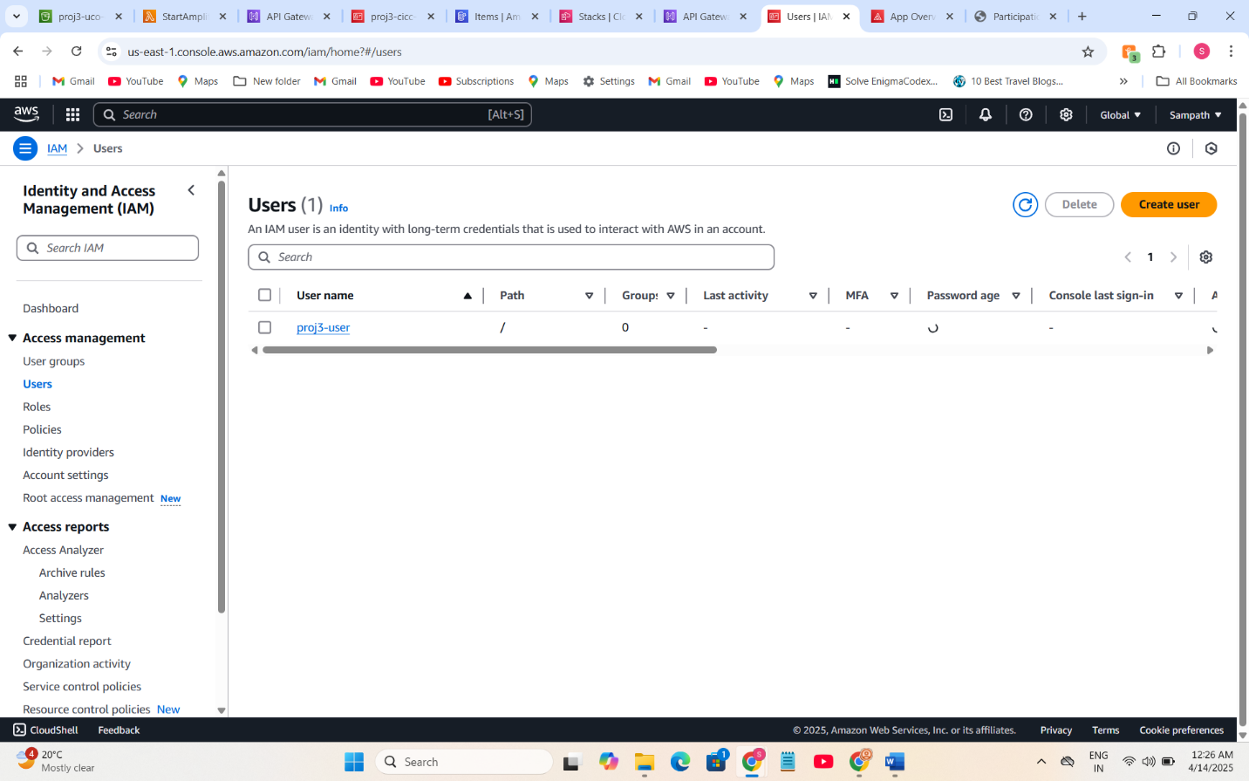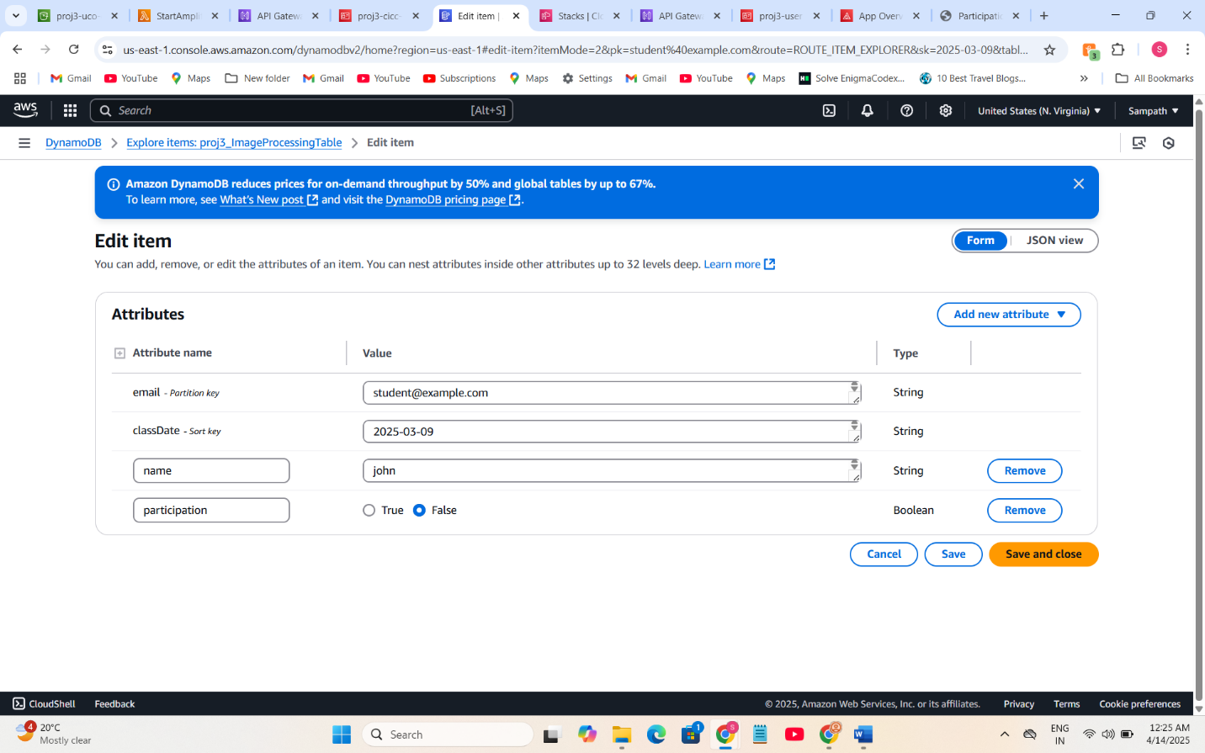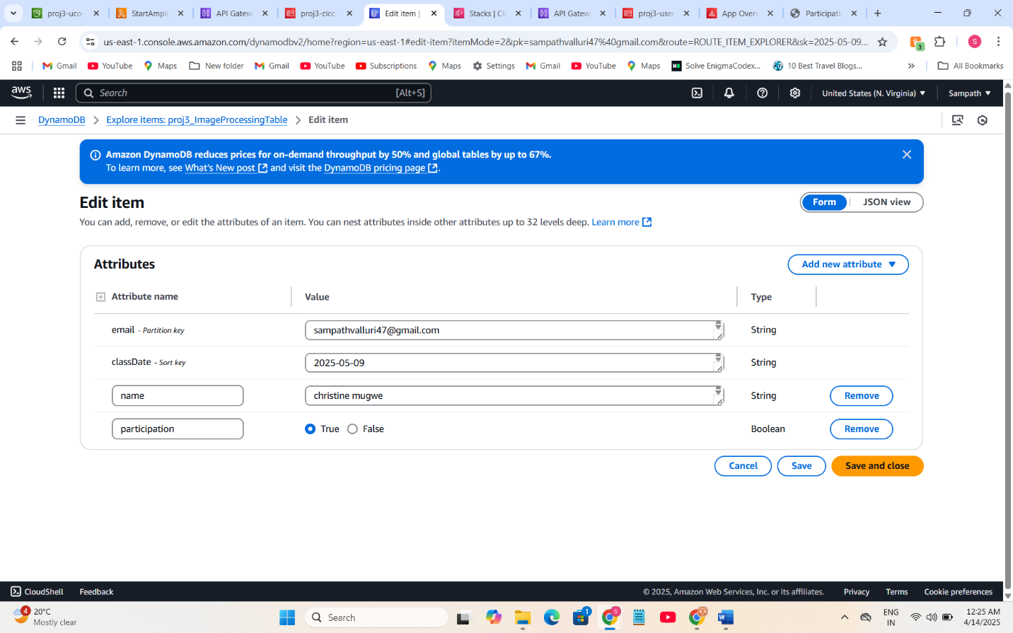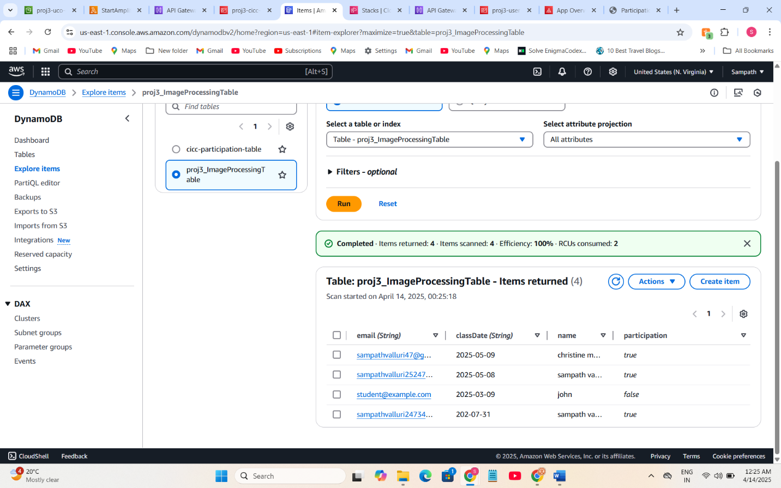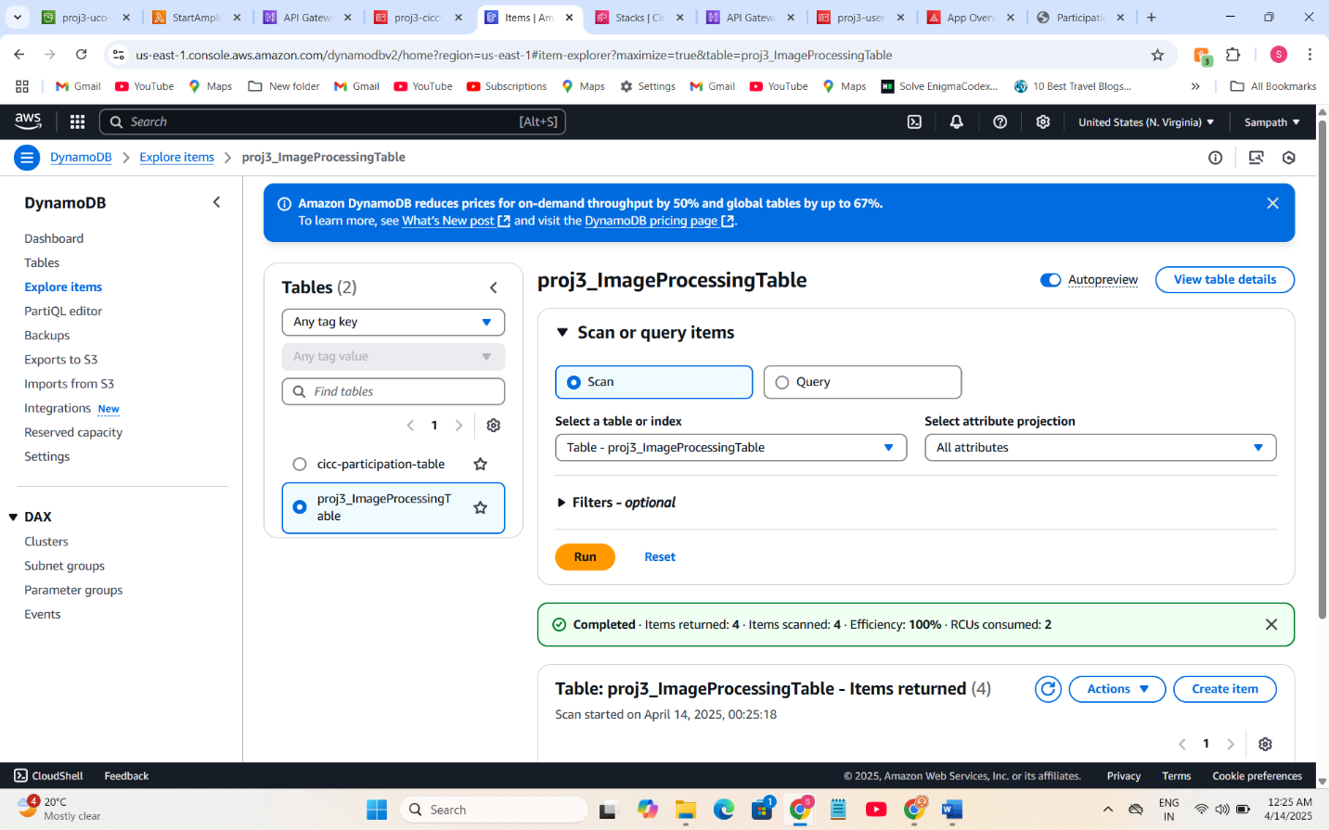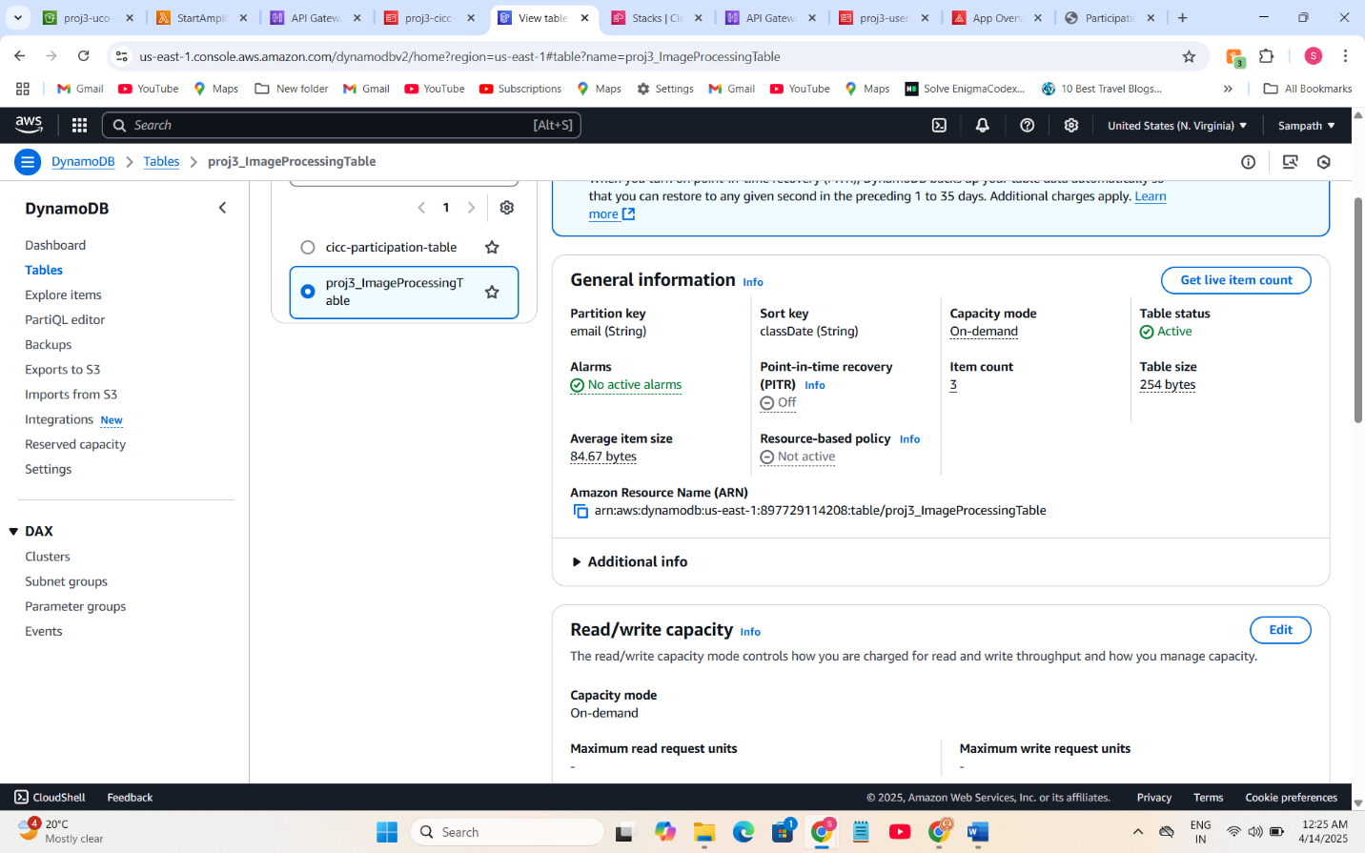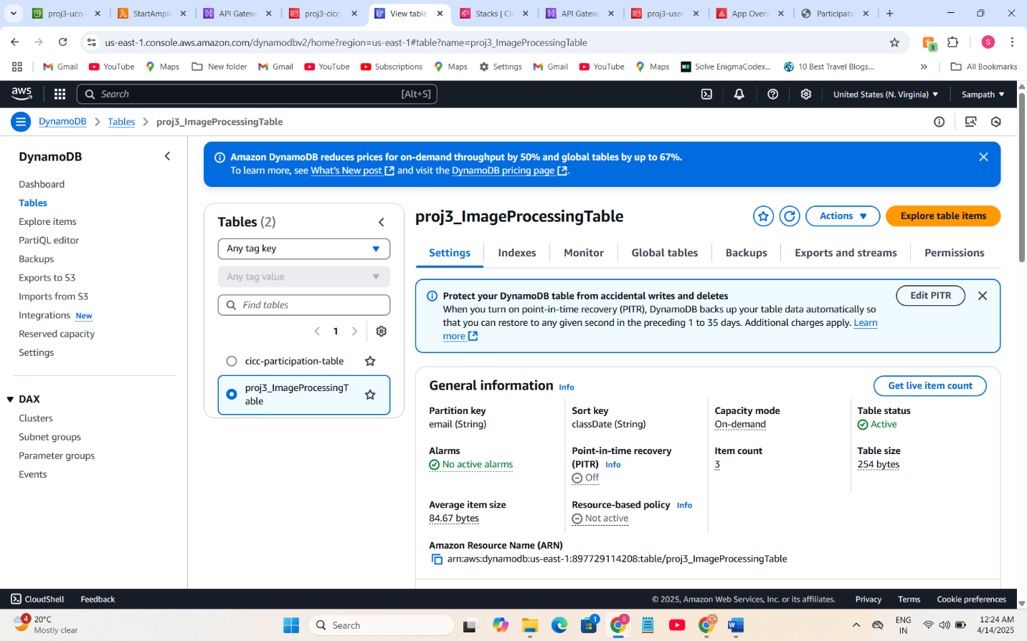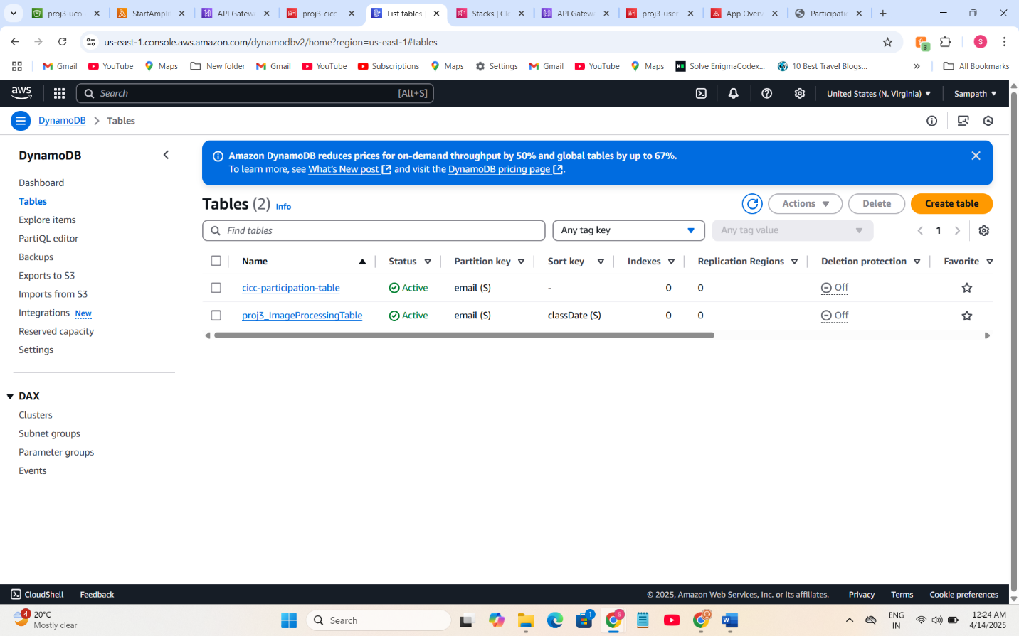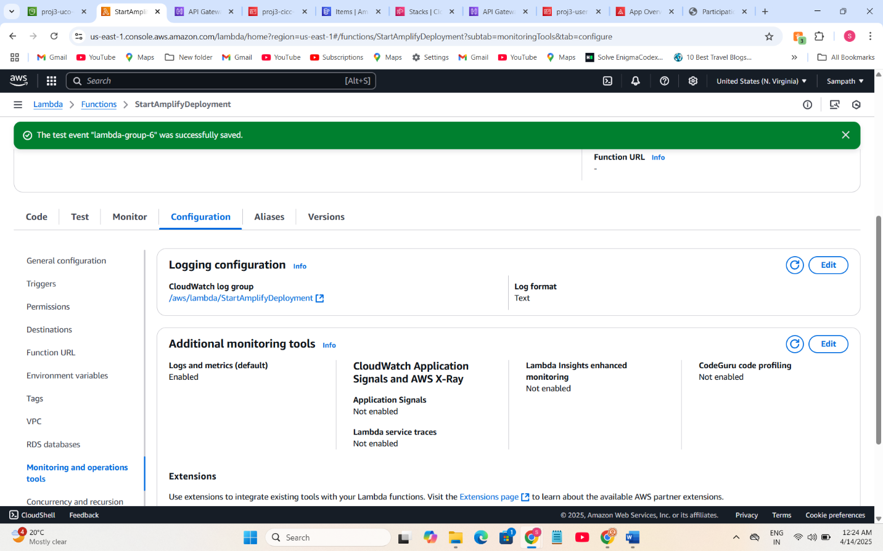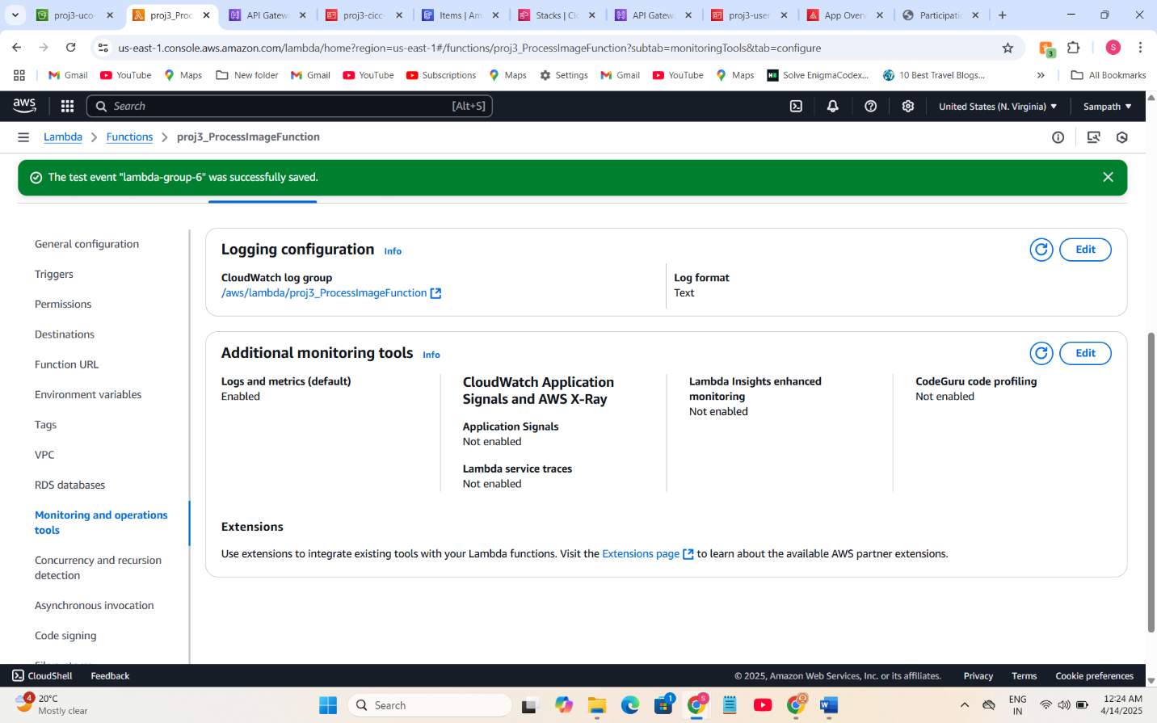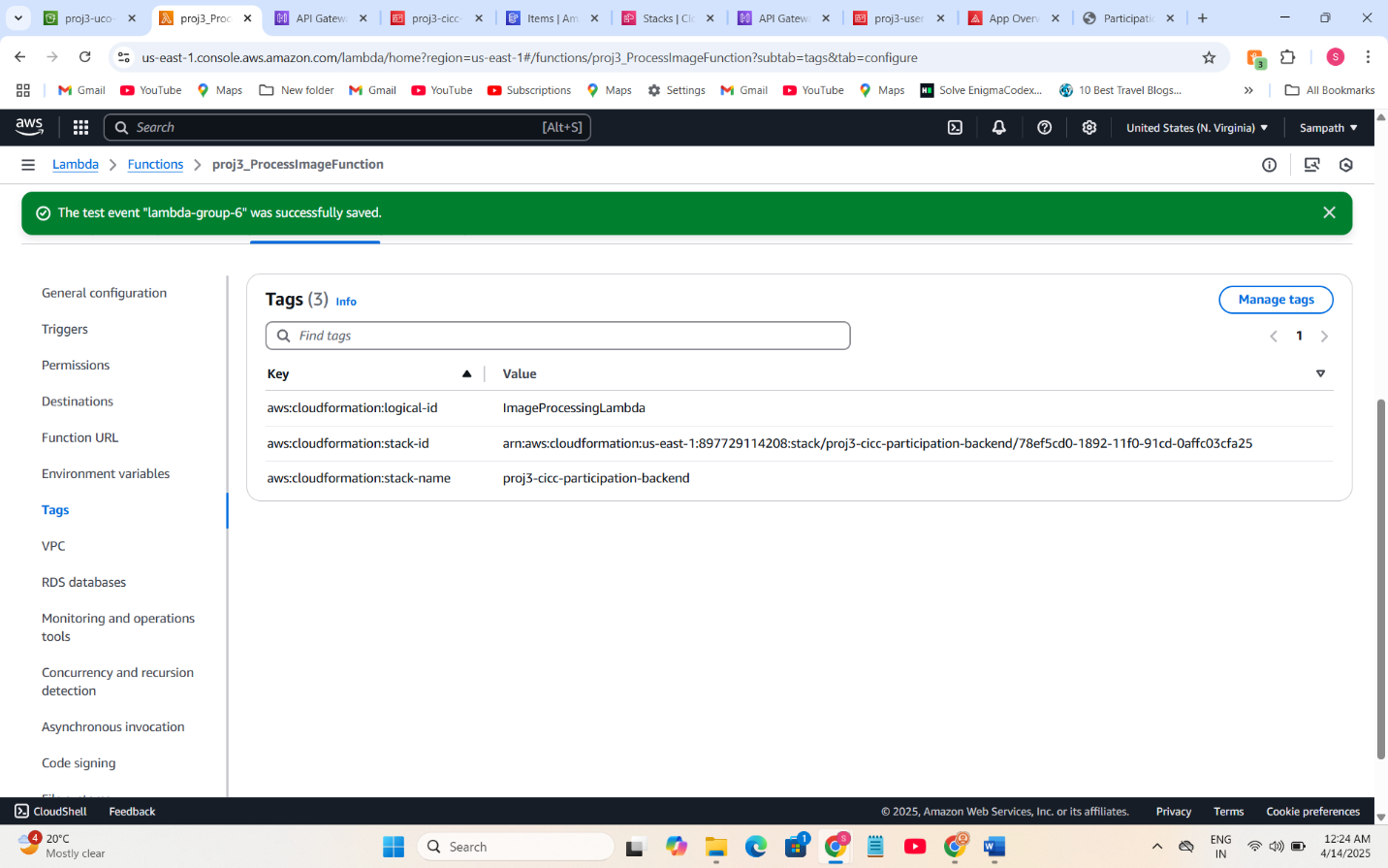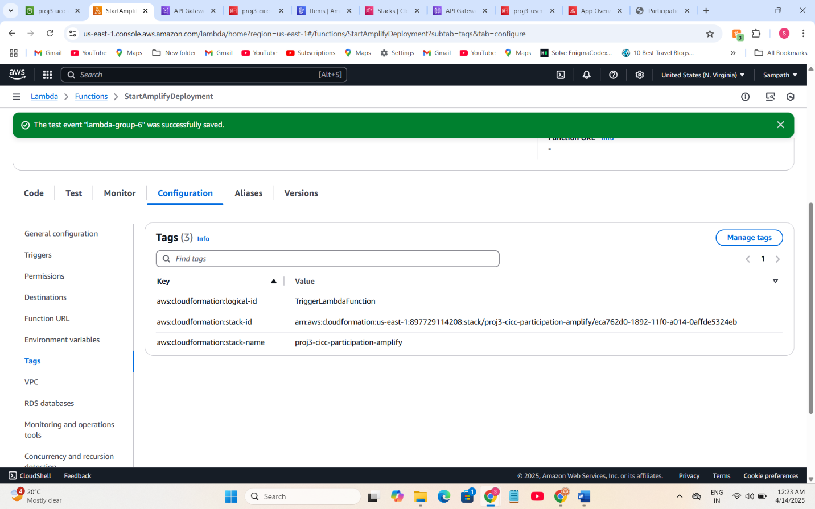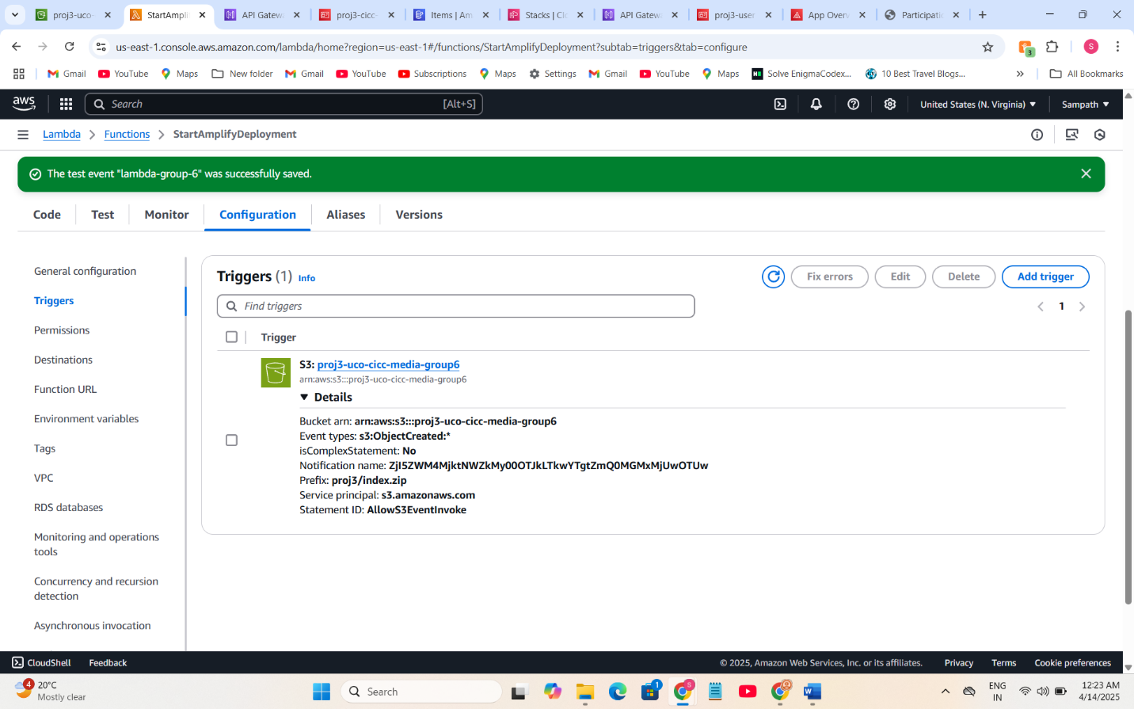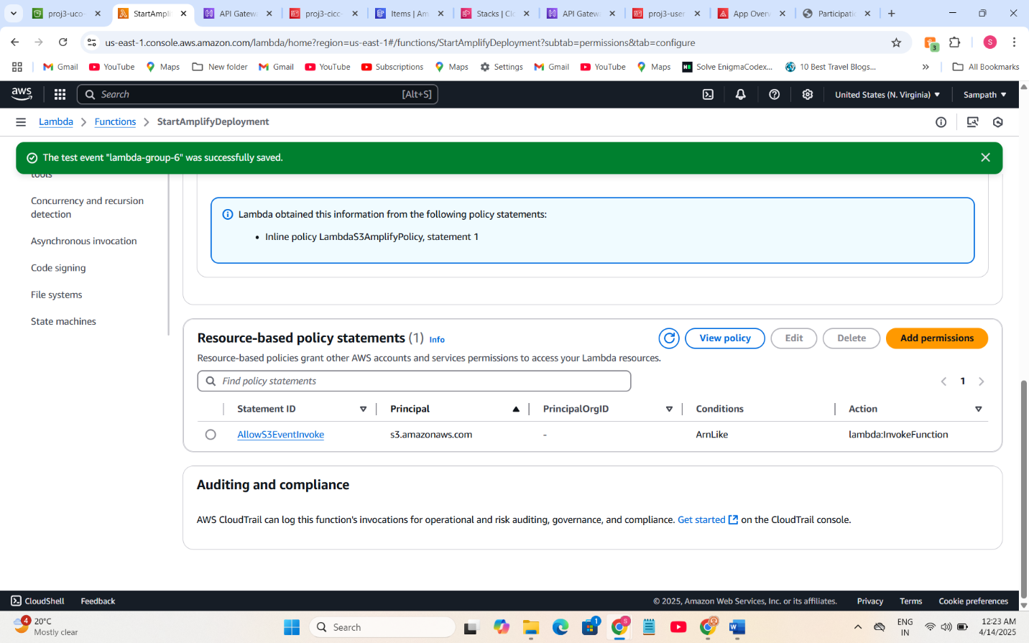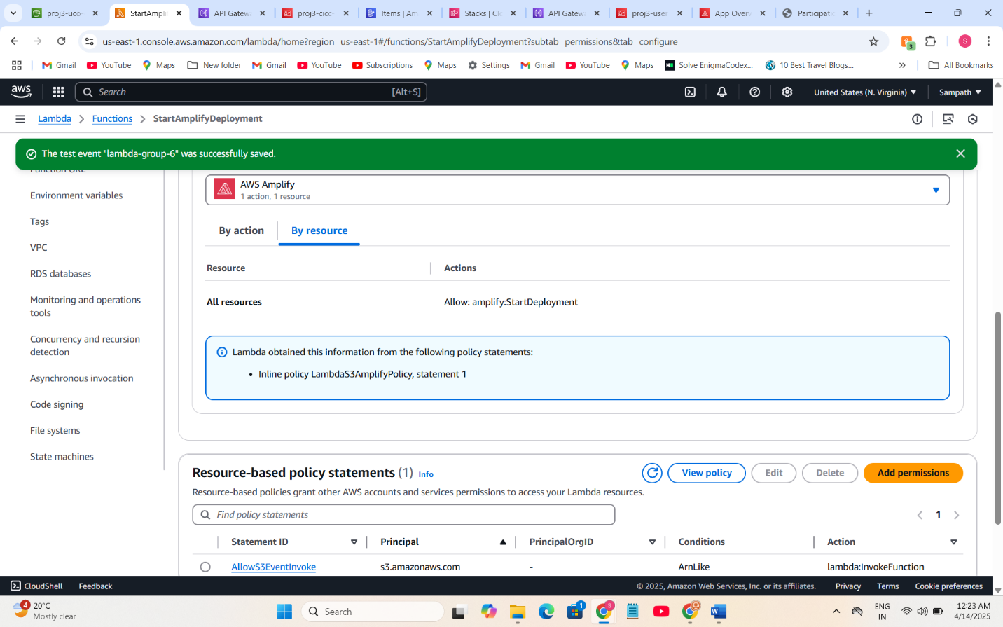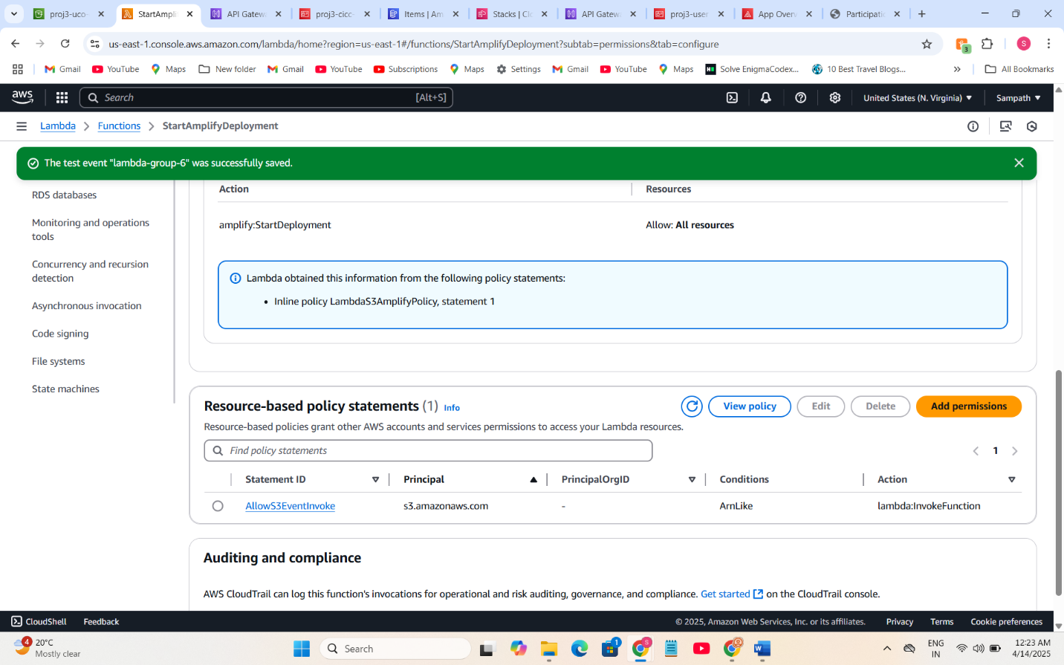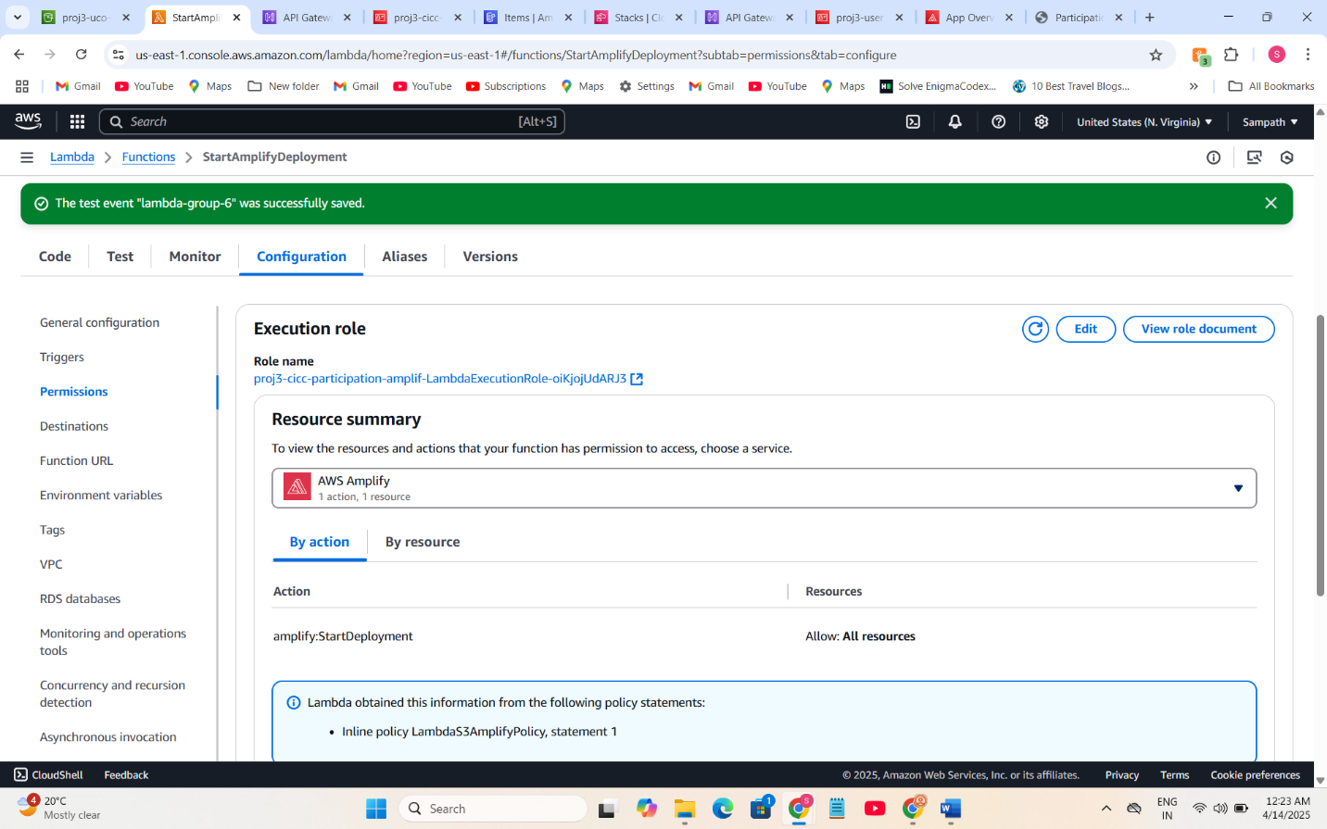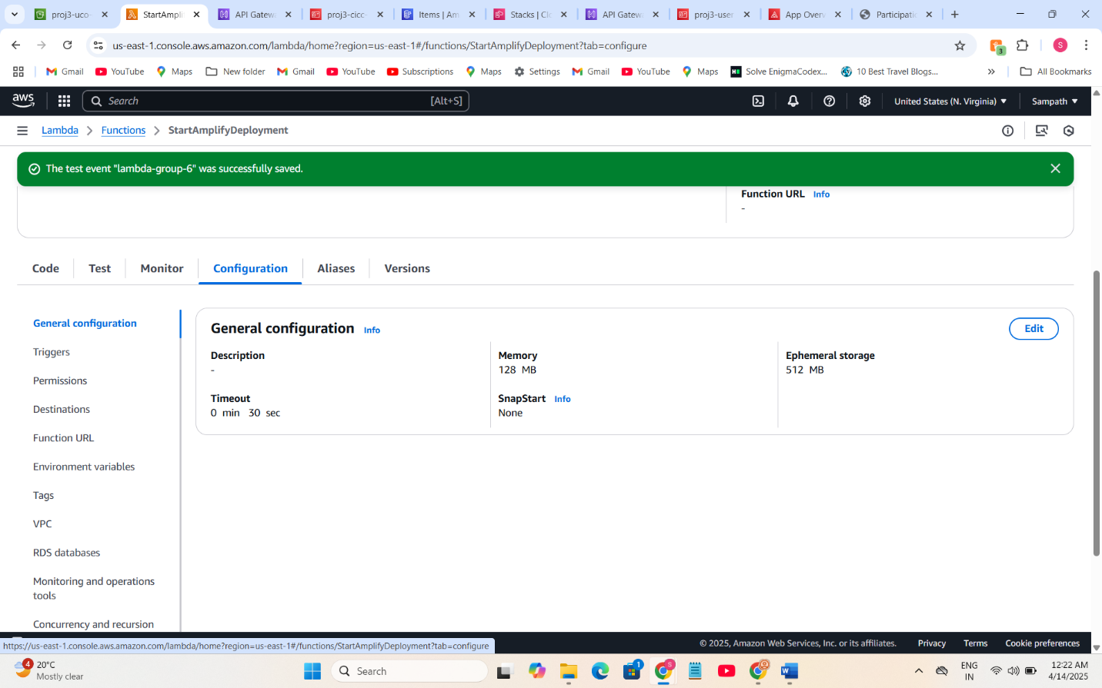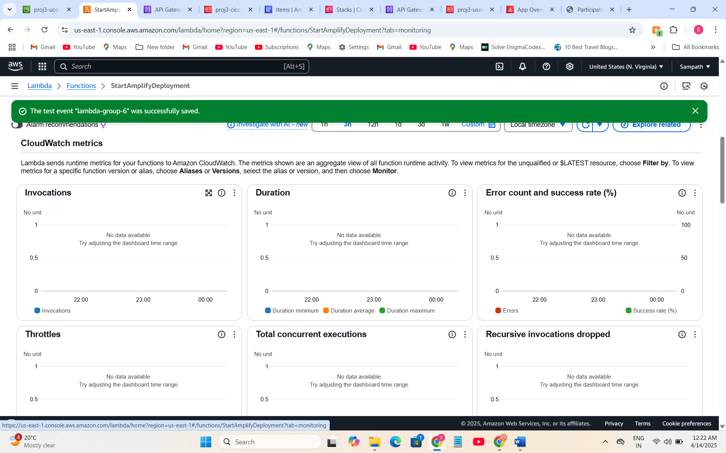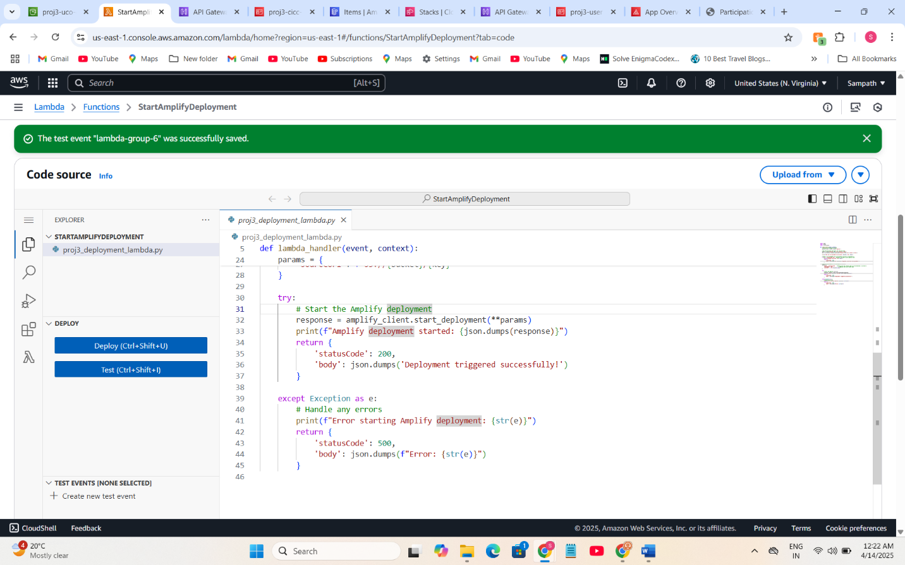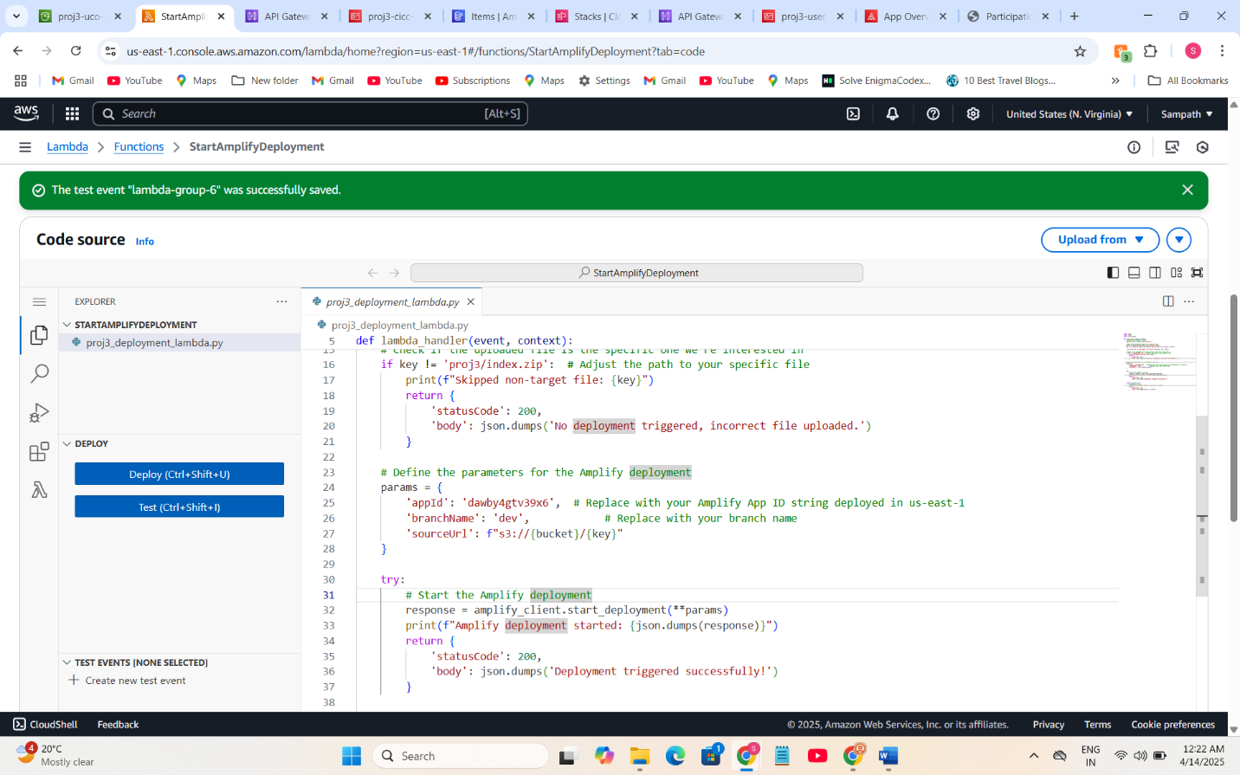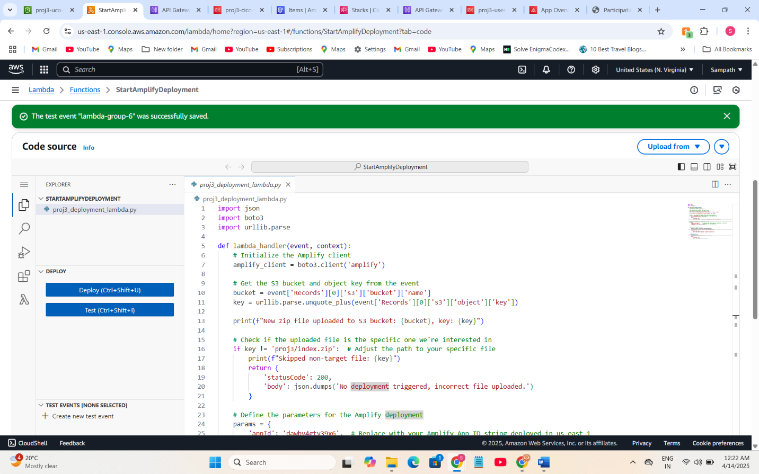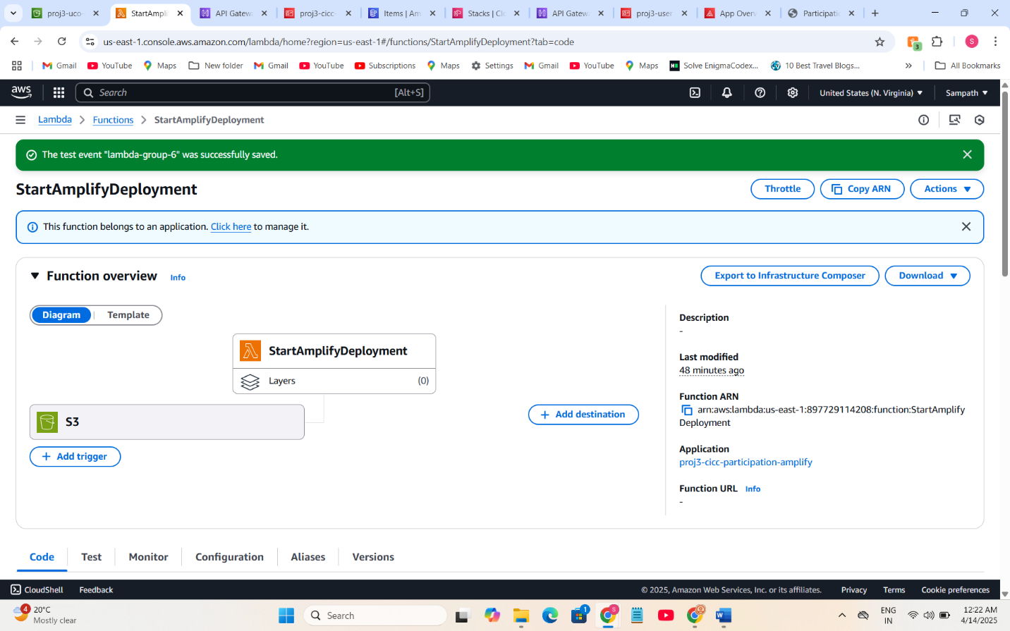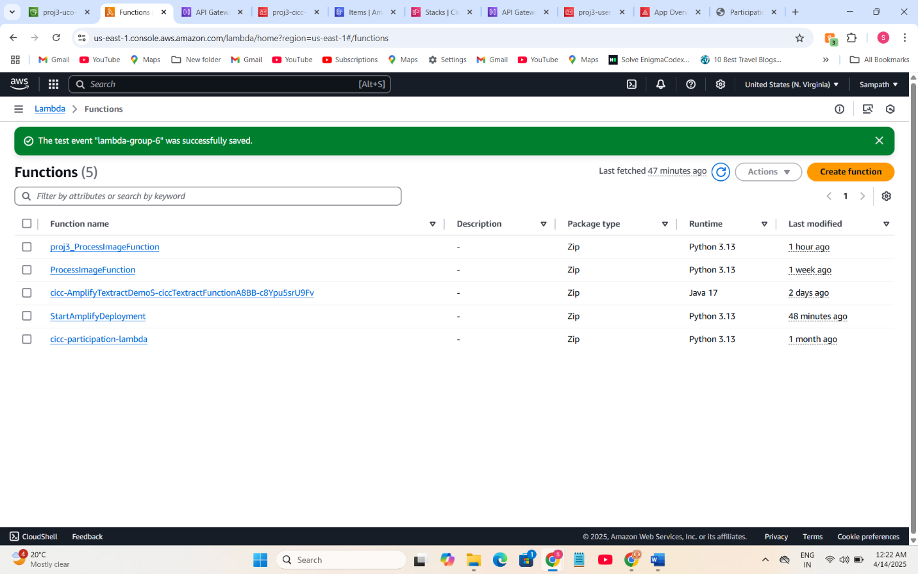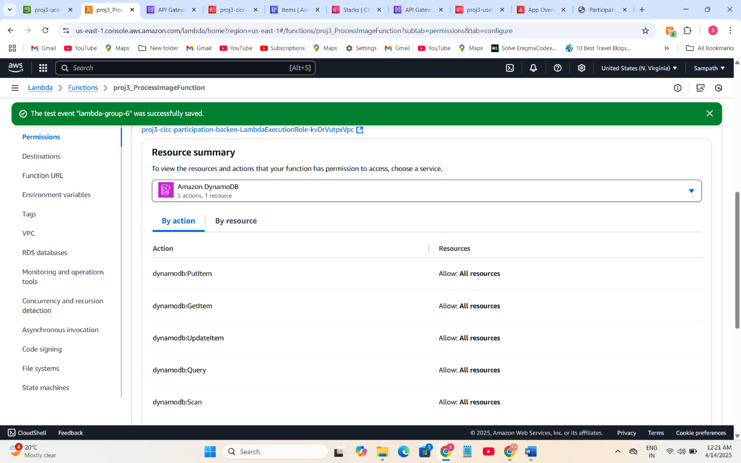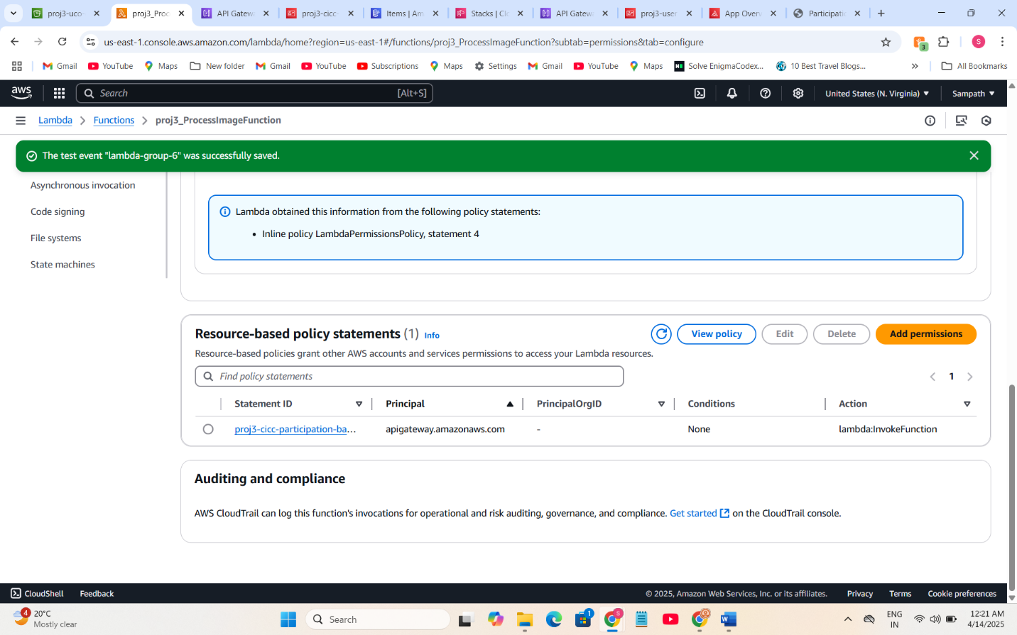  
  
  
  
  
  
  
  
  
  
  
  
  
  
  
  
  
  
  
**4.  
A)**  
**IAM** (Identity and Access Management) is a free AWS service, meaning creating and managing IAM roles and policies does not incur costs.  
**Lambda**: AWS Lambda offers 1 million free requests per month and 400,000 GB-seconds of compute time, which is ample for a student project with minimal traffic.  
**API Gateway**: The free tier includes up to 1 million API calls per month, covering my expected usage.  
**S3:** AWS S3’s free tier provides 5 GB of standard storage along with generous allowances for GET and PUT requests, which is sufficient for storing and retrieving a few images.  
**DynamoDB**: The free tier offers up to 25 GB of storage along with enough read/write capacity for low-traffic applications like this project.  
**Textract and Rekognition:** These services include free tier usage (subject to monthly limits) for tasks like text extraction and face detection. Given the limited number of images processed during development and testing, the usage remains well within the free tier boundaries.  
**Cloud Formation**: You don’t pay to create or run CloudFormation stacks.You don't pay anything for uploading and running that template via CloudFormation.  
By carefully selecting free-tier eligible services (t2.micro, 5GB S3 storage, IAM), ensuring data transfer remains within AWS, and monitoring usage via the AWS Free Tier Dashboard, I can confidently confirm that this project remains within the AWS Free Tier and will not incur charges.  
 **To Avoid Charges Later:  
Resource Cleanup:** After completing testing and project submission, you can delete or shut down all AWS resources (Lambda functions, API Gateway endpoints, S3 buckets, and DynamoDB tables) to prevent ongoing charges.   
**Remove Custom IAM Roles/Policies:**Delete any custom IAM roles or policies created specifically for this project. This avoids accidental usage or permissions that might trigger other services.  
**Monitor Billing and Set Up Alerts:**Enable AWS Budgets and billing alerts. These tools can help you monitor your usage and get notified if you’re approaching any free-tier limits or if unexpected charges occur.  
**Cost Management Practices:** Use AWS Cost Explorer and budget tools to track usage and spending, ensuring that the project’s resource consumption stays within free tier limits.  
**Minimal Configuration:** The project is designed to operate with the minimum configuration necessary, so only the essential services are used, reducing the risk of inadvertently incurring costs.  
 **Delete All CloudFormation Stacks**  
Since all your infrastructure (Lambda, API Gateway, Amplify, S3, IAM roles, etc.) was created via CloudFormation, simply deleting the stacks will delete all resources.

**B)**  
The GitHub Actions workflows (CI/CD pipelines) to automatically package, upload, and deploy Lambda functions whenever code changes are pushed to your GitHub repo. Here's how:  
  
  
Each workflow runs only when certain files change, specifically:  
  
Lambda function 1 (backend): triggered when changes are pushed to cicd-main/backend/**  
  
Lambda function 2 (frontend): triggered when changes are pushed to cicd-main/frontend/**  
  
Both run only on the master branch  
  
dynamically passed the Amplify App ID to the frontend lambda via CloudFormation outputs, and then configured S3 event notifications to trigger this Lambda when index.zip is uploaded.   
**Backend Lambda CI/CD**name: Deploy Lambda Function  
  
on:  
 push:  
 branches:  
 - master  
 paths:  
 - 'cicd-main/backend/**' # Trigger only when backend files change  
  
jobs:  
 deploy:  
 runs-on: ubuntu-latest  
  
 steps:  
 - name: Checkout code  
 uses: actions/checkout@v4.2.2  
  
 - name: Set up Python  
 uses: actions/setup-python@v5  
 with:  
 python-version: '3.11' # Match your Lambda runtime (adjust if different)  
  
 - name: Install dependencies  
 run: |  
 python -m pip install --upgrade pip  
 pip install boto3 # Add other dependencies if needed  
  
 - name: Zip the Lambda function  
 run: |  
 if ls cicd-main/backend/lambda_function.py 1> /dev/null 2>&1; then  
 cd cicd-main/backend  
 zip -r ../proj3_lambda_function.zip lambda_function.py  
 ls -l ../proj3_lambda_function.zip # List the zip file to verify it's created  
  
 else  
 echo "No Lambda function files found to zip."  
 exit 1  
 fi  
  
 - name: Configure AWS Credentials  
 uses: aws-actions/configure-aws-credentials@v4.1.0  
 with:  
 aws-access-key-id: ${{ secrets.AWS_ACCESS_KEY_ID }}  
 aws-secret-access-key: ${{ secrets.AWS_SECRET_ACCESS_KEY }}  
 aws-region: us-east-1 # Replace with your AWS region  
 # Step 5: Upload ZIP to S3  
 - name: Upload to S3  
 run: |  
 echo "Current working directory:"  
 pwd  
 echo "Listing files in the current directory:"  
 ls -l   
 echo "Listing files in the cicd-main directory:"  
 ls -l cicd-main  
 aws s3 cp cicd-main/proj3_lambda_function.zip s3://proj3-uco-cicc-media-group6/proj3/ # Replace with your bucket and path  
  
 - name: Deploy to AWS Lambda   
 run: |   
 aws lambda update-function-code \  
 --function-name proj3_ProcessImageFunction \  
 --s3-bucket proj3-uco-cicc-media-group6 \  
 --s3-key proj3/proj3_lambda_function.zip

|  |
| --- |
| **Frontend Lambda CI/CD** |

|  |
| --- |
| name: Deploy Lambda Function  on:  push:  branches:  - master  paths:  - 'cicd-main/frontend/**' # Trigger only when backend files change  jobs:  deploy:  runs-on: ubuntu-latest   steps:  - name: Checkout code  uses: actions/checkout@v4.2.2   - name: Set up Python  uses: actions/setup-python@v5  with:  python-version: '3.11' # Match your Lambda runtime (adjust if different)   - name: Install dependencies  run: |  python -m pip install --upgrade pip  pip install boto3 # Add other dependencies if needed   - name: Zip the Lambda function  run: |  if ls cicd-main/frontend/proj3_deployment_lambda.py 1> /dev/null 2>&1; then  cd cicd-main/frontend  zip -r ../proj3_deployment_lambda.zip proj3_deployment_lambda.py  ls -l ../proj3_deployment_lambda.zip # List the zip file to verify it's created   else  echo "No Lambda function files found to zip."  exit 1  fi   - name: Configure AWS Credentials  uses: aws-actions/configure-aws-credentials@v4.1.0  with:  aws-access-key-id: ${{ secrets.AWS_ACCESS_KEY_ID }}  aws-secret-access-key: ${{ secrets.AWS_SECRET_ACCESS_KEY }}  aws-region: us-east-1 # Replace with your AWS region  # Step 5: Upload ZIP to S3  - name: Upload to S3  run: |  echo "Current working directory:"  pwd  echo "Listing files in the current directory:"  ls -l   echo "Listing files in the cicd-main directory:"  ls -l cicd-main  aws s3 cp cicd-main/proj3_deployment_lambda.zip s3://proj3-uco-cicc-media-group6/proj3/ # Replace with your bucket and path   - name: Deploy to AWS Lambda   run: |   aws lambda update-function-code \  --function-name StartAmplifyDeployment \  --s3-bucket proj3-uco-cicc-media-group6 \  --s3-key proj3/proj3_deployment_lambda.zip    **C)**  **5 VISITS** 1.For storing templates. 2.From the Amplify Console copy the Amplify-hosted web app URL to test and share the deployed frontend. 3.To verify CI/CD for the web UI and Lambda deployments from CI/CD pipeline  **D)** **Using CloudFormation Templates** By deploying the API Gateway through a CloudFormation stack as part of the backend setup. This means it likely defined the CORS configuration directly within the proj3_backend.yml file (stored in S3 and referenced in the Java deployment code). In CloudFormation,configure CORS headers like: Access-Control-Allow-Origin Access-Control-Allow-Methods Access-Control-Allow-Headers These are typically defined inside the AWS::ApiGateway::Method or AWS::ApiGateway::Resource resources using an OPTIONS method for preflight requests. **Allowing Only Required Methods and Resources** From the backend-first deployment process, the API was built modularly and only included the endpoints that were necessary (e.g., for image upload or lambda triggers). Defined only the needed routes Explicitly listed the methods allowed (like GET, POST) Added a CORS preflight handler (OPTIONS) for each route that needed it This keeps the API secure and avoids exposing unnecessary endpoints or methods. configured CORS in the API Gateway using a CloudFormation template during backend deployment. This setup: Allows only specific methods like GET and POST Enables access only from your Amplify frontend URL Adds an OPTIONS method to handle CORS preflight requests This ensures only required resources and methods are accessible, improving security and avoiding unnecessary exposure. |